

Gargieston Primary School

& Early Childhood Centre

Our Curriculum Rationale

Contents

Who are we?

What makes Gargieston PS & ECC?

How have we designed our Curriculum?

 How are we embedding the principles of curriculum design?

Our Curriculum Structure

Contexts for Learning

Who are we?

Our core values of respect, happiness and kindness can be seen, heard and felt across the school.

Our vision is:

“Together we achieve!”

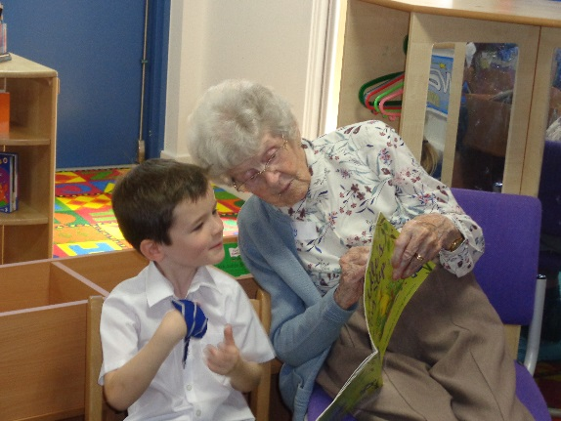 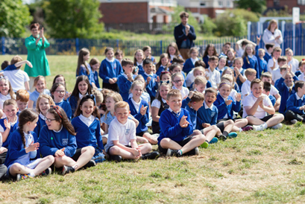 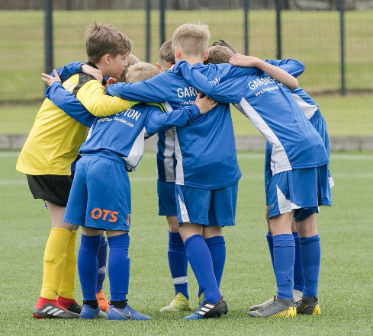

What makes Gargieston PS & ECC?

At Gargieston, we believe that we have particular qualities which make us unique.

Our pupils, staff, parents, visitors and other agencies agree that we:

* Have a strong positive ethos
* Collaborate well as a team
* Respect each other and listen to the views of others
* Have high aspirations for our children
* Value and encourage parental engagement and parent voice
* Have children at the centre of everything we do
* Provide creative, innovative and exciting opportunities for children to learn
* Have a talented and committed staff team
* Care about our children and their families
* Provide a range of opportunities for children to develop skills in sport and music
* Celebrate the achievements of our children within and outwith school

How have we designed our Curriculum?

When considering the design of our Curriculum, we wanted to ensure that we placed our learners at the centre of our planning. As a school community, we reviewed our Values and Vision to ensure that they are a true representation of who we are at Gargieston Primary School & Early Childhood Centre and what our aspirations are for our learners.

Our core values define and shape our school and form the base layer of our curriculum. At Gargieston Primary School & Early Childhood Centre, we want all of our children, staff, parents and community partners to experience our core values of:

* **Respect**
* **Happiness**
* **Kindness**

These core values are underpinned by our vision

* **Together we achieve!**

Our next consideration when planning our Curriculum was to ensure that we encouraged our children to develop the attributes and capabilities of the 4 capacities.

We believe that these will allow them to flourish in life, learning and work both now and in the future.

We aim to provide a variety of opportunities for our learners to become:

* **Successful Learners**
* **Responsible Citizens**
* **Confident Individuals**
* **Effective Contributors**

At Gargieston Primary School & Early Childhood Centre, we follow the advice and guidance contained within the Curriculum for Excellence documents. These identify the key principles for curriculum design:

* **Challenge and enjoyment**
* **Breadth**
* **Progression**
* **Depth**
* **Relevance**
* **Personalisation and choice**
* **Coherence**

How are we embedding the principles of curriculum design?

At Gargieston Primary School & Early Childhood Centre, we consider the principles of curriculum design as we plan, teach and assess children’s learning. They are the core foundations to ensure each child reaches their full potential and they also form the basis of our monitoring and tracking as a school leadership team.

|  |  |
| --- | --- |
| Curriculum Design Principle | How do we achieve this at Gargieston Primary School & Early Childhood Centre? |
| Breadth | * Breadth is achieved by designing learning activities and contexts based on all the experiences and outcomes from the Curriculum for Excellence * Our staff plan for all pupils to have the opportunity to make good progress through all experiences and outcomes * Pupils work through all experiences and outcomes at a pace which ensures secure understanding and the confidence to apply their learning in different contexts * More time is provided for areas of the curriculum where pupils require consolidation or additional support * Pupils are provided with motivating and challenging activities within all experiences and outcomes to ensure they have the opportunity to experience aspects such as skills for learning, life and work. |
| Depth | * Pupils are given opportunities to become secure in their learning rather than moving too quickly from one topic or level to the next * Collaboration between staff and pupils allows them the opportunity to add depth to learning by spending time discussing learning, explaining it to others, applying knowledge and skills in a variety of contexts and probing and researching particular issues * Staff use informed professional judgements about when pupils require further learning activities and contexts to secure learning within a level and when they need to move onto more challenging activities |
| Challenge & Enjoyment | * Staff have high expectations and aspirations for all children * Activities are suitably challenging, engaging and motivating * Planning within the experiences and outcomes focuses on creating opportunities for pupils to actively engage in their learning * Tasks selected are differentiated to present appropriate challenge and support for all pupils * Resources are developed or selected to promote active learning * Activities promote opportunities to develop and demonstrate creativity and innovation * There are opportunities to celebrate personal achievement across a range of different contexts |
| Progression | * The organisation of experiences and outcomes into levels supports planning for progression to meet the differing needs of all learners * Formative assessment evidence is actively used to allow teachers to make professional judgements about pupils’ progress. This will inform when they are ready for the challenge of new and stimulating learning contexts or to extend and deepen the learning experience. |
| Relevance | * The curriculum content connects directly with children’s experiences, learning and interests in and beyond the school environment * Pupils know their learning styles and how they learn best. They have choice in how they record their work and have a good knowledge of their personal targets * Staff use their in-depth knowledge of the whole child during learning and teaching to inform and shape contexts for learning * Pupils know why, what and how their learning relates to everyday life, the local community and the world of work |
| Coherence | * Pupils experience a blend of programmes of study across the curriculum areas. This includes interdisciplinary learning and opportunities for personal achievement * We actively engage with partners within the workplace and within our local community * Through highly motivating contexts for learning, children see the links between different aspects of learning within and across subjects and children have the opportunity to apply their skills within a variety of contexts * There is coherence and consistency in the development of literacy, numeracy and health and wellbeing * There are strong links between our ECC and P1 and P7 and Grange Academy with robust transition programmes in place for all children and enhanced transition planning for identified children * In preparation for transition to Grange Academy, pupils develop a clear understanding of the curricular areas and subject choices on offer and how they can continue to progress on their educational journey |
| Personalisation & Choice | * Staff use their knowledge of pupil’s prior experiences, learning and interests to customise support and ensure high quality feedback is given during teaching * Pupils have the opportunity to undertake personal projects and have a choice of activities * Pupils are involved in planning, assessment and evaluating processes * Pupils are encouraged to be independent learners * There are a wide range of opportunities for personal achievement across a wide range of sporting, musical, academic and community based projects within and out with the school. |

Our Curriculum Structure

When designing our curriculum we took a number of key factors into consideration. We considered what we wanted our **learners to look like** at Gargieston Primary School & Early Childhood Centre and took the following factors into consideration:

* **Our local community**
* **Our attainment results**
* **Our high aspirations for our children**

Furthermore, we considered the skills and attitudes we wanted our learners to have developed by the time they leave us.

**● Transferrable skills ●** **Critical thinking** ● **Resilience ● Self Confidence**

● **Motivation ● Communication skills (written & oral) ● Problem solving**

**● Social skills ● Healthy relationships ● Respect ● Empathy**

**● Tolerance ● Responsibility ● Creativity ● Kindness**

**● Collaborative skills ● Independence ● Positive mental attitude**

At Gargieston Primary School & Early Childhood Centre, we believe that our curriculum provides our learners with many of the opportunities necessary to develop these characteristics. However, we believe that it is our values, culture and ethos as a school that will help shape a number of these. We unanimously agreed that we wanted our children to feel happy, safe and confident at school.

**Based on this we made the following key decisions:**

1. We will organise our Curriculum Experiences under the 4 contexts for learning:

* **Curriculum areas and subjects**
* **Interdisciplinary learning**
* **Ethos and life of the school**
* **Opportunities for personal achievement**.

2. We will ensure that **Health & Wellbeing** remained a high priority as we want our children to be resilient, sociable learners who have positive mental attitudes.

3. We will prioritise **Literacy and Numeracy** as core areas.

4. We will **BUNDLE** the remaining 5 areas of the curriculum using an Interdisciplinary approach. This includes Social Studies, Science, RME, Technologies and Expressive Arts. This decision was taken to ensure that our children gained a breadth of experience and developed transferrable skills through a meaningful, creative and motivating context for learning.

5. We will provide our learners with opportunities to **work together** as a school community. Our children will have opportunities to do this across classes, stages and across the whole school.

6. We will ensure that we have a focus on the **SKILLS** our learners were developing. We will develop aspects of our planning and assessment surrounding STEM subjects and skills for learning, life and work.

Contexts for Learning

|  |  |  |  |
| --- | --- | --- | --- |
| Curricular Areas | Interdisciplinary Learning  (IDL) | Ethos & Life of the School | Opportunities for Personal Achievement |
| Literacy  Numeracy  Health and Wellbeing  Modern Languages  ICT skills  PE skills | IDL Bundles  • Social Subjects  • Science  • Technology  • RME  • Expressive Arts  • Whole school focus  weeks | **We will provide opportunities for our children to:**  · Exercise their responsibilities as members of a community  · Participate responsibly in decision-making  · Contribute as leaders and role models  · Offer support and service to others and demonstrate the values of the school community | **We will provide opportunities for our children to:**  · Develop their resilience and confidence  · Experience a range of achievements within and beyond the classroom  · Undertake activities which they find challenging  · Work closely with different organisations  · Have their voices heard |