Dear Parents

P7 TRIP TO LOCKERBIE MANOR

As you know, we leave for Lockerbie Manor on Monday 12th June. I hope the following information will be helpful.

Departure/Return Times
Pupils should arrive at school as normal and do not need to wear their school uniform. The bus will depart at 1.00pm. We expect to arrive back at school by about 3pm on Friday 16th June.

Eating
The children will have lunch at school before they leave and there will be no eating on the bus. No snacks or sweets should be brought as everything will be provided and there is a strict rule of no eating in the dormitories. Please do not put any food in suitcases.

Pocket Money
Each child has £5 pocket money included in the total amount paid for the trip and this can be used to buy postcards including stamps and the use of the vending machines. Children should bring no cash with them and group leaders will look after the pocket money for the children.

Lockerbie Manor
Lockerbie Manor has a special ethos based on building relationships and teamwork. The centre does not allow electrical or battery operated appliances. Please support us by ensuring that your child does not bring Ipods, radios, games machines, tablets, kindles or mobile phones. Parents should be aware that mobile phones are not permitted on any residential trips and it is very important that this rule is adhered to. Books or magazines are a good idea for bedtime. If your child wishes to take a camera we would suggest a disposable one, in case of accidents, with your child’s name written on it.

Contact
Miss Quinn will have a mobile phone and a list of home phone numbers. Should there be a problem she will contact you. The school will be in daily contact with Lockerbie Manor and we will put daily updates on our website: https://blogs.glowscotland.org.uk/er/StJosephs/. The school will also be able to answer general enquiries, however, if you need to get an urgent message to your child the office number of Lockerbie Manor is 01584 861333.

Health & Safety
The health and safety of your child is a prime concern. Please speak to him/her about the importance of sensible behaviour and following the instructions of adults. Good behaviour will allow everyone to get the most from the trip.

Medicine/Dietary Requirements
If your child will requires medication when away please contact the school office and we can send home a medical consent form. A signed Medicine Consent Form is always required for staff to administer medicine to your child. Please ensure that the medicine is handed into the office the week before the trip or to group leaders by 9.00am at the latest on the morning of departure. All medicines should have the child’s name clearly marked on the container. Any medication which may possibly be required during the trip e.g. inhalers, should be taken on board as hand luggage and clearly marked with your child’s name. Children who are prone to travel sickness and who take medicine for this, should take the necessary dosage on Monday morning before they leave the house and give the necessary dosage with consent form to the group leader for the return trip.

Clothing
Lockerbie Manor will provide any safety equipment for activities. We recommend that new clothes are not worn as they could be damaged and will certainly get dirty. Denim jeans are not suitable for outdoor activities. Please see reverse for a list of clothing recommended by the centre.

Group Leaders
Miss Quinn Miss Cocozza Miss Brew
Miss Cunning Mrs Briggs Mrs Tweedly

I am sure both staff and children will have a most enjoyable time.
Yours faithfully
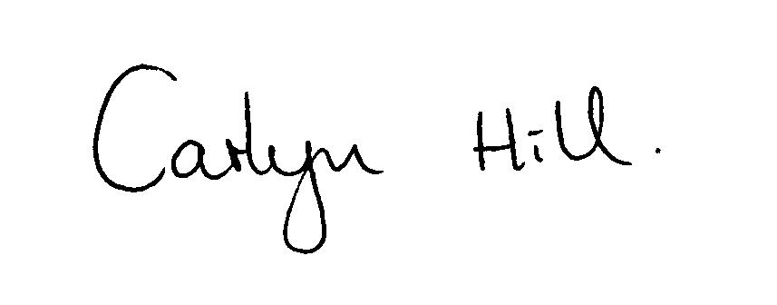

Carlyn Hill (Head Teacher)

Please mark everything with your child’s name.

All Children are required to bring a sleeping bag (is best) or Duvet Quilt with cover / pillowcase.

Outdoor Clothing
- 3 woolly jumpers or heavy sweatshirts
- 5 warm T-shirts (3 must be with long sleeves)
- 5 pairs of old jogging/tracksuit bottoms (full length)
- hat & gloves
- 8 pairs of thick socks
- underwear
- old trainers that can get wet or walking boots (not wellies)
- Spare pair of trainers
- Cagoule and waterproof trousers to keep out wind and rain
- Midge Cream / Midge Head Net
- Sun Cream / Sun Hat
- Swimsuit
- Plastic Water Bottle (with name on)
- Torch
- Toiletries etc (please note deodorants must be roll-on, no aerosols)
- Back pack for jumper, water, sun cream, medication to be with pupils at all time

Additional clothing (for indoors)
- Towel – 2 or 3 ( Essential they are not provided)
- Bin Bag for wet clothes
- Night clothes
- Toiletries
- Shoes/trainers
- T-shirts
- Jogging bottoms or similar
- Socks
- Sweatshirt

ITEMS NOT ALLOWED

- Mobile Phones IPods
- Games machines TVs
- Hairdryers/Straighteners Electrical appliances
- Chewing Gum Football Strips

Primary 7 Trip

to

LOCKERBIE MANOR

Monday 12th June 2017

To

Friday 16th June 2017

