Dear Parent/carer,

**Active Travel**

We are delighted to be participating in East Ayrshire Council’s new Active Travel initiative ***Shoot to Saturn*** this session. The programme aims to encourage children and young people to make their journeys to and from school active ones!

Transport is responsible for almost half of the CO2 emissions here in East Ayrshire – with over half of these journeys being ones that are less than a mile. These are journeys that we could easily make on foot, rather than driving.

As well as reducing our CO2 emissions and reducing the congestion at our school gates, walking, cycling or scooting to and from school helps us stay fit and healthy, gets us ready to learn and saves money!

***Shoot to Saturn***

Upon returning from a space mission to Saturn, the crew aboard the Clean Green Rocket discovered that they had lost all the Cosmic Crystals they had gathered during their trip back to Earth. Thousands of Cosmic Crystals are now floating around space and it’s our job to get them back.

Throughout the year, we have 3 different areas of space to search for cosmic crystals:

|  |  |  |
| --- | --- | --- |
| Challenge #1 | Explore space between Earth and the Alpha Space Station. | 30th September – 13th December (10 weeks) |
| Challenge #2 | Explore space between the Alpha Space Station and the Beta Space Station | 13th Jan – 4th April  (12 weeks) |
| Challenge #3 | Explore space between the Beta Space Station and Saturn | 28th April – 6th June  6 weeks |

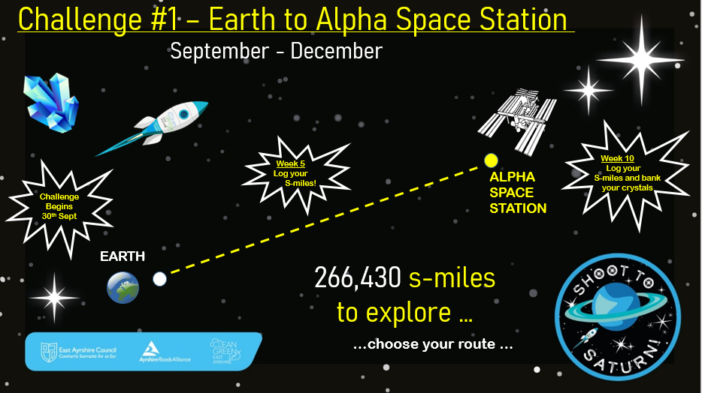

For Challenge #1, the route we have chosen to explore for Cosmic Crystals is Orange Orbit.

To complete this route and arrive at the Alpha Space Station on time to bank our Cosmic Crystals, we need to gather 6000 s-miles.

***Earning S-Miles***

Each time our young people travel to/from school by walking, scooting/cycling, they will earn an S-mile for their class.

Park & Stride – pupils will earn an S-Mile even if they walk part of the journey to/from school.

A walking circuit will be available in the playground for pupils who travel to school by taxi/bus and for any pupil who wishes to gather bonus S-miles for their class during break/lunch times.

***Earning Bonus S-miles***

Bonus S-Miles can be earned by parents/siblings/staff walking the journey to school too. Children will record your journeys in their class record.

Class walks, outings and Daily Mile time also earn Bonus S-Miles for classes.

***Supporters***

Parent/carers can help us gather Bonus S-miles by telling us about any additional active travel journeys that are made to school, outwith the morning drop off/afternoon pick up times.

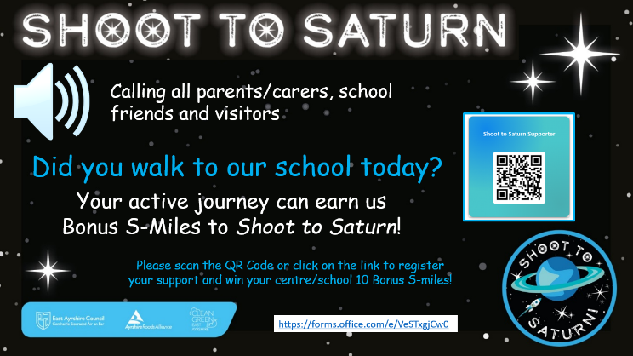

For example, walked to school to drop off a forgotten lunch box? To attend a meeting? For parent’s afternoon?

Scan the QR Code on display on the banner at the main gates and earn Bonus S-miles for the school!

You can also earn Bonus S-miles for our school by telling us about your active travel journeys outwith school times.

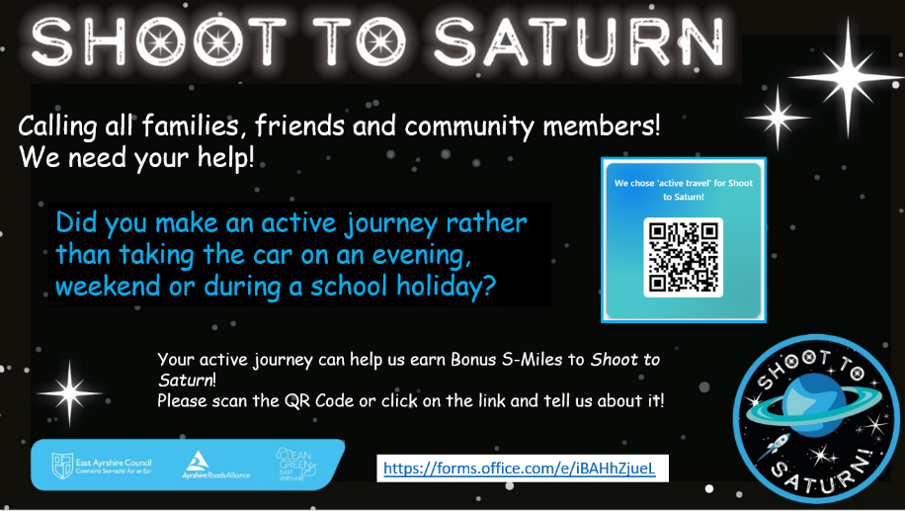

Did you make an active travel journey in the evening, at the weekend or during a school holiday, instead of taking the car?

Scan the QR code or click on the link and tell us about it. Mission control will award Bonus S-miles to your chosen school. <https://forms.office.com/e/iBAHhZjueL>

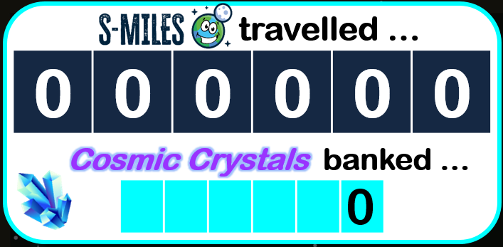

***Logging our S-miles***

All of the S-miles and Bonus S-miles we earn during challenge 1 will be shared with Mission control and added to the ***Shoot to Saturn***

***S-mile-ometer***.

With your support, we are confident that we will make it to the Alpha Space Station on time and bank lots of Cosmic Crystals that we find along the way.

We look forward to keeping you updated on our progress and thank you in advance for helping us ***Shoot to Saturn***!