New Cumnock Primary School Parent Council presents:

Thursday 30th March 2023

P1-P3/4: 5.30-6.30pm

P4/5-P7: 6.45-7.45pm

New Cumnock Primary School

(Enter through Community Entrance)

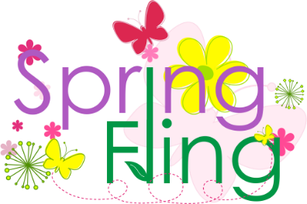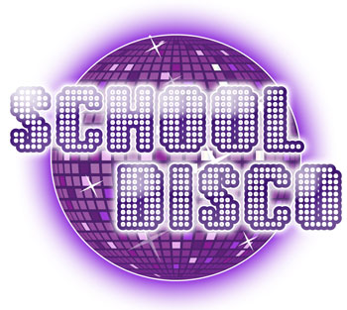

You are in control of the playlist!

Visit the school blog and complete the Form to request your favourite song or scan the QR code below to access the Form.

Entry - £2 per child (to be paid at the door)

Spring Fling Disco

To ensure safety of our pupils, all children must be collected by an adult at the end of their disco session.

Bring money to visit our Tuck Shop