New Cumnock Primary School Parent Council

Saturday 26th November 2022

10am-12pm

New Cumnock Primary School

(Enter through Community Entrance)

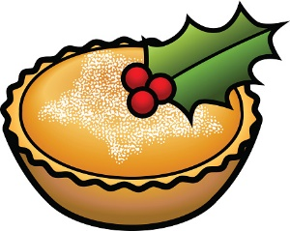

Also featuring stalls from:

* Little Miss Bows
* Lucious Beauty by Kirsty
* Maggie Moon’s Home Décor
* Rainbow Melts by Libby
* Jodie’s Bows

And lots more!

Santa’s Grotto

Don’t miss out on our:

* Bottle stall
* Raffle
* Festive Tattoo Station
* Preloved toy stall
* Festive Face Painting

Tea, coffee, hot rolls, shortbread and mince pies for sale

Class Christmas crafts for sale

Christmas songs performed by our school choir

Christmas Fair