

Angus Schools
Guide to
E-referral



THE ANGUS FOODBANK

E-FORM DISTRIBUTOR HANDBOOK FOR SCHOOLS

‘Fighting poverty at its point of need’

Every year thousands of people are facing crisis in the Angus area. Schools are becoming increasingly aware of the rising need to tackle poverty within the school community, with the help provided by agencies like The Trussell Trust and Angus Foodbanks we will be able to support the families most in need without having to go through a formal referral process to Social Work or other partners.

The distribution of food to those in need (clients) is the core business of the foodbank. Emergency food packages provide 10 nutritionally balanced meals (3 days) for clients. The selection has been developed with support from the Salisbury District Hospital Nutritional and Dietetics Department, part of the South Wiltshire Primary Care Trust.

Angus Schools will be able to support this work by issuing e-vouchers at their discretion.

Please Note: - Use of this service is a short term fix and signposting to partner agencies is essential when/if regular use is required. Please note ANY family you assess as “in need” may be referred. You may refer as many families as necessary to this service.

Introduction
Thank you for adopting “e-referral” as a way to refer your families to Angus foodbank for emergency food assistance. Without the help provided by agencies like yours, Angus foodbank would be unable to help people in need in our local community.
We believe that e-referral will help more of your clients receive the help they need, at the time they need it most; and will make referral easier for your staff.
What is e-referral?
E-referral is a way to refer a client without the need for a pre-printed red voucher. It uses a bespoke data system shared by all foodbanks in the Trussell Trust network, and can work in two ways:
- Printed e-referral vouchers
The client’s details are captured into a computer (or other connected device) and a personalised voucher is printed for them to take to the foodbank.
- “Code-only” referrals
The client is not given a voucher, but just a ten-digit code to take to the foodbank.
All Angus foodbanks are able to accept “code only” referrals at its foodbank centres.

Why use e-referral?
There are multiple benefits from using e-referral, such as:
- Your staff will not need to issue red vouchers or re-order them.
- You will be able to see the client’s history of foodbank referrals. You will be able to see if the client has not used previous vouchers, which might mean they need help to visit the foodbank. You will also see if the client has been getting vouchers from other agencies, in case you need to take that into account.
- Staff will be able to see the foodbank centres nearest to the client’s postcode and their opening times. These will be printed with the personalised voucher, or given verbally for “code only” referrals. This should help clients get to the foodbank centre most accessible to them.
- The client details you enter into the system will be immediately accessible to the foodbank when the client visits. This will improve our ability to help your clients, and will reduce the errors that arise when transcribing entries from hand-written vouchers.

Your responsibility
Your principal responsibility remains to make sound judgements about your clients’ need for emergency food. We rely upon your judgement, and trust you either because the situations of your clients are well-known to you, or because your staff are skilled in assessing the needs of the family and determine how best they may be helped.
We ask you to be alert to potential abuse, particularly where a client appears to be getting vouchers from multiple sources, or multiple vouchers in a short period (though there can be circumstances where this is justifiable).
When using the e-referral system, you will have ready access to our phone number and email, and we welcome you contacting us if they have any uncertainties.

Signing up for e-referral
Responding to the invitation
E-referral is not automatically available to all referral agencies, but only to those invited to use it. The invitation will come to your school as an email with a link labelled “Accept invitation”. By clicking on the link, you indicate that you wish to use e-referral as well as, or instead of, red vouchers. You will be given opportunity to set your password, which you will need to retain along with your log-in identity.

ENSURE THIS PASSWORD IS RETAINED AND ACCESSABLE FOR FUTURE USE SHOULD THERE BE A CHANGE OF STAFF. If this is the case a new GDPR form will need to be completed and returned to the Foodbank.
Accessing the data system
Once your GDPR form has been returned to the Foodbank you will be registered centrally. This will enable you to access the online forms via the process below. Please ensure you retain a signed copy of this consent form in school.
- A link will be sent to you via email enabling you to set up a username and password for your e-voucher account. You will then be able to add addiotional staff memebers to this account (only if a GDPR form has been returned)
The foodbank client data system is accessed online via
https://data.foodbank.org.uk.
On arrival in the system, you will be asked to enter your username and password.
Once you are in the data system, you will see a menu bar with five main options:
To prepare for use of the system, you will first need to visit Settings and carry out two tasks:
- Check your Agency details are correct.
If your details change in the future, please edit them here. The foodbank will then always have your latest contact details. (In the same way, the latest contact details for the foodbank will always be available to you via the Partner Foodbank screen).
- Click Users to give staff access to e-referral:
Adding Users
You will need to add into the system the details of staff that you want to have access to e-referral. To do so, go to the Settings/Users section and click on the Invite new user button.
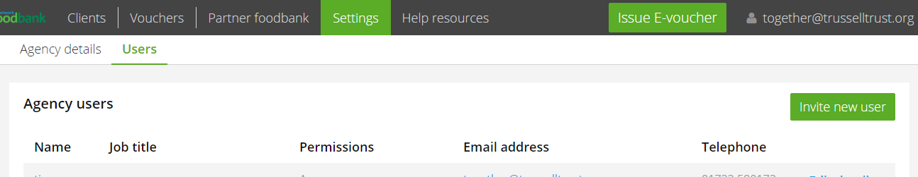

You will be asked for the following details of the new user: their name, job title, a unique email address, phone number (optional), and whether they are a “user” or “manager”. Managers have the ability to add, edit and remove users, and amend the “agency details”, as well as all the other functions available to all Users.
Once you have entered a user’s details, click the Send invitation button. The user will then receive an email similar to the one that invited you to e-referral.

Stopping e-referral
If at any point it looks like e-referral isn’t working for you, please let us know. We can turn off your access to it.
To remove access for one of your staff, just go to Settings/Users, find their name, click Edit details, and click Delete and the bottom of the screen.

Additional items
Reporting problems
Please contact Angus foodbank if you are unsure about when and how to make e-referrals. We are always very happy to discuss this with you.
Please also contact us if you find a technical problem in the system, which we will report for you.

Data security
Like all foodbanks in the Trussell Trust network, Angus foodbank takes data security seriously. Angus foodbank is registered with the Information Commissioner’s Office, and expects all its data system users to sign up to standards that protect client personal data. All personnel are also required to sign a confidentiality agreement. Please ensure you have returned your Schools GDPR form for each member of staff who will be responsible for administering the e-voucher we suggest this is the HT and one other member of the management team. Client data in the system is fully encrypted, both when stored and when being communicated across the internet.
In order to prevent abuse of the system, you will see the dates of all the foodbank vouchers issued to your clients, not just those issued by you. This visibility of client voucher history means that you can be confident that a client is not “doing the rounds” to get multiple vouchers. You will also see if other people from your client’s postcode have been getting vouchers, since different members of the same household will sometimes try to get vouchers separately.
To make clients aware of this, printed vouchers contain the following statement:
“To help prevent misuse, the date and location of client’s foodbank visits may be visible to other foodbanks and some referral agencies”
In order to meet Angus Council standards an additional form called ‘Foodbank Consent – School Copy’ must be completed and stored securely in school for a period of 12 months from the date of issue.

Making referrals
To make an e-referral, log into the data system https://data.foodbank.org.uk and click on the Issue e-voucher button. This starts a six-step process
- Step 1: Search for client
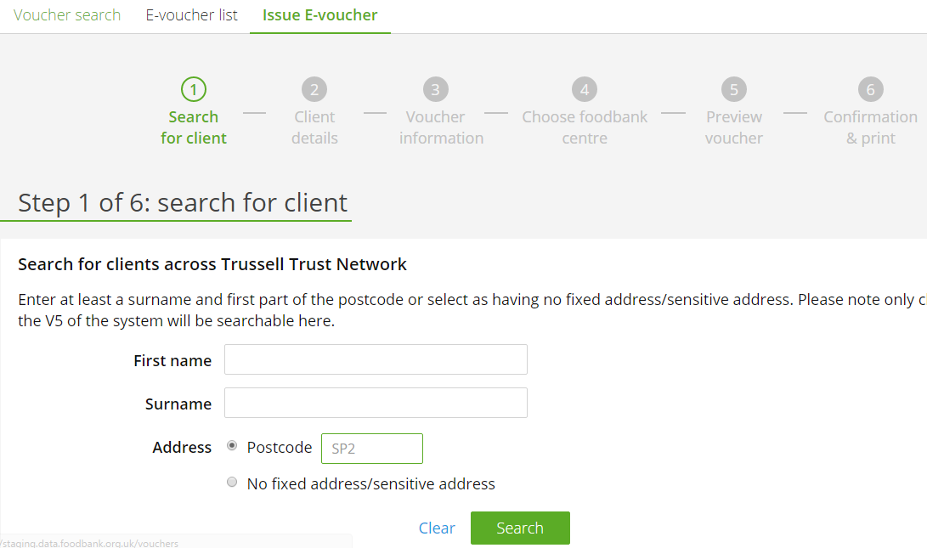
Enter the client’s details and click Search to see if they are already in the system. You will need to enter at least their surname and at least the first part of their postcode. Any matches will then be displayed.
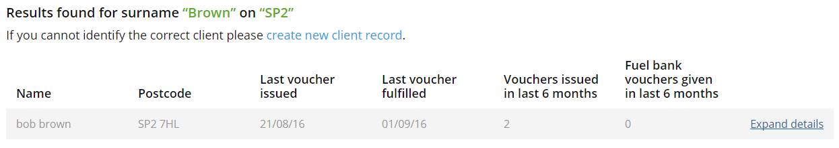

If the correct client is not listed, click on create new client record. You will be taken to Step 2: Client details.
If the correct client is listed, click on Expand details. You will see the history of foodbank vouchers for this client and for anyone else at the same postcode (unless the location has been flagged as a “sensitive address”, such as a women’s refuge).
If the voucher history raises no concerns, click on Issue voucher. You will be taken to Step 2, where the known “client details” will already be displayed. You will be able to amend these details if you need to, or go straight to Step 3: Voucher information.
Issuing more than 3 vouchers
At this point, you will be alerted if the client has already had more than 3 vouchers in the last 6 months.
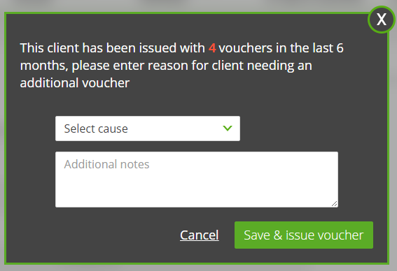
This message does not stop you issuing another voucher; but there should be good reason to do so. This is usually because the client’s crisis is genuinely continuing, while available steps are being taken to resolve the crisis. It could also be because the client has been hit by a new crisis.
Best practice is to contact the foodbank before issuing more vouchers. However, if you are confident that the client needs a further voucher, you can record the reason here. You may be able to find a suitable reason in the drop-down list, or you may simply type a note. This will be visible to the foodbank when the voucher is processed. We may wish to get in touch to discuss the clients’ continuing needs, and will sometimes need to put a limit on the number of vouchers a client can have.
Clients with unfulfilled vouchers
Sometimes a client will not use a voucher, and it remains “unfulfilled”. As a result, they may well have been issued more than three vouchers, but not used all of them. There are several possible reasons for this:
- embarrassment: the client is reluctant to visit the foodbank
- unable to travel: the client was ill or lacked necessary transport
- problem relieved: the voucher was not needed, as alternative help became available
- “timed out”: the client delayed, and assumed the voucher had become invalid
- “insurance” : the client is holding a voucher against a future time of need
- lost voucher
- stockpiling multiple vouchers
It is worth asking the client about unfulfilled vouchers. If the client’s explanation seems reasonable, your staff should feel comfortable issuing an extra voucher.
However, a new voucher should not be issued if the client has had other vouchers in the last couple of days. The food provided by the foodbank should last three days at least. A client should not need a second vouchers within three days, other than in exceptional circumstances (for example, if a bank holiday weekend meant that the client would not get essential foodbank help for an extended period).
Step 2: Client details
At this stage, record the main information about the client:
  - First name
  - Surname
  - Whether the client has no fixed abode, or a sensitive address
  - Details of the address
  - Postcode (required)
  - Number of adults and children in the household
These details will be retained for any future referrals. If they change in the future, they can always be amended, either as a temporary change (for example, if children come to stay for a while) or a lasting change.

- Step 3: Voucher information
This is the main stage in the referral process, where you record details about this particular referral. It consists of two parts.
The first part is “Referral agency information”. This displays your agency name, contact number and the name of the staff member making the referral. The staff name and contact number can be amended, if necessary. This information will be visible to the foodbank, and will help them if they have a query or need to speak to the referrer.
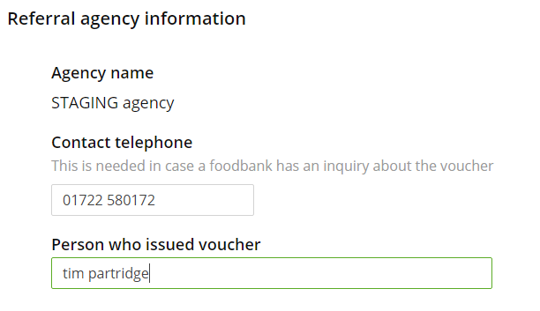

The second part deals with “Client circumstances”. It records six important pieces of information about the client. This information will help the foodbank understand the client’s situation, and so be better able to help them. It will also provide valuable insights into patterns and trends lying behind demand for foodbank assistance.
- Can the client provide ID when collecting food at the foodbank?
It is preferred if clients can bring ID when visiting the foodbank with a printed e-referral voucher. Clients with a “code-only” referral must bring ID if possible. Where available, photo-ID would be best, but it is not essential.
There are circumstances where a client has no suitable ID. Please do not hesitate to refer such a client; but for “code only” referrals, please contact the foodbank and agree the day and foodbank centre of their visit to avoid any risk of refusal.
- Number of adults and children currently in the household
These should already be correct, but can be edited at this stage if necessary.
- Is anyone living in the household employed?
Please record this information if known, or if the client is willing to share it. It does not affect in any way the help the client will receive from the foodbank.
- Main cause of crisis
Please record what you judge to be the main cause of the client’s crisis.
Eleven main causes of crisis are offered. For most of these eleven crises, extra information can be recorded under Main cause details. For example, if the main cause is “benefit change”, the details might be “sanction” / “job seekers allowance” / “13 weeks”.
The recording of Main cause details is optional. However, they can be very helpful to the foodbank’s understanding of the client’s situation and need for support, as well as informing understanding about the drivers of food poverty.
If none of the eleven main causes of crisis are appropriate, you can select “other” and record relevant information in a text box.
- Secondary causes of crisis
Many clients have multiple contributory problems, in addition to the main crisis. Please tick the ones that you believe apply to your client.
- Additional notes for foodbank
Use this to record anything you would wish the foodbank to know. This might include things like dietary constraints, if they need dog/cat food or toiletries, language problems, or social difficulty.
However, these notes will only be visible when the foodbank accesses the voucher information in the data system. It is NOT the practice at our foodbank centres to access the data system in the client’s presence. We would therefore encourage you to use this “notes” facility.

Before proceeding you will be asked the following question, which determines the steps that will follow. If you select “No” you will go to Step 5 and generate a “code only” referral. If you select “Yes” you will go to Step 4 first and generate a printed voucher.
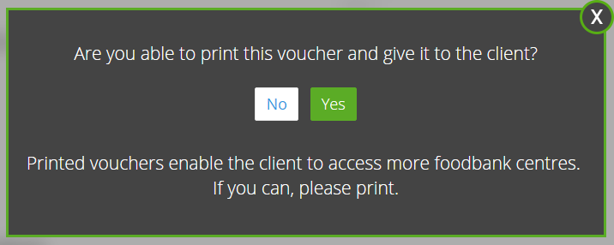
- Step 4: Choose foodbank centre
At Step 4 you will be shown location details, maps and opening times of the ten foodbank centres closest to the client’s postcode in a straight line.
Four of these will be printed on the client’s voucher. The four closest will already be ticked, but you can change that selection if other foodbank centres appear preferable.
Click Continue to reach Step 5.
- Step 5: Preview voucher
Step 5 shows the final voucher. If it is to be printed, it will include maps and opening times of the selected foodbank centres.
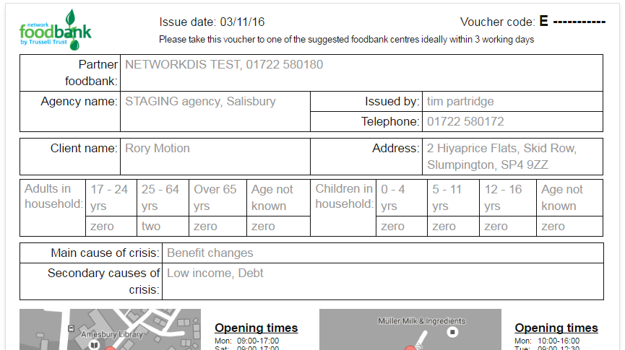

Click Save & generate voucher code to reach the final step.
- Step 6: Confirmation & print
The final step displays the voucher number for this client referral.

- If you have selected to print the voucher you will see a Print voucher button.
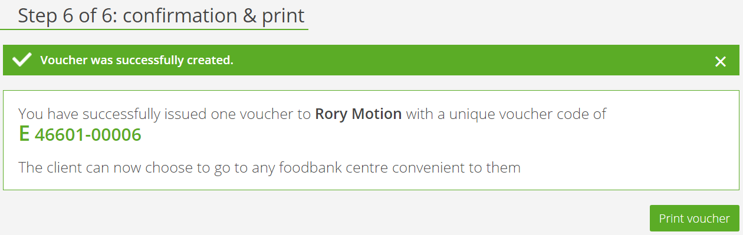
- This button generates a PDF of the voucher which can be printed. There is no need to save a copy of the PDF, as the voucher information can always be revisited via the data system.
Please do not send the client a copy of this PDF for them to print. That could be too easily abused.
- If you selected not to print the voucher, you will be shown the foodbank centres nearest to the client’s postcode that have been registered as accepting “code-only” referrals.
A client with a “code only” referral can only visit one of these foodbank centres (unless you have agreed specific arrangements in advance).
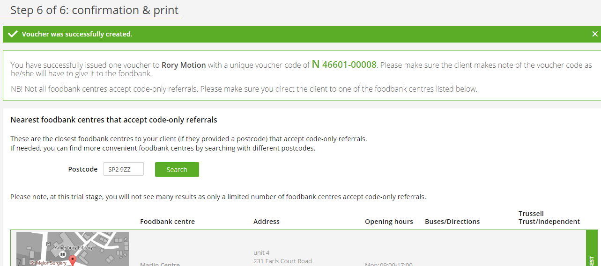
When making a “code-only” referral, there are three things you must always tell the client:
- their voucher code (they must record this accurately and take it to the foodbank centre)
- the foodbank centre(s) that may be easiest for them to visit
- remind them to take suitable ID (ideally photo-ID, if available)
If the client visits a foodbank centre that is not registered for “code only” referrals, the foodbank centre will have no way of checking the voucher code. The client is then likely to be refused.
The foodbank centre(s) of Angus foodbank are able to accept “code only” referrals, and so will be shown in the list of potential “code only” foodbank centres.
The number of foodbank centres accepting “code only” referrals is likely to grow over time.

Monitoring client use
The data system offers you several ways to monitor activity.
Voucher search
You can use “voucher search” to look up details of a particular referral.
You could just enter the voucher code and click Search. However, there are more useful options available if you click Show more search options.
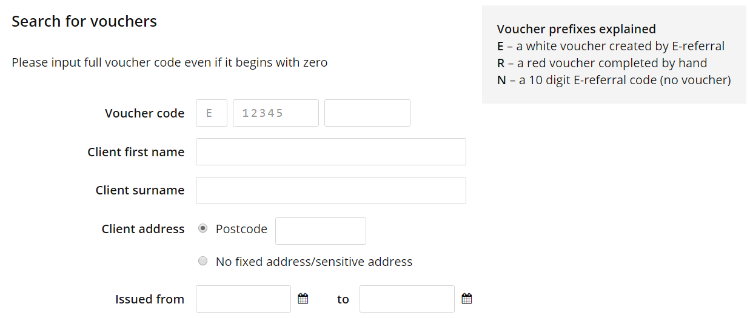
For example, you could search for all referrals for a named client, or referrals related to a particular postcode; or you could see all referrals made (vouchers “issued”) in a given period.

The search results will show, for each matching record, the voucher code, client name, issuer name, date of issue and status (“fulfilled” or “unfulfilled”).
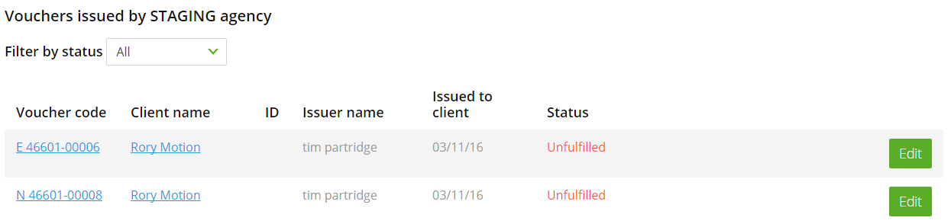
Click the Edit button if you want to check or amend the “Voucher information”, such as main and secondary crises.
Alternatively, click on the client’s name if you want to check or amend the “Client details”, such as address.

E-voucher list
The “E-voucher list” screen also gives you access to the “Voucher search” facility.
More importantly, it lists the e-referral vouchers that your agency staff have issued.
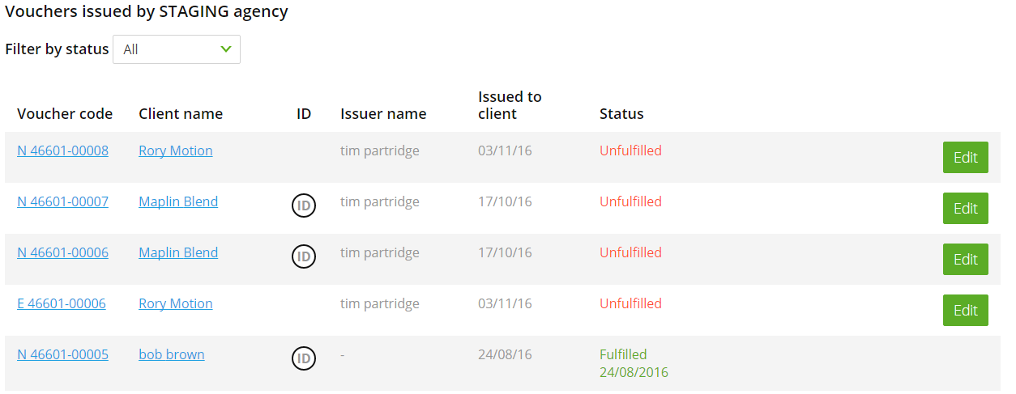
This will help you to monitor activity, showing when vouchers are issued and by which staff members. It will also show when vouchers are being used (“fulfilled”).
If it helps, you can filter this list just to see “fulfilled” or “unfulfilled” vouchers.

 | Printed e-vouchers  (“white voucher”) | “Code only”  e-referrals
Printed voucher? | Yes  printed by agency  as required | No
Requirements: | access to data system and printer | access to  data system
Acceptable at: | all foodbank centres | all foodbank centres
Client needs to take ID to the foodbank? | Recommended | Yes
Letter at start of voucher number: | E | N

