

Renfrewshire Coucil

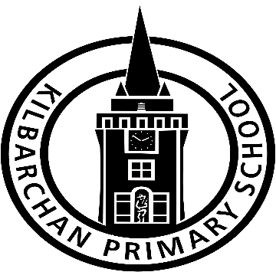

The very best!

Kilbarchan Primary School

STANDARDS AND QUALITY REPORT

June 2019

This report will inform you of the school’s progress and achievements in the last session and let you know about our plans for 2018-2019. I hope that you find it helpful and informative.

Fiona MacKenzie

Head Teacher

OUR SCHOOL

Kilbarchan Primary School lies at the very heart of the village. We are a non-denominational school that serves all who live in the community and beyond, priding itself on a welcoming and inclusive ethos. Our expected roll is that of around 240 pupils in August 2019, around 13% of which are from placing requests.

The school building itself was built around 30 years ago**, and was further developed in the last 5 years by the addition of an outdoor learning space. This area has been significantly improved over the last 2 years by parents, pupils and staff and now contains appropriate materials and resources to support high quality outdoor learning. Kilbarchan Primary is open plan; with infant and upper school departments, a large central gym hall, AV room, nurture space, Snug and our much-loved Book Box. There are extensive school grounds with a football pitch, stage area, garden and trim trails, all of which are used regularly by the pupils.**

**The positive relationships we form with parents and carers are crucial to the development of the children in our care. We have an active and supportive Parent Council who meet regularly and work in partnership with the school staff and pupils. Their ideas, suggestions and feedback are always well received and serve to ensure our provision meets the needs of the whole school community. Parents and carers are also invited in for workshops, curricular sessions and opportunities to discuss the progress of their children on a regular basis**.

**We have a** Head Teacher, two Depute Head Teachers and an Acting Principal Teacher. There are eight FT class teachers, four PT class teachers, two classroom assistants, two additional support needs assistants, a home link worker, a business support officer and two music instructors. The environmental services team comprises a janitor, catering and cleaning staff. **Together, staff provide a warm and** supportive **environment** for learning **where children are** supported to reach their full potential.

OUR VISION, VALUES AND AIMS

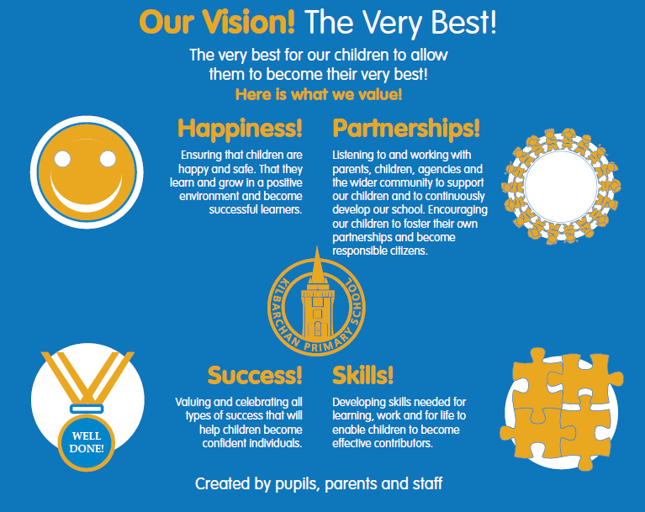

SUCCESSES AND ACHIEVEMENTS

✓ We continue to provide various sporting opportunities both in school and across the authority for all children to be active by participating in competitions, festivals and friendly tournaments. This session pupil participation at clubs has increased**.**

✓ The school has developed a nurture space to provide individuals a quiet and confidential space to speak with an adult. All pupils were consulted on naming this area, and have decided on ‘The Snug’. In addition to ‘The Snug’, the school has developed a breakout space for classes to discuss elements of wellbeing. Pupils have named this area ‘Kidscape’ which homes a variety of new health and wellbeing resources to explore sensitive topics.

✓ Dive into Writing and Concrete, Pictorial, Abstract Maths Parental Workshops were well attended and received 100% positive feedback.

✓ Family Learning Literacy events, such as P1 Book Bugs, P2-3 Read Write Count were well attended and enjoyed by Pupils and Parents/Carers.

✓ Increased opportunities to expand upon pupil knowledge of authors and genres of texts through author visits. P4-7 pupils welcomed poet/author Joe Coelho and expanded upon this learning experience by exploring his work in almost all classes.

✓ All P7 Pupils were selected to participate in the local Morrison’s ‘Inspired by Burns’ poetry competition and we were delighted to have first and second place winners.

✓ Our KPS World Book Day challenges and activities promoted an enjoyment for reading amongst all pupils. Links with Waterstones enriched pupil experiences and enabled them to exchange their World Book Day token for a book of their choice. In addition, our KPS Sponsored Reading Challenge raised £1436, which supported the purchase of varied books to improve classroom libraries.

✓ All P1 staff have engaged in training to support the implementation of P1 Play Pedagogy. They have further liaised with colleagues within other establishments to share good practice prior to developing a play based learning approach within the P1 classrooms. This will be further developed next session.

✓ Our P7 Quiz Team secured first place in the Cluster Rotary Quiz and Kilbarchan will host the Rotary Quiz next session.

✓ Primary 6 pupils secured 1 silver and 4 bronze awards at the Scottish Mathematical Challenge.

✓Pupil Fairtrade Group hosted a Fairtrade coffee morning to share information with parents/carers.

✓ The school has a strong focus on sustainable practices and this year we have been involved in providing affordable school clothing, recycling batteries and bringing attention to single use plastic materials

✓ The school continues to donate to the Renfrewshire Foodbank, raising awareness of challenges faced by the local community whilst actively making a positive difference in the lives of families

✓ We have continued to welcome and offer a wide range of community involvement including Church of Scotland, Community Police talks, Active Schools events, Skoobmobile, Kilbarchan Nursery, I Am Me Cinebus, SSPCA & NSPCC seminars as well as a variety of schools trips to enhance pupils’ learning experiences.

✓ All P7 Pupils were responsible for planning and prepared a successful and informative Burns Supper to showcase their learning.

✓ School Show

✓ Pupil Council led a successful whole school fun day and raised £684.50 for Children in Need.

✓Primary 7 pupils ran a highly successful Bake Sale using their enterprise skills, which raised £400. The money will go towards their Leavers’ Prom with plenty left over to donate to local charities.

**HOW SUCCESSFUL HAVE WE BEEN IN IMPROVING OUR SCHOOL?**

**School Leadership**

✓ Leadership at all levels is actively encouraged and promoted in Kilbarchan Primary ensuring that high standards and expectations are shared across a school to achieve excellence and equity for all

✓ The Head Teacher attended a range of training opportunities in areas such as data analysis, additional support needs and values based leadership thereby improving the standard of leadership within these key professional areas

✓ Acting Depute Headteacher undertook Aspiring Leadership training. This has assisted them in developing their knowledge, skills and capacity to lead and deliver school improvement effectively.

✓ Almost all teachers have distributed leadership responsibilities linked to their skills and interests. Our motivated staff drive forward aspects of the School Improvement Plan, share good practice and lead professional training. This has resulted in greater consistency across the school and increased quality and standards of teaching and learning.

✓ Pupil leadership groups include; Pupil Council, Fairtrade, Paired Readers, Eco Group and Peer Buddies. This ensures that pupil voice is heard and pupils have opportunities to make a genuine difference to their school.

✓ All classes consult and take action from Pupil Voice in the planning of the curriculum and the moderation of learning and teaching. All teaching staff are involved in the creation of the monitoring schedule, observation criteria and balance of development activities within the Working Time Agreement. All parents are consulted on our Pupil Equity Fund programmes and are invited to discuss our School Improvement Plans and Policy changes. Through this involvement all stakeholders have the opportunity to have lead the development of the curriculum and plan improvements within the school.

✓ Pupil Equity Funding (PEF) has created three leads within Literacy, Numeracy and Health and Wellbeing. These members of staff were able to lead targeted approaches with specific groups of children and work in collaboration with teaching staff to ensure programmes met identified needs in order to raise attainment.

**Teacher Professionalism**

✓ All staff undertook training on Dive into Writing approach which has supported staff to deploy a wide range of innovative and creative resources and teaching approaches to enthuse and motivate children in Literacy. This has resulted in increased engagement and contributed to a rise in attainment.

✓ Almost all teachers participated in training to improve professional understanding of best practice in the teaching of reading, leading to a more consistent approach to the teaching of reading; improved choice of texts for children in every class; more stimulating class libraries and the purchase of a phonic based reading scheme. This has allowed the children to have more quality experiences of reading and develop skills in selecting texts, using reading for relaxation and using reading to challenge their learning.

✓ Almost all teaching staff have been involved in establishment and inter-establishment moderation of professional judgements within writing, ensuring a consistent understanding of benchmarks and progression for all pupils

✓ P1 teachers trained in a play based learning approach, ensuring a smoother transition from nursery and learning that better fit the needs of the children.

✓ This session a further 2 teachers have undertaken Stages of Early Arithmetical Learning (SEAL) training. Children in Primary 1 -3 are better at demonstrating a clear grasp of number knowledge due to SEAL and this approach is now being extended within Primary 4 and 5 with 2 Teachers undertaken training in Beyond SEAL.

✓ School Numeracy Champion attended a CountOnUs ‘Numeracy Blueprints’ event delivered by Chris McKenna and from this professional learning it was determined that this resource would have a positive impact upon learning and teaching. This professional learning was subsequently extended to almost all teaching staff specifically supporting the development of concrete, pictorial and abstract learning.

✓ Depute Head Teacher and Acting Principal Teacher have completed Nurturing Relationships Professional Learning this session. This has supported the creation of a Core Working Group who will work in partnership with Education Psychology Department to develop a whole school Nurture Approach based upon the key principles outlined in the training.

**Assessment of Children’s Progress**

✓ Progress of all pupils is reviewed through the use of termly excellence and equity meetings between Senior Management Team (SMT) and class teachers. There is a clear focus the Interventions for Equity as a basis for supporting the most vulnerable and disadvantaged children. Teachers report increased confidence in making professional judgements about children’s progress and in identifying interventions that will make a positive difference to progress and attainment.

✓ All teaching staff have been trained in the use of the whole-school tracking spreadsheet and can confidently input data, record interventions and evaluate impact.

✓ Through Pupil Equity Funding, we have provided targeted learning support for identified pupils across the school. The PEF Leads have employed consistent assessment practices to evaluate the impact of approaches used leading to a positive impact on attainment for all as well as closing the poverty related attainment gap.

**HOW SUCCESSFUL HAVE WE BEEN IN IMPROVING OUR SCHOOL**

**Parental Engagement**

✓ All parents and carers are asked for their opinions on the provision of service by the school. This takes place at each Parents’ Night and the results are then analysed, shared and where appropriate acted upon. The ‘You Said, We Did’ display provides further evidence of their voice in action.

✓ The reporting process has subsequently been improved by acting upon such feedback. All parents and carers are informed about pupil progress on a four-termly basis. This comprises of two sets of Parents’ Nights and two Sharing the Learning reports.

✓All parents and carers of children with additional support needs are invited to attend Getting It Right for Every Child/Learner (GIRFEC/L) meetings throughout the year and as a result collaborate to evaluate progress and agree on next steps.

✓ Throughout the year all parents and carers are invited to attend workshops and focus group meetings on aspects such as school improvement planning, policy writing, Concrete Pictorial Abstract methods in Maths. This has developed their understanding of these new approaches thereby better supporting their children at home.

✓ The school has continued to develop communication with parents and carers, utilising Twitter as an additional platform for communication. By increasing the types of communication employed we have increased opportunities to share our work.

✓ Kilbarchan Primary have worked hard this year to improve parental engagement and this has been successful. We have created more opportunities for parents to help enrich the educational experience of our pupils. We have seen a marked increase in regular parent helpers who are supporting and enhancing the learning in classes. This is extremely positive and we will continue to build on this.

✓ The School is very well supported by all members of the Parent Council who work closely with staff and pupils to ensure our priorities and the needs of the whole school community are met.

**Performance Information**

✓ Classroom observations, pupil learning conversations and jotter monitoring effectively support the triangulation of self-evaluation evidence and the quality of the learners’ experiences.

✓ The tracking system is used by all teaching staff and captures socio-economic data and observations that can be used to ensure equity.

✓ The Head Teacher was trained in the creation and application of Pivot Tables to support the analysis of pupil progress and minimise inequity.

✓ The management team and Active Schools Co-Ordinator use data in order to apply a targeted approach to creation and development of clubs and activities, thereby improving health and wellbeing across the school and increasing uptake amongst specific groups.

**School Improvement**

✓ Emotionworks was introduced to almost all staff, including teaching, support and clerical staff. In addition, it was introduced to pupils through our whole school assembly programme and reinforced in classrooms with teacher led tasks and as a result, our children have developed emotional literacy skills.

✓ Through partnership working with Active Schools, we are now tracking wider achievements and pupil involvement, comparing levels of activity amongst children. It has enabled us to provide tailored experiences for pupils.

✓ We have worked closely with our Education Manager to self-evaluate key aspects of our school. This has helped us to celebrate success and identify areas for development.

✓ HGIOS4 2.3 Learning, Teaching and Assessment indicate strengths in differentiated teaching approaches (fluid grouping),

**OUR NEXT STEPS – PRIORITIES FOR 2019-20**

We believe that we have made good progress during session 2018-19 and we will use the improvement priorities listed below to build on this progress moving forward.

✓ School priority 1: Develop nurturing approaches in partnership with Renfrewshire Educational Psychology Department and implementation of Emotionworks.

✓ School priority 2: Raise attainment for all in Literacy, particularly in Listening & Talking and Writing, through whole school committees, holistic assessment approaches and Primary 1 Play pedagogy.

✓ School priority 3: Raise attainment for all in mathematics, through the development of numeracy across the curriculum approaches, cluster moderation and professional learning opportunities and Primary 1 Play pedagogy.

The school will continue to close the attainment gap by focusing upon targeted support groups for literacy and numeracy, additional staffing and through the development of our nurture spaces.

Full details of the school’s improvement priorities and actions are detailed on the school improvement plan which can be accessed on our website or by contacting the school office.

**KEY STRENGTHS OF THE SCHOOL**

✓ Happy, confident and kind children who represent our shared high standards within the establishment and community.

✓ A positive ethos that permeates throughout the school, it is welcoming, nurturing, inclusive and supportive for all.

✓ High expectations for all learners and staff, leading to increases in attainment and the reduction in inequity.

✓ Wider achievement is celebrated on a regular basis, demonstrating an interest and involvement in the progress of pupils beyond the school walls.

✓ Positive relationships with parents, carers and partners, built on a mutual recognition of our values and high quality communication.

✓ Distributed Leadership roles for almost all staff, determined by pupil need, school improvement priorities and professional interests.

✓ Pupil Voice is firmly embedded in the planning and observation process. All pupils are encouraged to contribute and ideas are acted upon for the benefit of the class.

✓ A clearly defined transitions programme for both Early Year and Secondary. In addition, pupils experience a smooth transition from year to year through the professional dialogue between staff.

HAVE YOUR SAY!

Please take the opportunity to share your thoughts with us as we use feedback to help us make improvements to the school. You can do this by speaking to staff, participating in Parent Council meetings, responding to questionnaires/surveys and by completing evaluations at school events.

**Kilbarchan Primary School**

**Meadside Avenue, Kilbarchan, PA10 2LA**

**Phone: 0300 300 0163**

**Website: https://blogs.glowscotland.org.uk/re/kilbarchanprimary/**

**Twitter/Facebook: @KilbarchanPS**