Numeracy

*Warm up – Counting in 10s*

1. Start at 0 and count up to 100
2. Start at 100 and count back to 0
3. Start at 23 and count up to 93
4. Start at 67 and count up to 107
5. Start at 95 and count back to 35

**Challenge – Can you start at 521 and stop at 591?**

Below is a link to an online place value game. If you can, give it a go. It is great fun!

[**https://www.topmarks.co.uk/learning-to-count/place-value-basketball**](https://www.topmarks.co.uk/learning-to-count/place-value-basketball)

I wonder if anyone is brave enough to try the 3 digit numbers.

**Main Lesson**

Today we are going to be revising the concept of rounding. We worked on this in class way back in August. Let’s see what you can remember.

Rounding to the nearest 10:

Remember when we are rounding to the nearest 10 we are looking to see what multiple of 10 the number is closest to. Lets’ start with 2 digit numbers.

**Examples:**

When you round 23 to the nearest 10 we are deciding if it is closer to 20 or 30. This time the answer is 20.

Can you work out what 44 would be when you round it to the nearest 10?

What do you think happens when we round something with 5 ones? For example 65 is exactly half way between 60 and 70. If it is not closer to one or the other what should we do?

I wonder if you can remember our rounding rhyme. Here is a picture to remind you:

[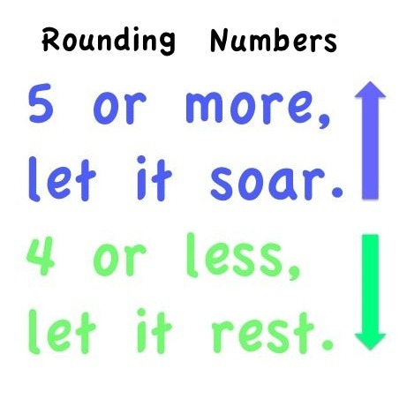](https://www.google.co.uk/url?sa=i&url=https%3A%2F%2Fwww.tes.com%2Flessons%2Fqs6CNXYQcnB2Mw%2Frounding&psig=AOvVaw22UU7KR_9SIvGnrzGwTrql&ust=1587638591589000&source=images&cd=vfe&ved=0CAIQjRxqFwoTCKDTv-Ts--gCFQAAAAAdAAAAABAe)[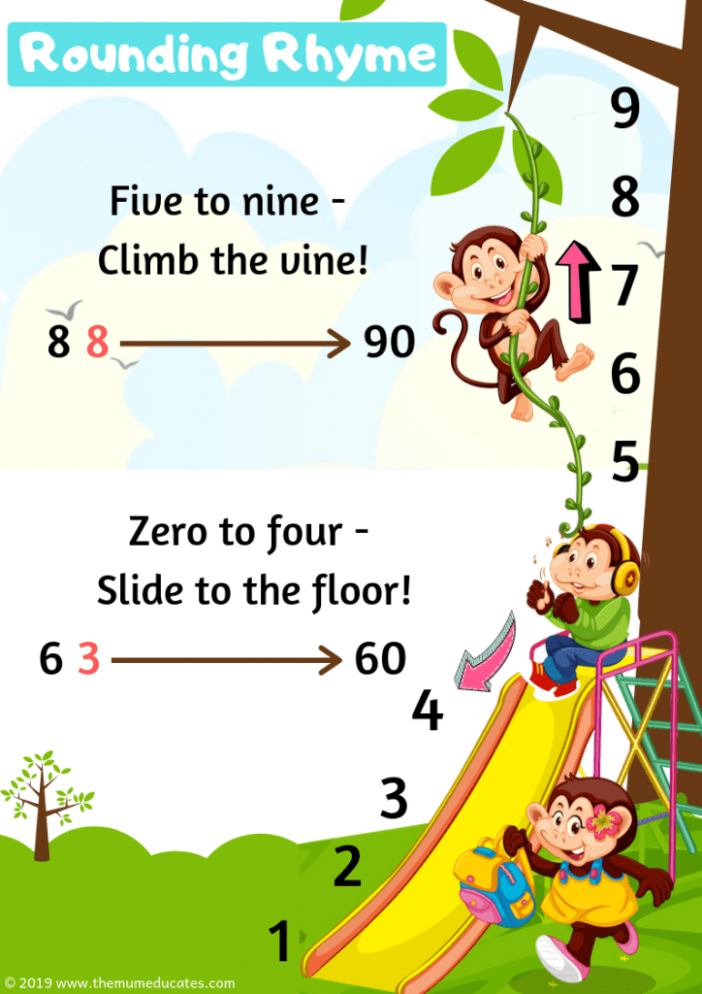](https://www.google.co.uk/url?sa=i&url=https%3A%2F%2Fthemumeducates.com%2Frounding-numbers-free-worksheets%2F&psig=AOvVaw22UU7KR_9SIvGnrzGwTrql&ust=1587638591589000&source=images&cd=vfe&ved=0CAIQjRxqFwoTCKDTv-Ts--gCFQAAAAAdAAAAABAZ)

Go back to the blog post and open up the rounding power point. Have a go at the game and keep your rounding rhymes in mind. When you have finished there is a rounding activity for you to try. If you want, you could give the challenge activity a go.