Ass Prog & Achiev & Monit & Tracking in BGE - Final - Sept 2014.doc

East Renfrewshire Council: Education Department

Assessing Progress and Achievement and Monitoring and Tracking Progress in the Broad General Education

September 2014

1. Introduction

This paper provides further guidance on aspects of the Education Department’s paper on Assessment, Moderation, Profiling and Reporting. It considers assessing progress and achievement and monitoring and tracking in the Broad General Education (BGE), providing information on:

- a school assessment framework;
- assessing learning in the curriculum;
- progression frameworks;
- monitoring, tracking progress and target setting in the BGE;
- professional dialogue about learners’ progress; and
- using attainment data and reporting at local authority and school level.

2. School Assessment Framework
There is an expectation at national and local authority level that schools will develop and implement an assessment framework. The school assessment framework should include the following:

- purpose and principles of assessment;
- links between learning, teaching and assessment;
- place of formative assessment;
- range of assessment methods;
- place of summative assessment and standardised tests;
- arrangements for moderation;
- arrangements for tracking and improving children’s progress; and
- recognising achievement, profiling and reporting.

3. Assessing Learning in the Curriculum
The use of the National Assessment Resource (NAR) flowchart provides the most robust approach to periodic assessment. This approach involves the integration of assessment with ongoing learning and teaching that features two or three experiences and outcomes (Es and Os). It is not desirable that teachers should assess an individual E and O. In terms of the Curriculum For Excellence Working Group Report on Tackling Bureaucracy, periodic assessment should be naturally occurring in appropriate learning situations, be part of the ongoing processes of learning and teaching and involve “bundling” of Es and Os.

Planning for learning and teaching includes planning for assessment. Learners should participate in this process, which should involve:

- acknowledging learners’ prior experiences and learning;
- engaging with the Es and Os and Principles and Practice papers;
- planning rich learning experiences and agreeing success criteria;
- using a range of appropriate assessment approaches; and
- using a variety of assessment evidence to moderate and make judgements on progress, in order to provide feedback and inform next steps in learning.

The NAR Flowchart and associated support material provide clear details of the processes which lead to effective assessment in which the learner is placed at the centre. The NAR Flowchart can be found at:

http://www.educationscotland.gov.uk/Images/NAR-Flow-chart_tcm4-671023.pdf

Moderation of assessment should be based on “ongoing” activities in school as well as focused activity at cluster and/or local authority level.

4. Progression Frameworks
Significant aspects of learning represent the core learning against which learners’ progress can be compared. They are identified and described in the Assessing Progress and Achievement papers for each area or component of the curriculum.

For example, there are five significant aspects of learning in Numeracy and Mathematics. These are:

- Use knowledge and understanding of the number system, patterns and relationships.
- Use knowledge and understanding of measurement and its application.
- Use knowledge and understanding of shape and space.
- Research and evaluate data to assess risks and make informed choices.
- Apply numeracy and mathematical skills.

There are seven significant aspects of learning in Literacy and English. These are:

- Engage with and create a broad range of texts, including Scottish and Scots texts.
- Use reading and listening strategies to understand, analyse and evaluate texts.
- Find and use information.
- Develop critical literacy skills, including evaluating sources.
- Write with increasing accuracy, making effective use of spelling, grammar and punctuation.
- Create texts of increasing complexity using more sophisticated language.
- Develop and use higher‐order thinking skills.

Progression through these significant aspects of learning is illustrated overleaf in the progression frameworks for Numeracy and Mathematics and Literacy and English.

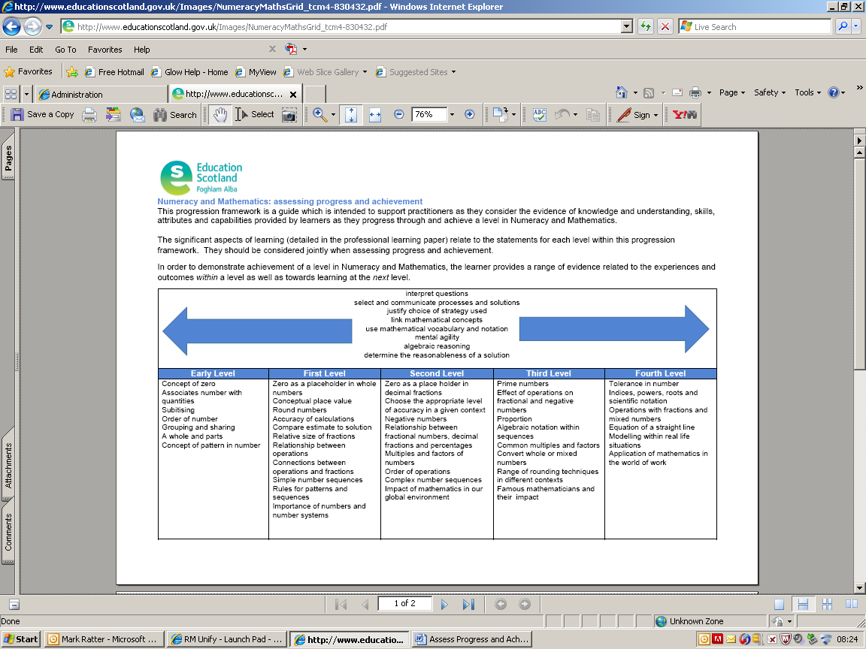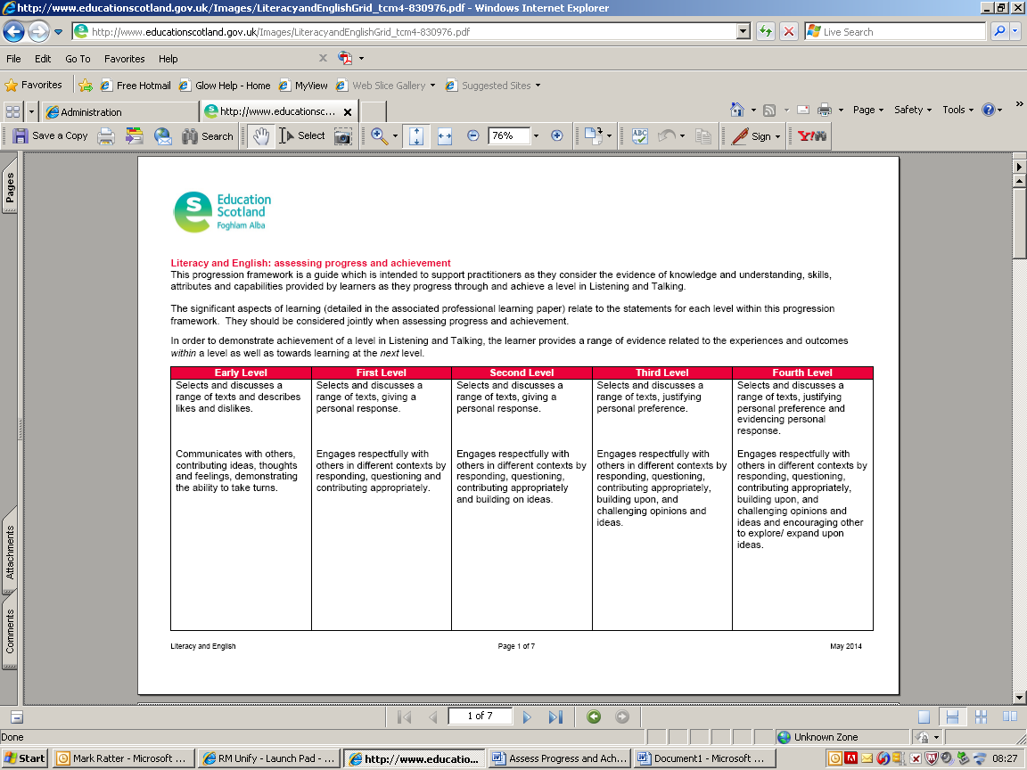
Numeracy and Mathematics Literacy and English

Significant aspects of learning have been identified for all curricular areas. All progression frameworks show the knowledge and understanding within a level and skills permeating all levels.

The significant aspects of learning, detailed in the associated Assessing Progress and Achievement papers, relate to the statements for every level within each progression framework.

The ERC Skills Framework provides more detail about the skills across and within all of the levels in each curricular area. Both the Education Scotland progression frameworks and the ERC Skills Framework bring together a coherent body of knowledge and understanding and related skills, as detailed in the Es and Os. Key features of both frameworks are that they:

- provide sound evidence of learning in accordance with the principles of Building the Curriculum 5: A Framework for Assessment;
- support the practice of holistic (best fit) assessment;
- inform assessment of progression within a level and achievement of a level; and
- can be readily used to plan further progression within a level and from one level to the next.

Drawing from evidence across the relevant significant aspects of learning, practitioners should make holistic (best fit) judgements about the achievement of a level in a curriculum area or a component of a curriculum area. This approach uses a range of evidence which provides more robust, valid and reliable assessment information than assessment which is based on evidence derived from single brief learning experiences or one-off pieces of work.

The Education Scotland progression frameworks should be used to ensure that the significant aspects of learning are being overtaken by the learners. Their use, in conjunction with formative and summative assessment approaches, will help inform teachers’ judgements.

The range and quality of learner work related to significant aspects of learning required to achieve a level are illustrated in annotated exemplification. A number of exemplars of emerging practice, marked as ‘early insights’, are available on the Education Scotland website which can be accessed at:

http://www.educationscotland.gov.uk/learningteachingandassessment/assessment/progressandachievement/professionallearningresource/index.asp

5. Monitoring, Tracking Progress and Target Setting in the BGE
The use of a range of information to monitor and track learners’ progress and achievement is a key aspect of raising attainment and achievement. Schools’ analysis of all evidence should be at the heart of monitoring, tracking and target setting approaches as it is this analysis which helps to inform planning to ensure the continued progress of all learners. Practitioners and senior managers should make use of tracking information to ensure that the pace of learning is appropriate for individual learners. It is what practitioners do with the information arising from monitoring, tracking and target setting processes that really matters. Senior managers should revisit learners’ targets with staff to ensure that they are met. This should lead to prompt and effective intervention to help every child or young person make the best possible progress, based on a range of assessment evidence.

East Renfrewshire Council’s policy document Recognising Achievement and Raising Attainment clearly emphasises the benefits of setting targets and the school’s approach to monitoring and tracking.

It is important that monitoring, tracking and target setting approaches are fit for purpose by using evidence from day to day learning and teaching. The purposes of monitoring, tracking and aspects of target setting are to:

- support dialogue with learners to improve learning;
- help learners to understand their own learning, which they may choose to inform their profiling activities;
- provide an overview of each learner’s progress and achievement over time and to share the information with parents in order to promote improvements in learning;
- identify the strengths or lack of progress in order to intervene as appropriate;
- provide a focus for professional dialogue, further assessment and moderation activities;
- help staff to review their practice in order to support learners further;
- ensure that evidence from partners and parents, as appropriate for children and young people, is included in planning future learning; and
- support analysis of the different groups of learners across a school, stage, department or the local authority e.g. by gender, ethnicity, those with additional support needs, those with high/low achievement or attainment or progress across different curriculum areas.

The focus should be on information that supports discussions about planning, learning, teaching and approaches to assessment so as to ensure appropriate progress, support and challenge in learning.

To be effective, monitoring, tracking and target setting processes should be accessible and manageable and provide valid, up-to-date and useful information. Most importantly, approaches should not be overly complex, bureaucratic, time consuming or unnecessarily impinge on time for learning and teaching. It is vital that monitoring, tracking and target setting approaches have a clear and appropriate focus on supporting both learning and professional dialogue.

6. Professional Dialogue about Learners’ Progress

Professional dialogue at all levels includes discussions with stage partners, departmental colleagues in school, across clusters and in the local authority. Dialogue should take account of prior achievements and influence future learning. Consequently, setting targets for learners’ and tracking their progress and achievement are fundamental to professional dialogue.

Professional dialogue should allow teachers to express views, reach consensus, come to judgements and arrive at a shared understanding of standards and expectations. This might be about making progress towards the standard, progressing well towards the standard or having achieved the standard as defined within the Es and Os.

7. Using Attainment Data and Reporting at Local Authority and School Level
For reporting purposes, the Education Department has adopted the terms “making progress”, “progressing well” and “achieved”. In order to provide more guidance around these terms and link this to moderation, the statements have been extended from those in Building the Curriculum 5 a framework for assessment: reporting document.

These terms should be used to assist with teacher professional judgement as detailed below.

“Making Progress”
The learner:
- has started to engage in the work of the new level;
- is beginning to make progress in an increasing number of outcomes (15% or more) across the breadth of learning described in the Es and Os for the level; and
- has started to provide evidence of making progress in the Es and Os.

“Progressing Well”
The learner:
- has achieved a breadth of learning across a significant number of the Es and Os (65% or more) for the level;
- can apply what he/she has learned in familiar situations;
- is beginning to undertake more challenging learning and apply learning in unfamiliar contexts; and
- is progressing well with the Es and Os.

“Achieved”
The learner:
- has achieved a breadth of learning across almost all (85% or more) of the Es and Os for the level, including any significant aspects of the curriculum area;
- has responded consistently well to the level of challenge set out in the Es and Os;
- has moved forward to more challenging learning in some aspects; and
- has applied what he/she has learned in new and unfamiliar situations.

The interconnected nature of these terms should be stressed. The Education Department recognises that progression in learning is not linear. Children and young people will progress and achieve in different ways and at different rates. They will develop different levels of skills across the different aspects of the curriculum and across their learning. It is important, therefore, that schools, teachers and others employ consistent approaches to tracking progress. Learners should be regularly and routinely involved in this process to assist with the reliability of the process.

7.1 Authority Tracking Database and Teacher Professional Judgement
Primary and secondary schools should record teachers’ professional judgements as to the level of achievement (from Early to Fourth) and progress in reading, writing and mathematics using the terms “making progress” (M), “progressing well” (W) or “achieved” (A). Pre-five establishments are expected to transfer the same information to primary schools. Evaluations should be based on what a learner has achieved and not what he/she is working towards.

In all sectors professional judgement should be based on a wide range of evidence, focusing on breadth, challenge and application of learning. There needs to be sufficient evidence based on how learners overtake learning intentions and success criteria. This should allow staff to be confident in their professional judgements. The evidence will come from both formative and summative approaches to assessment involving formal assessments, observation of learner progress and on-going naturally occurring approaches to integrating learning and teaching with assessment. Summative and formative approaches to assessment often make use of the same instruments of assessment. More guidance is available in the ERC training guides Moderation and Quality Assurance and An Integrated Approach to Learning, Teaching and Assessment.

Before entering data in the tracking database, teacher judgements should be moderated and quality assured at school level to improve and secure consistency of judgement.

The database has the facility to track progress in three periods over the school session: in October (prior to standardised testing in secondary); in January (prior to standardised testing in primary); and early in June.

In addition, the database layouts allow for both professional teacher judgements and standardised test information to be brought together to assist with moderation and quality assurance. The information from standardised tests has been processed to include the percentage of questions answered correctly at each level which allows for judgements to be made on the following percentages:

Making Progress: 15% to 64%
Progressing Well: 65% to 84%
Achieved: 85% to 100%.

Education Department guidance provides information on the detailed features of the tracking database and how to enter assessment information.

7.2 Authority and School Targets
Authority targets are set, based on intelligent use of a range of data and information. Targets for schools are negotiated in order that these make an appropriate contribution to the local authority target.

The EMIS Unit will devise and issue individual targets to be agreed with schools appropriate to their circumstances. These targets will be kept under review. Progress towards meeting targets should be reported in each school’s annual Standards and Quality Report, as should overall statements about attainment and CfE levels in line with national expectations, for example, the percentage of children attaining CfE First Level by the end of Primary 4.

7.3 Assessment Record
The electronic assessment record has been developed to support staff to record pupil progress within and across all curriculum areas and levels. Its purpose is to provide staff with a tool to record, on an ongoing basis, pupil progress in the Es and Os.

It is important to re-emphasise that staff should not be assessing individual Es and Os. Assessment should be naturally occurring in appropriate learning situations and part of the ongoing processes of learning and teaching and involve “bundling” of Es and Os.

Based on the percentage coloured (red, amber, green), staff can make an interpretation:

Making Progress: 15% to 64% of the Es and Os are red, amber or green.
Progressing Well: 65% to 84% of the Es and Os are green.
Achieved: 85% to 100% of the Es and Os are green.

The tool should support staff to make professional judgements based on a wide range of evidence focusing on breadth, challenge and application of learning. Schools and clusters should decide if and how this tool will be used and agree its contribution to transfer arrangements.

References

Assessment, Moderation, Profiling and Reporting, East Renfrewshire Council, (2011) https://glowscotland.sharepoint.com/sites/EastRenfrewshireCouncil/Staff%20Section/Documents/Curriculum%20for%20Excellence/ERCCfE/Assessment%20Moderation%20Profiling%20and%20Reporting.pdf
Curriculum for Excellence Working Group on Tackling Bureaucracy (2013) http://www.scotland.gov.uk/Resource/0043/00438622.pdf
Assessing Progress and Achievement Professional Learning Papers, Education Scotland (2014) http://www.educationscotland.gov.uk/learningteachingandassessment/assessment/progressandachievement/professionallearningresource/index.asp
Progression Frameworks, Education Scotland (2014) http://www.educationscotland.gov.uk/learningteachingandassessment/assessment/progressandachievement/professionallearningresource/index.asp
Building the Curriculum 5: A Framework for Assessment, Scottish Government (2011) http://www.educationscotland.gov.uk/Images/BtC5Framework_tcm4-653230.pdf
Monitoring and tracking progress and achievement in the broad general education, Education Scotland, (2014) http://www.educationscotland.gov.uk/Images/MonitoringTracking200214_tcm4-754310.pdf
Recognising Achievement, Raising Attainment, East Renfrewshire Council, (2009) http://www.erc.education/erdoc/documents/RARAStrategy.pdf
Building the Curriculum 5, a framework for assessment: reporting, Scottish Government, (2010) http://www.educationscotland.gov.uk/Images/CfEReportingdocument_tcm4-612845.pdf
Moderation and Quality Assurance, Training Booklet East Renfrewshire Council, (2014) http://www.erc.education/staff/ace/documents/LAR/Moderation-and-Quality-Assurance.pdf
An Integrated Guide to Learning Teaching and Assessment, Training Booklet East Renfrewshire Council, (2014) http://www.erc.education/staff/ace/documents/LAR/An_Integrated_Approach_to_Planning_Learning_Teaching_and_Assessment.pdf

