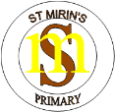

### **St Mirin’s Primary School**

**‘Be the best you can be’**



GIRFEC

Position Statement

**Getting It Right For Every Child in St. Mirin’s Primary**

**Position Paper**

**Section 1 - Rationale**

Getting It Right for Every Child is a **national policy** to help all children and young people grow, develop and reach their **full potential**. Its’ focus is to improve outcomes for children and their families, based on a shared understanding of their wellbeing.

GIRFEC promotes an **integrated approach** to understanding and developing children’s wellbeing across Council Services, Health and other partners. This means that partners will **work together** as early as possible to improve outcomes for children and young people. This means **information is shared** and recorded in a consistent way.

Our policy is based on Glasgow City Council’s ‘*Every Child is Included and Supported’, published in 2016.* In this it states that:

***‘It is Glasgow’s ambition to be ‘the nurturing city’.A nurturing city has schools in which children and young people feel they belong, they are listened to and they and their families are valued. The ethos of nurturing schools is supportive and all staff are clear about their roles and responsibilities. In nurturing schools, staff continually and collaboratively evaluate their practice to ensure that it promotes the wellbeing of all children and young people. They understand that supporting all children and young people and ensuring they make the best possible progress depends on the curriculum they provide, on learning and teaching of the highest quality and on their commitment to continuing professional development.’***

In the guide for GIRFEC published by the Scottish Government in 2012, it stated that:

***(The) GIRFEC approach is an attempt to ensure that no matter where they live or whatever their needs, children, young people and their families should always know where they can find help, what support might be available and whether that help is right for them (A guide to Getting it Right for Every Child, Scottish Government, May 2012).***

This is based on a system of shared value which considers the needs of all children and young people, ensuring all children have access to the supports they require as and when they require them. It is the cornerstone of our approach to supporting the children of St. Mirin’s Primary.

There are **fourteen GIRFEC values** which are based on the **‘Children’s Charter’:**

*Promoting wellbeing of child, keeping child safe, putting child at the centre, taking whole child approach, building on strengths and building resilience, promoting opportunities and promoting diversity, providing additional support, supporting informed choice, partnership with families, respecting confidentiality and sharing information, promoting values, bringing together expertise, coordinating help, building a competent workforce to promote child’s wellbeing.*

These link very closely to our own school values which were decided upon as a whole school community and are based on the Gospel values. Through these we recognise the dignity of the person as made in the image and likeness of God. Our values enable us to meet the needs of the whole child, promoting the spiritual, moral, social, intellectual, emotional health and wellbeing of each child.

**Our Aims for GIRFEC are to:**

* Create a Community of Faith based on justice and compassion through an active, spiritual life which permeates the whole school.
* Raise attainment by setting high expectations for all children and recognising their achievements.
* All staff act as role models in treating all members of the school community with care, kindness and respect.
* Ensure that we have consistent expectations and approaches in terms of learning and behaviour.
* Continue to promote positive partnerships with parents, parishes and external agencies to improve the quality of education we provide.
* Provide opportunities for continuous professional development for all staff.
* Ensure that all members of the school community are clear in their understanding of GIRFEC and their role within this.

**Section 2 – Supporting Learning in St. Mirin’s (GIRFEC)**

In St. Mirin’s we believe that all learners are unique and should therefore be treated as individuals. As a Catholic school, Christ is at the centre of our ethos, learning and teaching. We ensure our core business of learning, teaching and assessment enables all children to grow academically and spiritually, developing their god given talents and skills.

We strive to ensure our learners have consistent, coordinated support when they require it through ‘Getting it Right for Every Child’. By aligning our systems and processes with national and local policy, we place the child at the centre of their learning; ensuring they are supported and involved in the decision-making process. By sharing targets, we place children at the heart of their education and empower them to understand themselves as learners. We recognise and celebrate their strengths as well as consider development needs and next steps in learning. We actively encourage our learners to share their views, through a variety of ways, ensuring all our children are treated fairly, respectfully and have a sense of belonging to our school community.

We recognise the importance of the wellbeing indicators in enabling our children to successfully grow and develop to reach their fullest potential.

We understand children progress and develop at different rates and we respond to individual needs through professional learning and collaborative working as appropriate.

We keep abreast with current educational research in order for us to meet the needs for all learners. We aim to remove all barriers for our children and young people, ensuring equity for all. Currently, across our staff team, we are highly skilled in delivering targeted support in the following areas:

* English as an additional language
* Neurodevelopmental disorders
* Health and Wellbeing- social, emotional, mental and physical
* Literacy & English
* Numeracy & Maths
* Speech and Language
* Bereavement/loss

We have effective relationships with outside agencies who continue to support the development of our knowledge, understanding and skill base; ensuring the needs of all learners are being met. Our class teachers are committed to ensuring the delivery of high-quality learning and teaching which provides our children with stimulating and challenging learning environments, matched to their individual needs. Children have ownership over their learning through a variety of ways, ensuring we give them opportunities to develop personal responsibility.

We have robust approaches to assessment which enable us to measure attainment and analyse gaps effectively. This supports us in *getting it right for every child* and ensures the right support, at the right time.

Our highly effective planning is informed by the Learning, Teaching and Assessment Cycle:

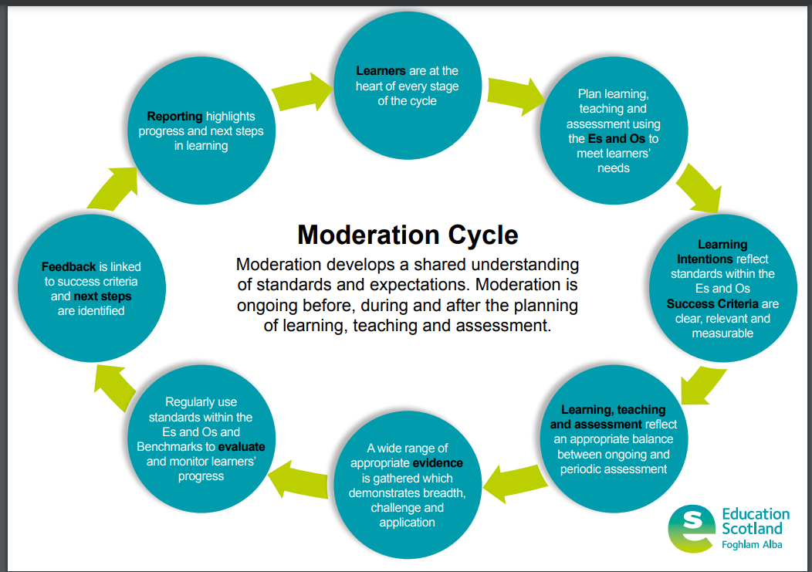

**The Planning Cycle in St. Mirin’s**

In Glasgow City Councils Policy for Inclusion, it outlines the roles and responsibilities of all staff.

We expect all staff to:

* know the children they work with very well;
* value, respect and listen to all children and young people and their families;
* fully understand the principles of nurture and use this understanding to ensure that children feel safe and respected and can grow and learn;
* understand and implement effectively Glasgow’s policies and procedures for keeping children safe and for supporting them;
* contribute, as appropriate, to the assessment of need, using the eight indicators of wellbeing as their organising principle;
* contribute, as appropriate, to the planning of appropriate support and the setting of targets which will lead to improved outcomes for children;
* track and evaluate the progress of all children and young people;
* work in collaboration with each other and with colleagues from other agencies or services to assess and meet needs; and evaluate fully their own professional development needs and ensure, through continuing professional development, that they have the right skills to meet the needs of all children and young people. All our staff are expected to work towards the common core skills.

***‘Every child is entitled to support to enable them to gain as much as possible from the opportunities which Curriculum for Excellence can provide.’*** *(The Education Additional Support for Learning (Scotland) Act 2014)*

**Staged Intervention**

Children need to be Safe, Healthy, Achieving, Nurtured, Active, Respected, Responsible and Included (also known as the **Wellbeing Indicators**) in order to achieve their potential. Our approach to ‘Staged Intervention’ has been formulated in line with Glasgow City Council’s policy and practice.

*‘Glasgow City Council Education Services’ approach to supporting learners rests securely on Scottish Government policy and on national guidance and, in particular, on the Additional Support for Learning legislation (2009) and the revised Code of Practice.’*

A child or young person’s need for additional support is addressed as shown in the diagram below through a cycle of identification, assessment, planning, providing support, and then reviewing the outcomes.

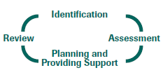

In St. Mirin’s we are committed to our responsibility for identifying and assessing children are not making expected progress in their learning.

**Identification and Assessment**

The identification process begins with the five key GIRFEC. This allows us to reflect on any barriers and identify more specific support needs.

* What is getting in the way of this child’s or young person’s wellbeing?
* Do I have all the information I need to help this child and young person?
* What can I do now to help this child and young person?
* What can we do to help this child or young person?
* What additional help, if any, may be needed from others?

Class teachers, supported by the Depute Head Teacher, take responsibility for further assessing and analysing assessment information. In St. Mirin’s, we value parents and carers as the first educators of their child and as such their views and concerns are sought throughout this process.

**Planning and Providing Support**

There are various stages of intervention that will be considered when planning for the needs of individual children. In St. Mirin’s we follow the Glasgow City Counicls’ Staged Intervention Framework below:

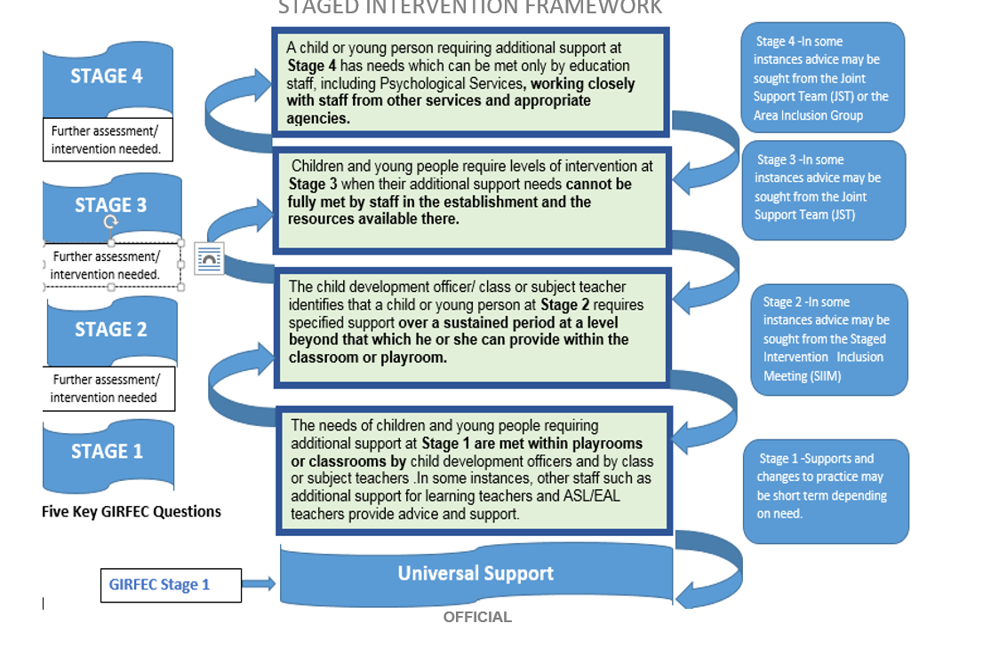

**Additional Support for Learning Target Setting (ASL Targets)**

For children who sit within stage 1 or 2 of the Staged Intervention Framework, the ASL Coordinator and class teachers work together to further assess individuals to inform next steps. Views of parents/carers and children inform individual targets, where appropriate, based on the experiences and outcomes within The Curriculum for Excellence. These individual targets work parallel to the day-to-day learning and additional actions and interventions are implemented to support individuals to achieve targets set. Staff across the school have responsibility for ensuring the correct support and interventions are in place.

**Wellbeing Assessment and Plan (WAP)**

Children on stage 3 or 4 of the Staged Intervention Framework have a Wellbeing and Assessment Plan (WAP). WAPs are created in conjunction and collaboration with appropriate agencies, children and their families. They are underpinned by the National Practice Model and provide a consistent way for staff to work with children and their families to understand a child’s individual growth and development in the context of their rights, unique family circumstances and wider world, exploring strengths, resilience, adversities and vulnerabilities.

The National Practice Model provides a shared framework for all agencies who have a role in supporting, promoting and safeguarding the wellbeing of children and young people. It brings together the My World Triangle, Resilience Matrix, eight wellbeing indicators (SHANARRI) and the 4 context for learning within The Curriculum for Excellence to support overall assessment.

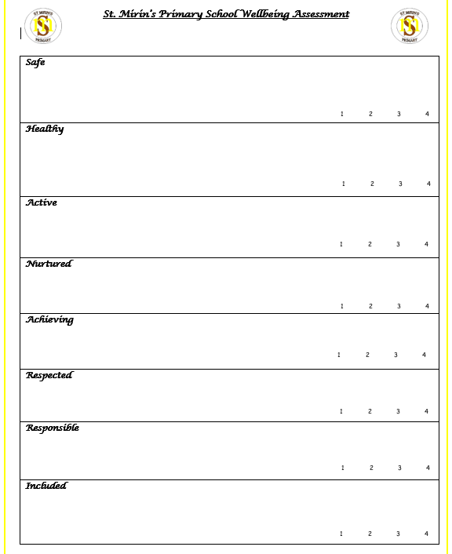

**SHANARRI Assessment**

We reflect on each of the wellbeing indicators collaboratively with children, parents/carers and other agencies as appropriate.

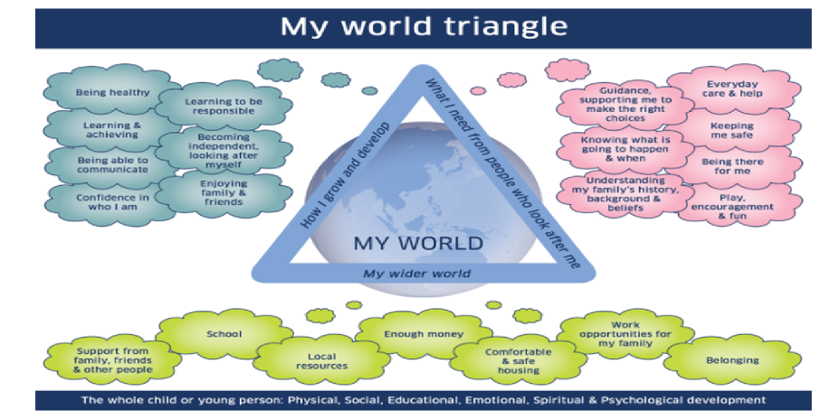

**My World Triangle**

The My World Triangle assessment supports us to gather information about a child’s whole world. It allows us to measure strengths and challenges in all parts of a child’s life.

**The Resilience Matrix**

The Resilience Matrix enables us, together with children, young people and families, to consider characteristics that may cause vulnerability and factors that can contribute to adversity, alongside factors that create a protective environment and resilience within the child or young person.

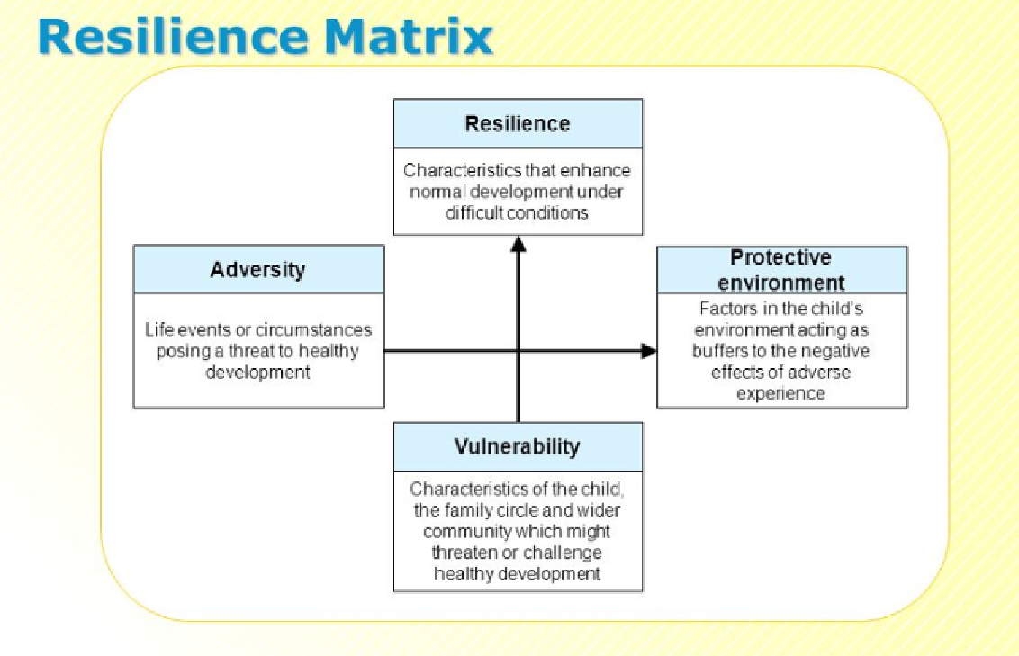

**At St Mirin’s Primary our vision, values and aims permeate all that we do:**

As a Catholic school we promote the Gospel Values through celebration, worship and service to the common good. These values include: **Kindness, Faith, Inclusiveness, Respect and Responsibility.**

Our vision is to foster a sense of community and faith at St Mirin’s Primary where every child feels safe, nurtured and included.

Our aim is to create an inspiring environment where children are motivated to grow and learn together. Through encouragement, positive reinforcement and engaging educational experiences, we strive to encourage all learners to ‘be the best they can be.’

**We have a cyclical approach to reviewing and evaluating our additional support for learning across the session. See the info graphic below for further information:**



