**Windyknowe Home Learning Tasks** Date issued: **Thursday 20th of August.**

Please complete home learning in your child’s home learning jotter. Return date to school will be: **Wednesday 1st of September**

|  |  |
| --- | --- |
| Literacy Task | Maths and Numeracy Task |
| We have been learning words ending in ‘at’ and ‘ap’.  Please practice writing your spelling words from the list below.   |  |  | | --- | --- | | cap  Laps  sap  tap  map  yap | pat  cat  bat  rat  sat  that |   Please help your child to write a list of things that they have in their bedroom. This will help them during their writing task, on the return week, when they will be writing a description of their bedroom. | We have been practicing to sequence numbers from 0-20.  Please complete the missing number lines on the page below. You can choose the task which suits your child best. |

|  |
| --- |
|  |

**Spicy Task:**

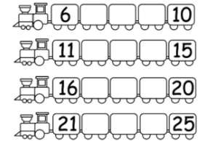

**Hot Task:**

