# Back to School

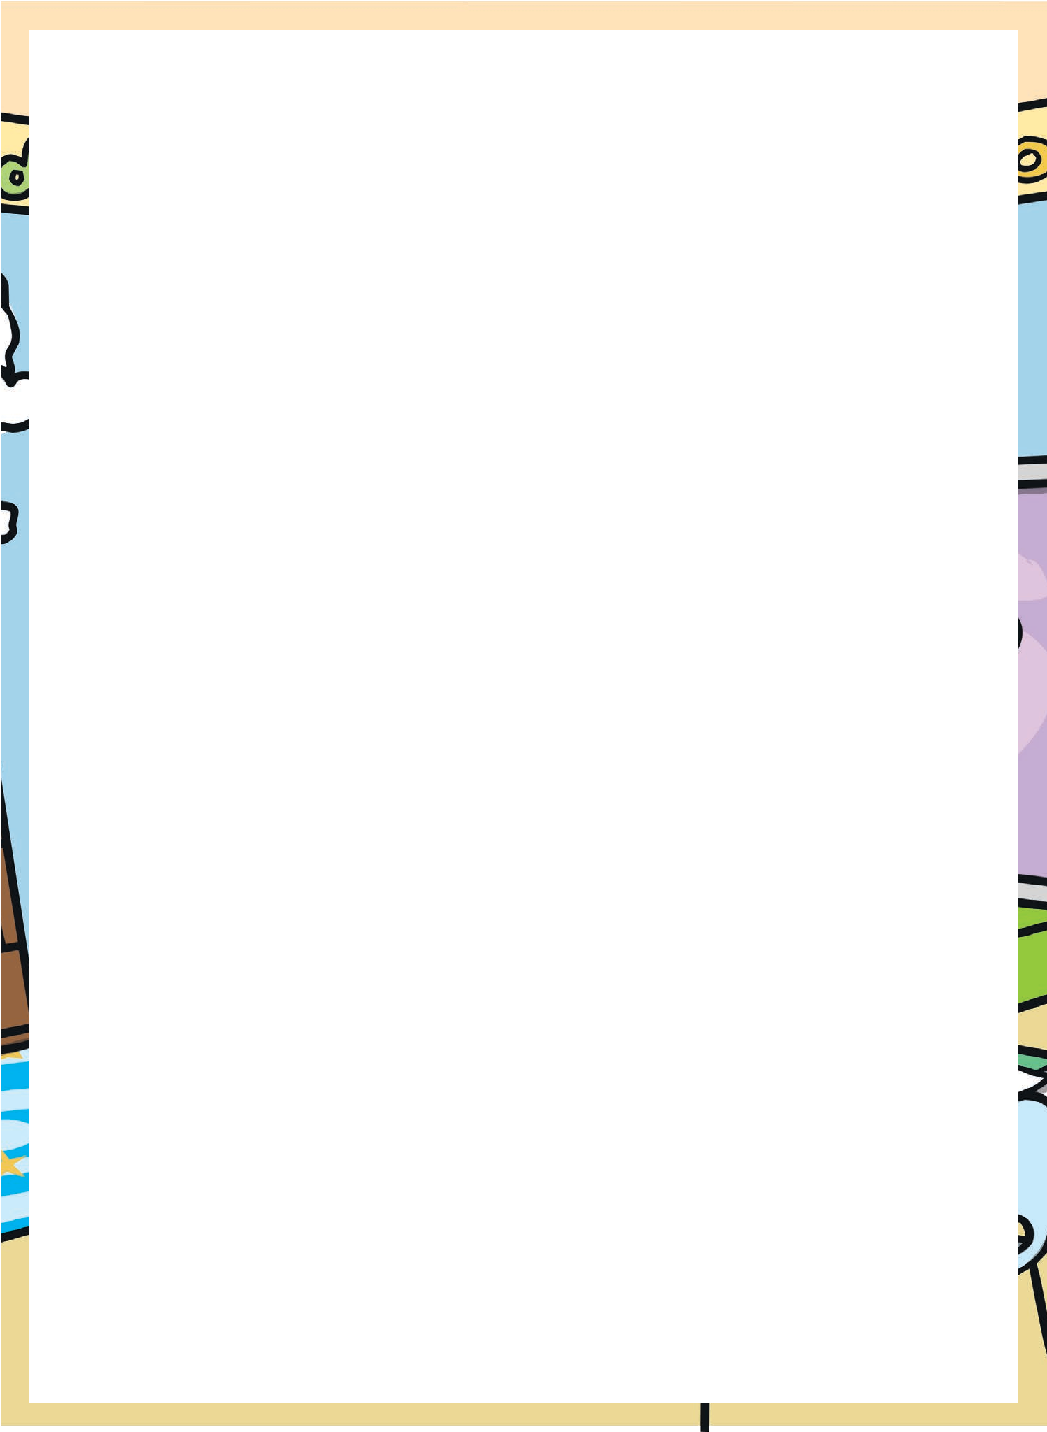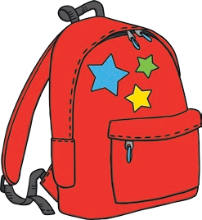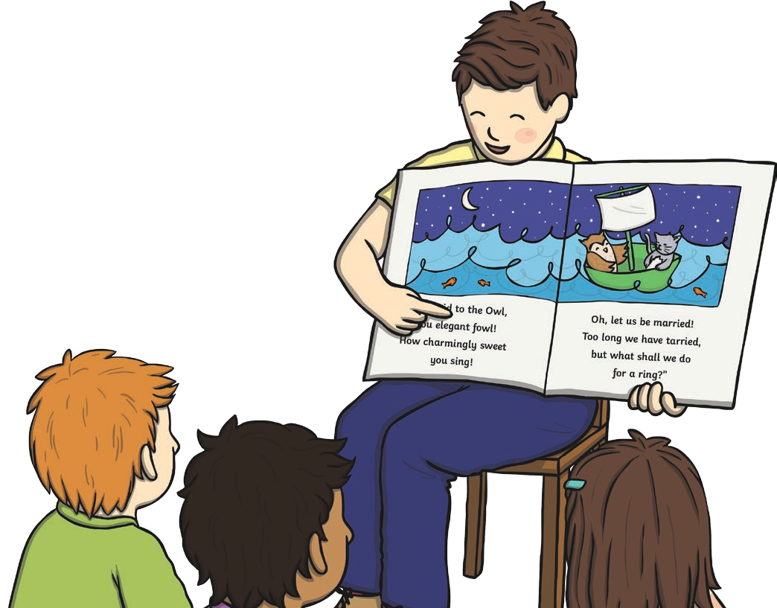

The summer holidays are over and that means back to school! Back to school is all about new things. Do you have a new school bag? Do you have

new shoes? Do you have a new class and a new teacher?

New things can make us feel happy and they can sometimes make us feel sad. But, coming back to school means there are lots of fun things to do in the year ahead!

So, what can you look forward to? Think about the topics your class will do this year. Water, Scotland or pets - there is so much you could learn about!

Perhaps your class will go on a trip this year. Where would be a good place to visit?

Will you write some super stories this year? How many books will you read?

Will you get faster at mental maths? Will you know all the times tables facts by the end of the year?

Will your class put on a show for others? Will you win a race at sports day? Will you play a new instrument or paint an amazing picture?

The school year won’t last long enough for you to try all these things!

Back to school is an exciting time and so is the whole school year! Make the most of all the things your teachers help you do, try your hardest and have fun. By next July, you’ll wonder where the year went!

# Questions

1. Back to school is

after the summer holidays.

before the summer holidays. before Christmas.

1. What new thing might you get for back to school? a new dog

a new backpack a new cup

1. How can new things make us feel?
2. What does coming back to school mean?
3. What can you look forward to in the year ahead?

