**Back to School**

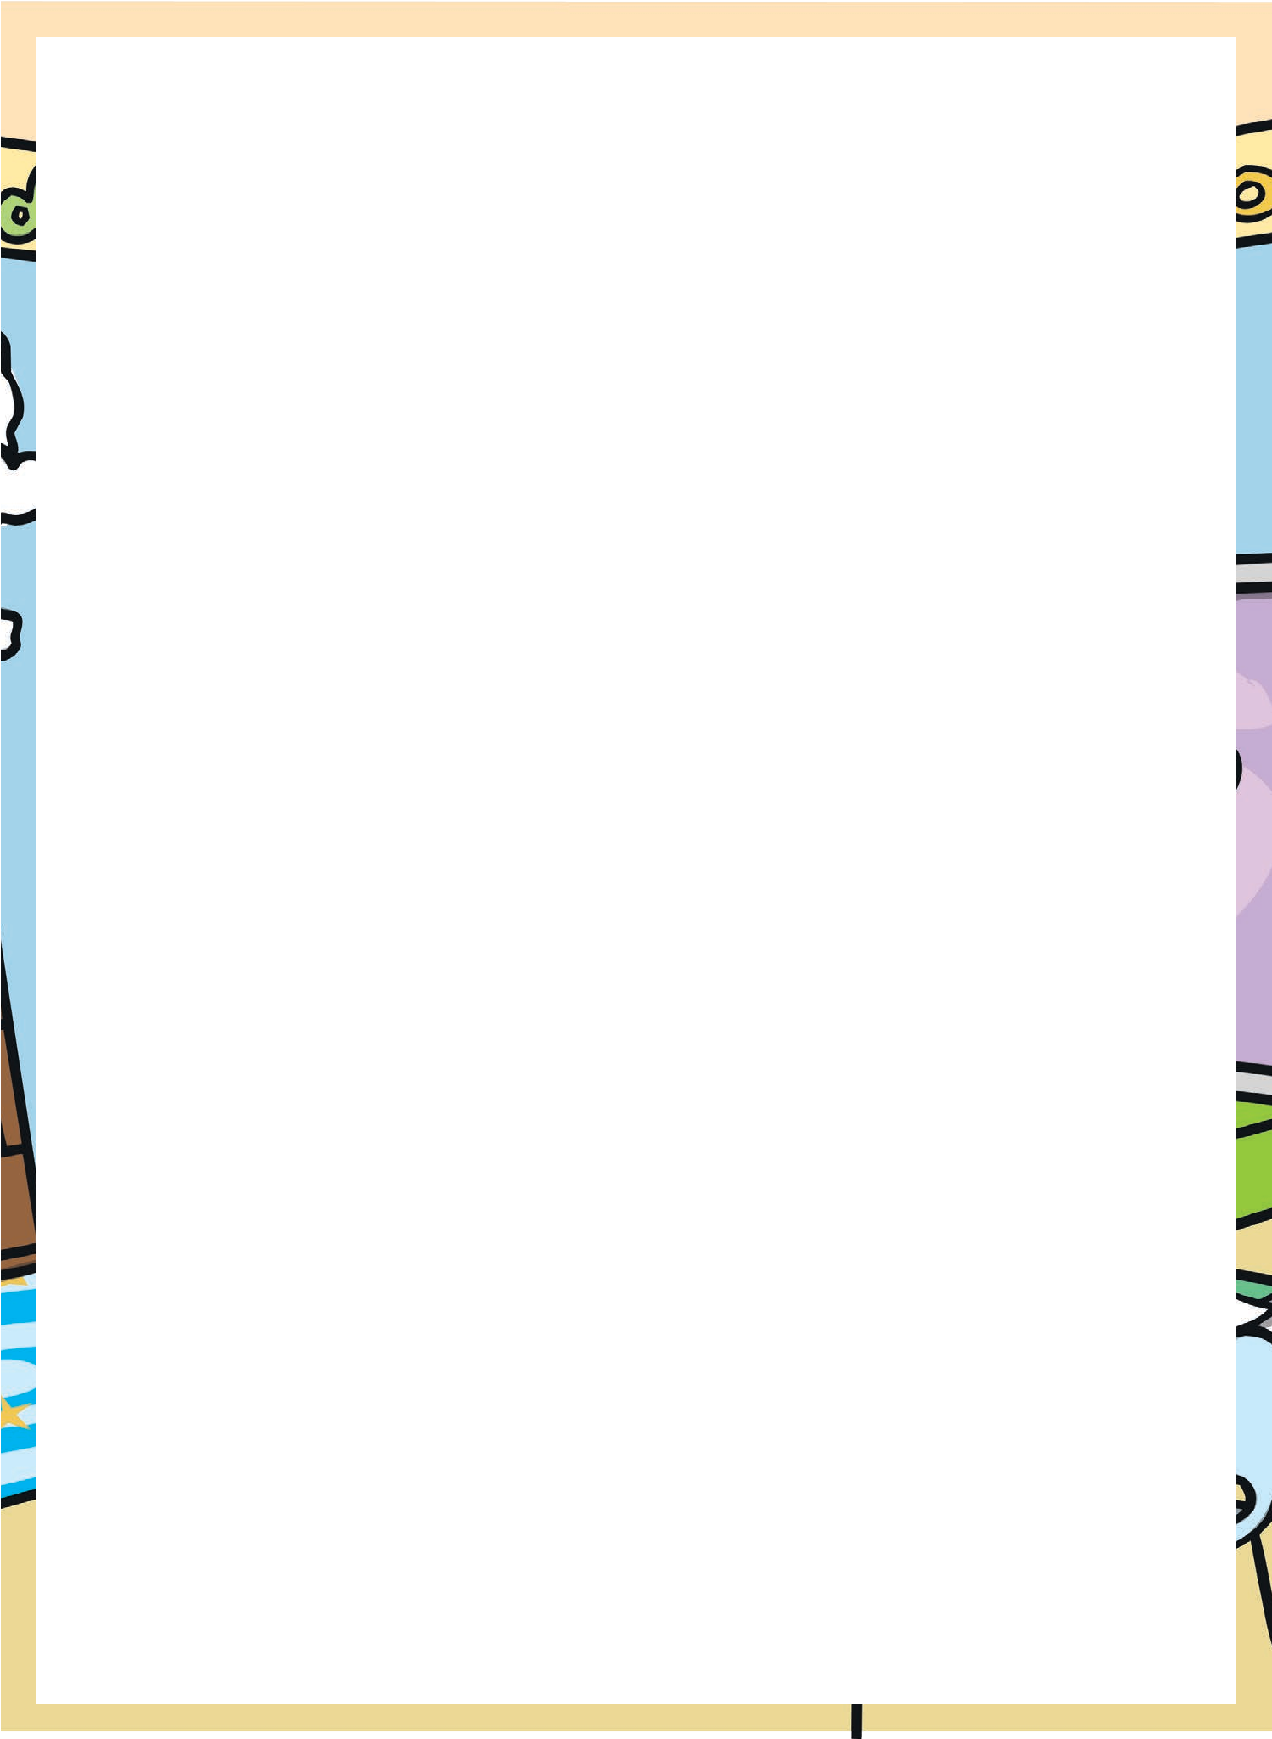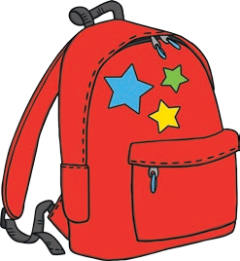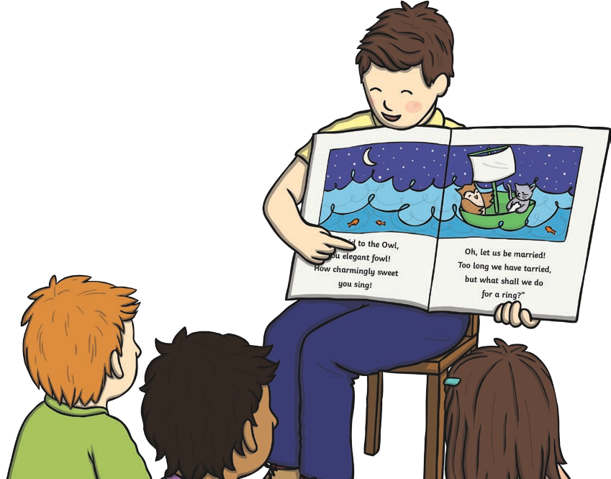

The summer holidays are over and that means back to school!

Back to school is all about new things. Do you have a new school bag or a new pencil case? Do you have new shoes or a new shirt? Do you have a new classroom, a new teacher or maybe even a new school?

New things can make us feel happy and they sometimes make

us feel a bit sad or scared. But once you are in your new class and you have met your new teacher, then you’re ready to get started again on all the exciting things to do in the year ahead!

What can you look forward to in the year ahead? Think about the topics your class will study this year - maybe water, Vikings, Scotland or pets. There are so many different things you could learn about!

Perhaps your class will go on a trip this year. Where would be a good place to visit?

Will you get better at writing stories or reading this year? How many books will you read in the year ahead?

Will you get faster at mental maths? Will you know all the times tables facts by the end of the year?

Will your class put on a show for others to watch? Will you win a race at sports day? Will you learn to play an instrument or paint an amazing picture?

The school year won’t last long enough for all the amazing things you could try to do!

Back to school is an exciting time but so is the whole school year! To make it the best year ever, remember

to have a go at all the things your teachers plan for you, try your hardest and enjoy it. By next July, you’ll wonder where the year went!

# Questions

1. When is it time to go back to school?
2. What new things might you have for coming back to school?
3. How can new things make us feel?
4. How can you make your school year the best year ever?
5. What are you looking forward to in the year ahead? Make a list of all the things you’d like to do or learn about at school.