**Back to School**

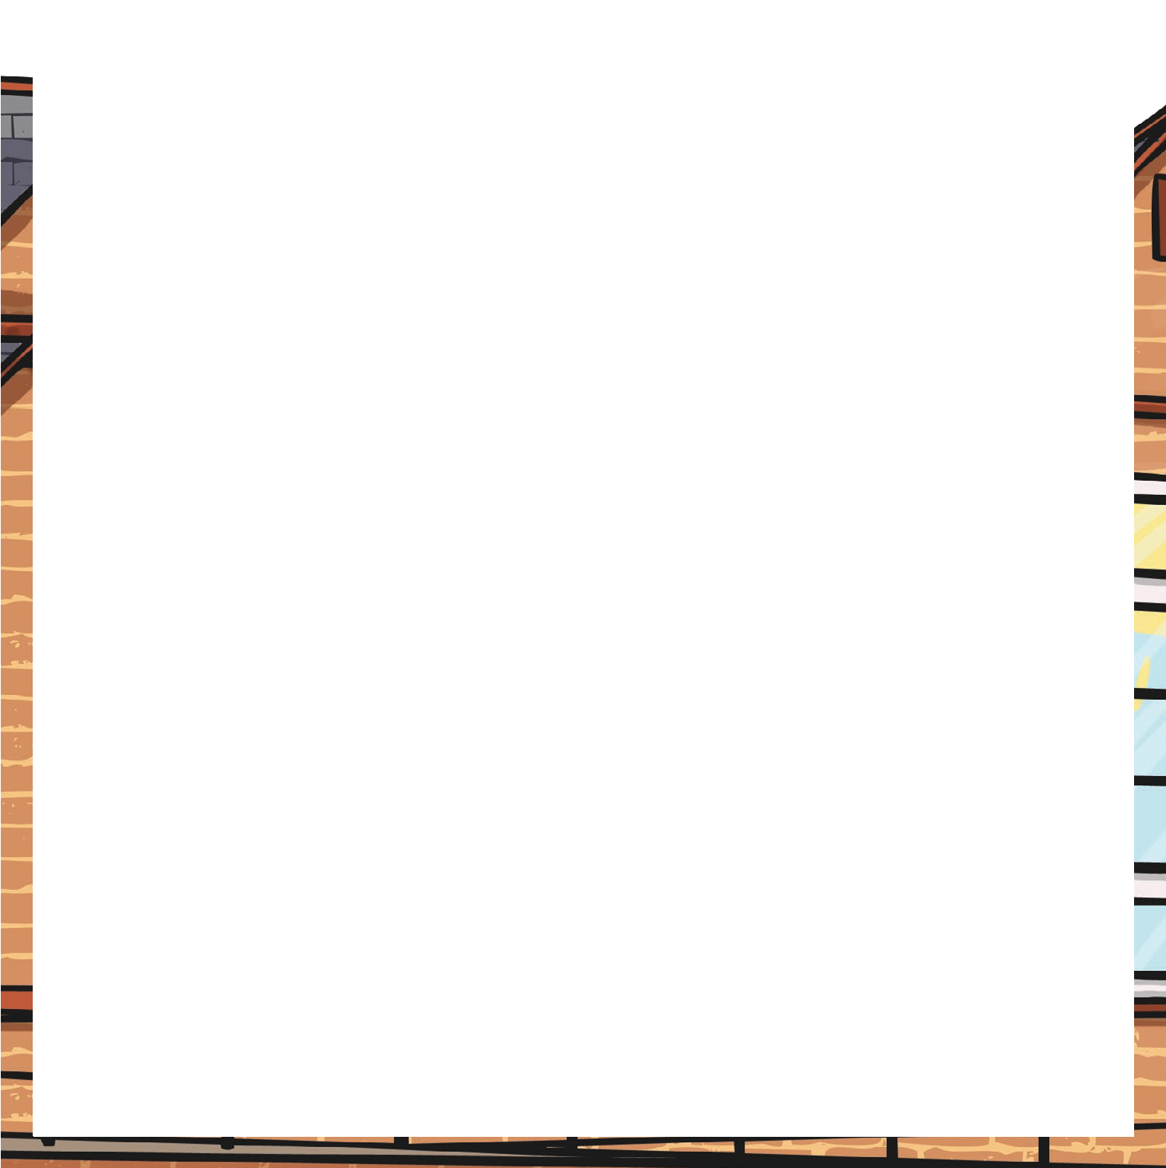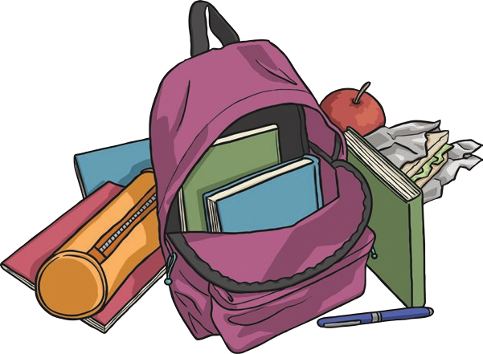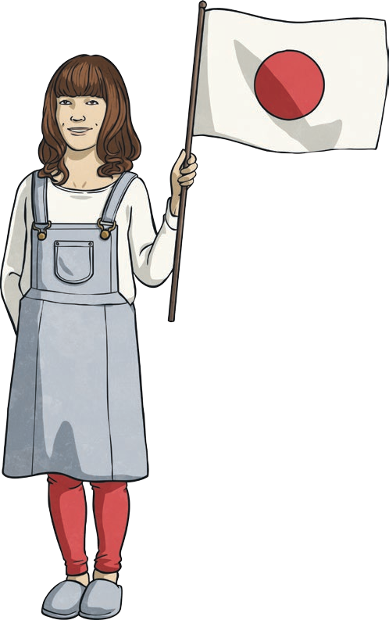

It’s that time of year again; the summer holidays are over and that means back to school! Back to school is all about new things. It’s the start of a new school year. Do you have a new school bag or a new pencil case? Do you have any new clothes for school? Do you have a new classroom, a new teacher or maybe even a new school?

When new things happen, some people feel excited and happy whilst other people find changes more difficult. The first day of the new school year

can be a bit worrying, particularly if you’re meeting a new teacher or joining a new class. However, once you’re in your new class and you’ve met your new teacher, these worries will hopefully disappear

and you’ll be ready to get started on all the exciting things to do in the year ahead!

So, what can you look forward to in the year ahead? Think about the topics your class will study this year; maybe you’ll focus on a historical topic like Mary Queen of Scots or the Second World War. Perhaps you’ll compare Scotland with another country, like Japan. Scientific topics

about the human body or the environment are always fascinating. There are so many different things you could learn about!

Perhaps your class will go on a trip this year. It might be a day away or even a week. School trips often visit cities like Edinburgh or Glasgow and take in tourist attractions like Edinburgh Castle, Dynamic Earth, Hampden Park or the Glasgow Science Centre. If you already live near these cities, perhaps your school will plan to go to an outdoor

activity centre. At these centres, you can try lots of different things like abseiling, kayaking, archery or even flying down a zip wire! That sounds like an exciting school trip! Where do you think would be a good place to visit, learn lots and have fun?

**Back to School**

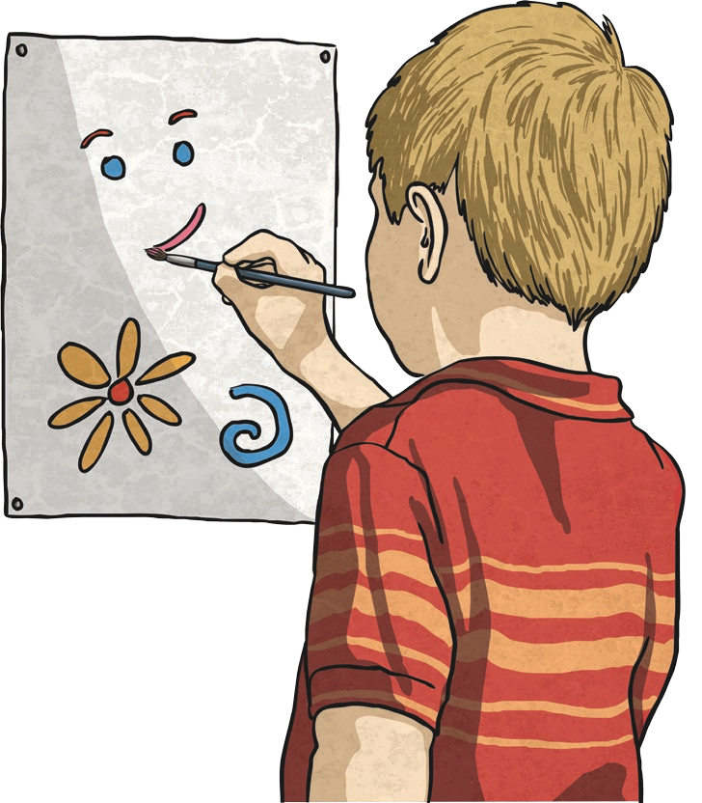

In the classroom, how will your skills in literacy improve? Will you get better at writing stories? Will you be able to write in different ways for different purposes? Will you be able to report on something without missing out key facts? Will you use amazing vocabulary, conjunctions and openers in your writing? Is this the year where you’ll be able to edit your work and add any missing punctuation, whilst not forgetting to check your writing makes sense? How many novels will you read in the year ahead?

Which new genres will you try out? Will you find a new author whose stories are so good that you don’t want to stop reading?

How about your skills in maths? Will you get faster and more accurate at mental maths? Will you know all

the times tables facts? Will you have mastered maths topics like telling the time using analogue, digital and 24-hour clocks?

How about dividing or working with fractions? It would be great if you had mastered fraction work by the end of the year!

Will your class put on a show for others to watch? Will you win a race at sports day or be part of the winning team? Will you learn to play an

instrument or paint an amazing picture? Will you write some code to create a fun computer program? The school year won’t last long enough for all the

amazing things you could try to do!

Back to school is an exciting time but so is the whole school year! To make it the best year ever, be willing to have a go at all the things your teachers plan for you. Give every

activity your best shot (even if you’re not that keen at first) and enjoy it. You might even discover that you’re good at something you hadn’t tried before. By next July, you’ll wonder

where the year went!

# Questions

1. Why is back to school all about new things?
2. How can people feel when new things happen?
3. Why do some people worry about the first day of school?
4. Why do you think classes study different topics like World War Two or the Human Body?
5. Why do some schools visit cities like Edinburgh or Glasgow?
6. Why do some schools choose to go to outdoor activity centres?
7. What types of activities can you try at an outdoor centre?
8. In what two ways could you improve your literacy skills this year?
9. In what two ways could you improve your numeracy skills this year?
10. What are you looking forward to in the year ahead? Make a list of ten things you’d like to do or learn about at school this year and say why you’d like to do each one.