**Back to School**

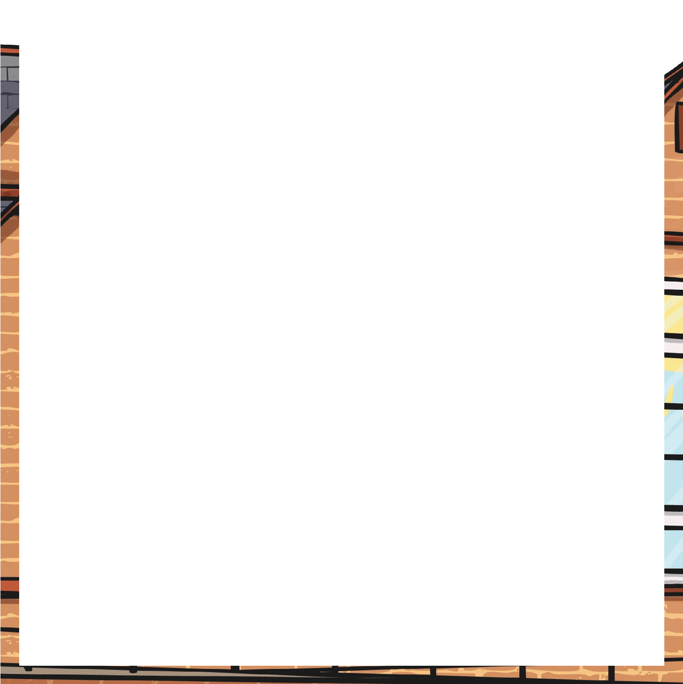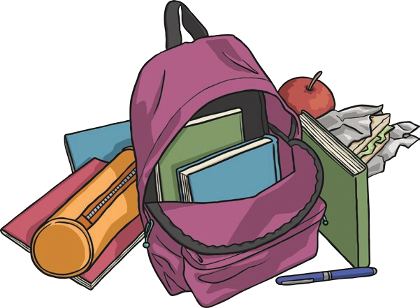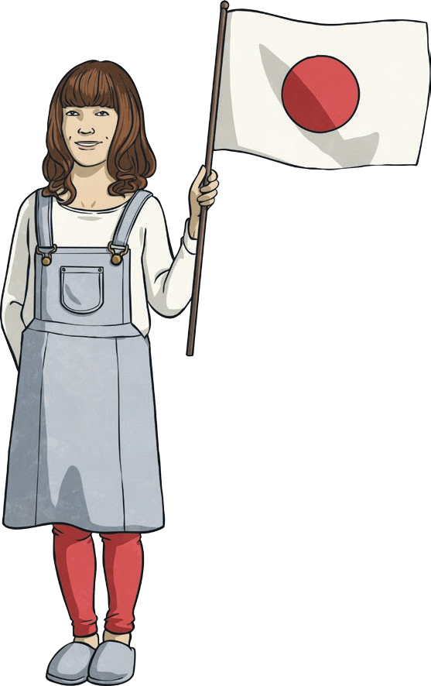

It’s that time of year again; the summer holidays are over and that means back to school! Back to school is all about new things. It’s the start of a new school year and a new routine to get used to. Do you have a new school bag or a new pencil case? Do you have any new clothes for school? Do you have a new classroom, a new teacher or maybe even a new school?

When new things happen, some people feel excited and happy. These people love the challenge of trying new things and being in new situations, whilst other people find changes more difficult. They can feel nervous and anxious about the new things they are about to experience. The first day of the new school year

can be a bit daunting, particularly if you’re meeting a new teacher or joining a new class.

You don’t want to get something wrong, something

you shouldn’t or not have any friends to hang around

with. However, once you’re in your new class and you’ve met your new teacher, then these worries will hopefully disappear and you’ll be ready to get started on all the exciting things to do in the year ahead!

So, what can you look forward to in the year ahead? Think about the topics your class will study this year; maybe you’ll focus on a historical topic like Mary Queen of Scots or the Second World War. Perhaps you’ll compare Scotland with

another country, like Japan, and find out about the contrast in cultures. Scientific topics about the human body or the environment are always fascinating. There are so many different things you could learn about!

Perhaps your class will go on a trip this year. It might be a day away or even a week. School residential trips often visit cities like

Edinburgh or Glasgow and take in tourist attractions like Edinburgh

Castle, Dynamic Earth, Hampden Park or the Glasgow Science Centre.

If you already live near these places perhaps your school will plan

to go to an outdoor activity centre. At these centres, you can try lots of different things like abseiling, kayaking, archery or even flying down a zip wire! That sounds like an exciting school trip! Where do you think would be a good place to visit, learn lots and have fun?

**Back to School**

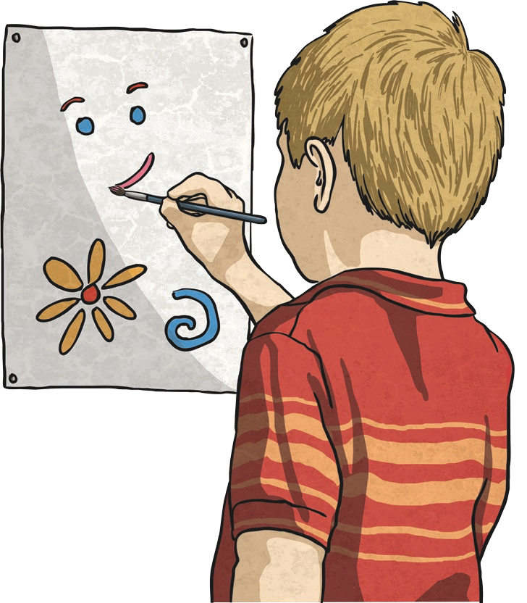

In the classroom, how will your literacy skills improve this year? Will you get better at writing stories? Will you be able to write in different ways for different purposes? Will you be able to persuade and argue a point in your writing? Will you be able to report on something without missing out key

facts? Will you use amazing vocabulary, conjunctions and openers in your writing? Is this the year where you’ll be able to edit your work and add any missing punctuation, whilst not forgetting to

check your writing makes sense? How many novels

will you read in the year ahead? Which new genres of reading will you try out? Will you find a new author whose stories are enthralling?

How will your maths skills improve in the year ahead? Will you get faster and more accurate at mental maths? Will you know all the times tables facts? Will you have mastered maths topics like telling the time using analogue, digital and 24-hour clocks? How about dividing or working with fractions? It would be great if you had mastered fraction work by the end of the year!

Will your class put on a show for others to watch? Will you excel at Sports Day or any other athletic events? Will you learn to play an instrument or paint an amazing picture? Will you write some code to create a fun computer program?

The school year won’t last long enough for all the amazing things you could

try to do!

Back to school is an exciting time but so is the whole school year! To make it the best year ever, be willing to have a go at all the things

your teachers plan for you. Give every activity your best shot (even if you’re not that keen at first) and enjoy it.

You might even discover that you’re good at something you hadn’t tried before. By next July you’ll wonder where the year went!

# Questions

* + 1. Why is back to school all about new things?
    2. How can people feel when new things happen?
    3. For some people, why is the first day of school a bit daunting?
    4. Why do you think classes study different historical or scientific topics?
    5. Why do you think some schools go on residential trips to cities like Edinburgh or Glasgow?
    6. What learning can be developed through a trip to an outdoor activity centre?
    7. What types of activities can you try at an outdoor centre?
    8. In what two ways could you improve your literacy skills this year?
    9. In what two ways could you improve your numeracy skills this year?
    10. What new things are you looking forward to achieving in the year ahead? Make a list of five targets for school this year, why you’d like to achieve each one and how you will know you’ve achieved it.