Friday 26.6.20

**P6 Memories- Come join Mrs Cross and Miss Purdie to reflect on a fantastic year together @ 9.30am on Teams!**

End of year wider achievements assembly – 10.45 am

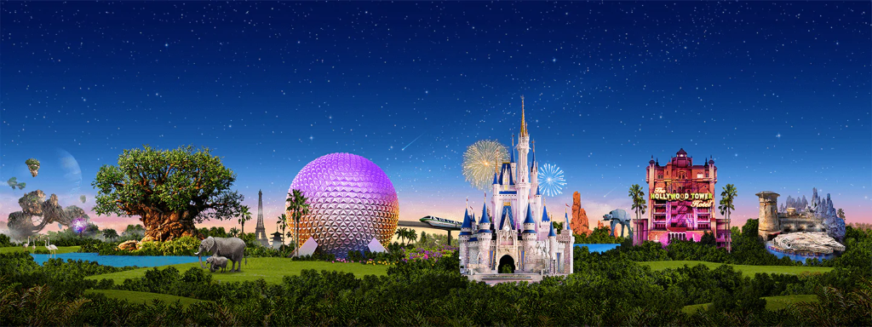

It’s our final day of P6 but also the final day of our virtual Disney Trip! Check out the PowerPoint attached with this document and complete the activities to end our trip.

Finally...  
Thank you primary 6 for an amazing year. We cannot thank you enough for being such a fantastic, creative and inspiring year group. Enjoy your summer and we will see you in August!  
  
Love Mrs Cross & Miss Purdie x

