Thursday 25.6.20
Good morning everyone! Here are your tasks for today:
Disney Trip! - Check out the PowerPoint attached with this document that includes some fun activities for the fourth day of our Disney Trip!
Literacy – Challenge!
LI: to apply knowledge of punctuation and grammar.
You will need to use your jotter or paper where you can keep notes and show working out!
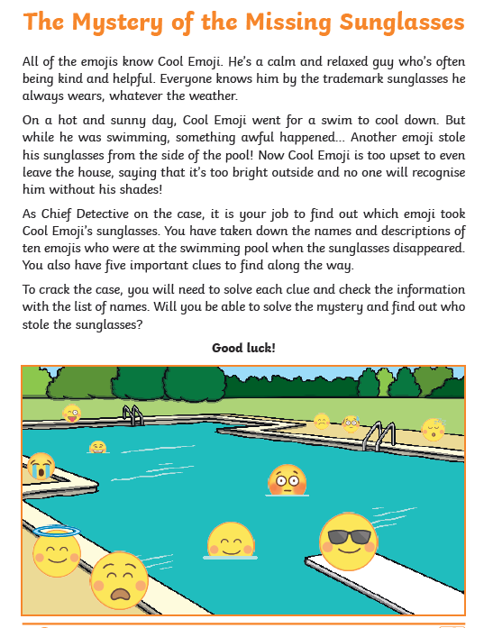
Attached with this assignment is the mystery challenge, if you are unable to print you may need to make a list of suspects and their features. Follow through the clues to see if you can find the culprit! The answers are at the end of the document (no peeking until you have completed the task!)

Maths - Fireworks and Parades (Times and Durations)
LI: to apply knowledge of timetables to work out timings and durations.
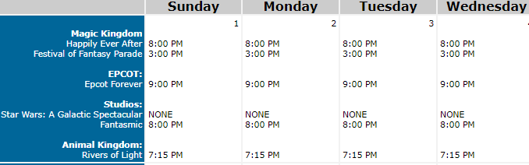
Hapilly ever After – 23 mins
Festival of Fantasy Parade – 17 mins
Epcot Forever – 22 mins
Star Wars: A Galactic Spectacular – 12 mins
Fantasmic! - 36 mins
Rivers of Light – 8 minutes

Answer the questions about the timetable and durations above!
1) On Sunday, what is the time difference between Rivers of Light and Epcot Forever?
2) If I went on the carousel ride at 2:45pm on Monday, and it lasted 12 minutes, would I have enough time before the Festival of Fantasy Parade starts?
3) If I was to watch all of the fireworks and parades one after the other with no breaks, how long would it take?
4) Show the time Rivers of Light would finish on a 24-hour digital clock.
5) I have a pass to have lunch with Mickey Mouse at 2:30pm on Wednesday. The whole experience lasts around 40 minutes. What Fireworks/Parades can I still go to see when I’m finished?
6) How many hours between Epcot Forever on Monday and the Festival of Fantasy Parade the following day?
7) If Star Wars Spectacular ran once every day for a week, how many hours and minutes long in total would that be?
8) Design your very own Disney Watch or clock! It is up to you whether it’s an analogue or digital device.

RRS – Health Lesson
LI: To understand and identify your rights.
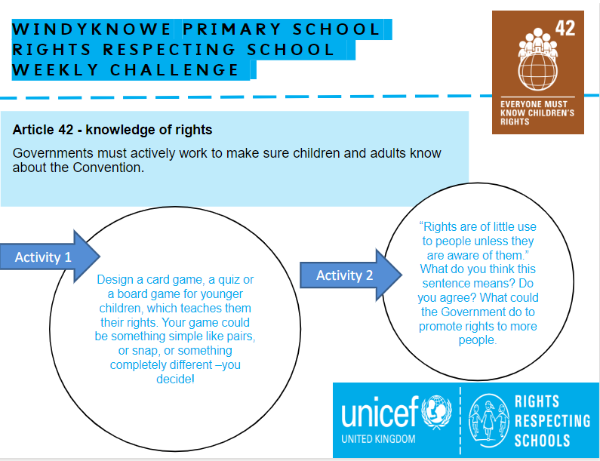

Music

Mr Muller has placed activities in your charanga inbox
This can be access here https://www.charangascotland.co.uk/yumu/login
If you are unable to access charanga and you don’t have a username or password, let Mr Muller know

