Wednesday 24th June

LIVE ON TEAMS TODAY
*11am – Work it out Wednesday with Mrs Angus*
*3pm – The Bolds to the Rescue with Miss Hesp/Miss Melrose*
*P5m last day with Miss Melrose, farewell chat 2pm.*

French
L.I. To describe my face in French
Log on to Linguascope using the school log in details. As before, click on the French flag in the beginner section. Next click on the ‘me and my family’ section (moi et ma famille). Then click on the face (le visage). The Présentation section will explain the vocabulary to you and you can have a go at playing some of the games to practice. Share what you have learned with a member of your household or on your team.

Spelling
As you have been practising so hard get someone in your household to test you on your spelling words. Then share your success with us!
Here are the words you have been practising:
Simile Spelling  3.6.20 | Mild Spelling  3.6.20 | Spicy Spelling  3.6.20 | Hot Spelling  3.6.20
common words | common words | common words | common words
live | leave | running | squirrel
give | group | seventeen | evening
about | nine | nineteen | piece
around | circle | liked | continue
house | high | listen | listening
hour | city | example | television
any | upon | started | experiment
body | here | clothes | believe
 | first | coming | state
 | shoe | heard | playground

Literacy
As it’s the results of Ready Steady Cook today could you share your favourite recipe with us on Teams or the blog? Why do you like it so much? We might even be able to try these recipes over the holidays!
I love fajitas! I like that everything is put out on the table and you help yourself to what you want!
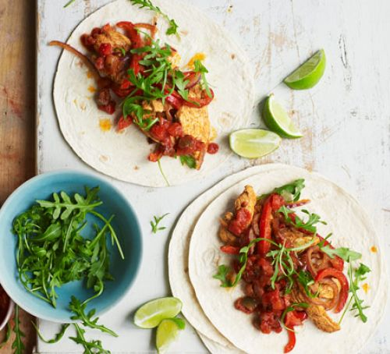

Easy chicken fajitas
By Member recipe by stevenmorris
PREP: 15 MINSCOOK: 10 MINS
EASYSave to My Good Food
Print

Ingredients
- 2 large chicken breasts, finely sliced
- 1 red onion, finely sliced
- 1 red pepper, sliced
- 1 red chilli, finely sliced (optional)

For the marinade
- 1 heaped tbsp smoked paprika
- 1 tbsp ground coriander
- pinch of ground cumin
- 2 medium garlic cloves, crushed
- 4 tbsp olive oil
- 1 lime, juiced
- 4-5 drops Tabasco

To serve
- 6 medium tortillas
- bag mixed salad
- 230g tub fresh salsa

Method
- Heat oven to 200C/180C fan/gas 6 and wrap 6 medium tortillas in foil.
- Mix 1 heaped tbsp smoked paprika, 1 tbsp ground coriander, a pinch of ground cumin, 2 crushed garlic cloves, 4 tbsp olive oil, the juice of 1 lime and 4-5 drops Tabasco together in a bowl with a big pinch each of salt and pepper.
- Stir 2 finely sliced chicken breasts, 1 finely sliced red onion, 1 sliced red pepper and 1 finely sliced red chilli, if using, into the marinade.
- Heat a griddle pan until smoking hot and add the chicken and marinade to the pan.
- Keep everything moving over a high heat for about 5 mins using tongs until you get a nice charred effect. If your griddle pan is small you may need to do this in two batches.
- To check the chicken is cooked, find the thickest part and tear in half – if any part is still raw cook until done.
- Put the tortillas in the oven to heat up and serve with the cooked chicken, a bag of mixed salad and one 230g tub of fresh salsa.

Numeracy
L.I. To revise previous concepts
Follow the lesson, video and interactive activities.
Algebros – Equivelant fractions https://www.bbc.co.uk/bitesize/articles/zb8wqp3
Mathletes - Fractions of an amount https://www.bbc.co.uk/bitesize/articles/zjtg47h
Ninjas/Magicians - Tenths https://www.bbc.co.uk/bitesize/articles/zvyrkxs

Here are some bonus challenge questions if you want to test your knowledge https://www.bbc.co.uk/bitesize/articles/z966dp3

