Wednesday 24.6.20
Good morning everyone! Here are your jobs for today. Remember to check out the next teacher daily challenge on the blog
Disney Trip! - Check out the PowerPoint attached with this document that includes some fun activities for the third day of our Disney Trip!

Literacy – Comprehension
LI: to read and research for information about an Olympic host country
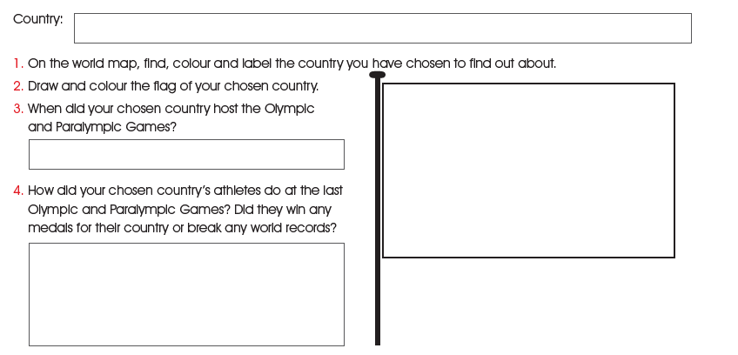
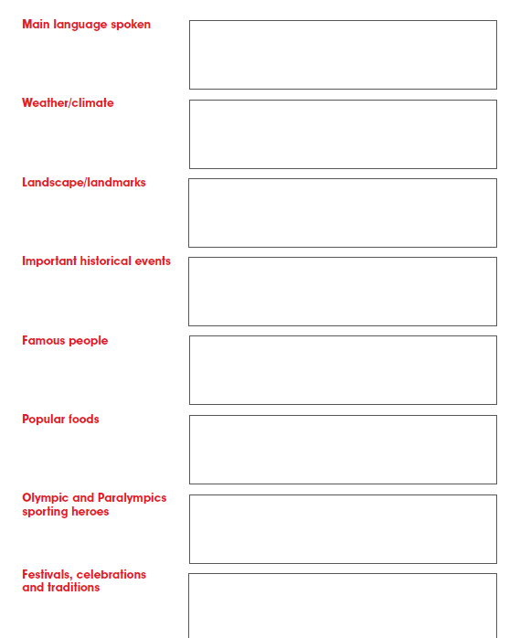
Numeracy
Rectangles: L.I- To be able to calculate improper fractions
Starter - https://www.youtube.com/watch?v=-imFslMIN1g
1) 14/2 2) 30/6 3) 36/3 4) 45/5 5) 52/4 6) 102/2
7) 90/5 8) 70/2 9) 36/3 10) 110/2 11) 18/2 12) 250/5
13) 155/5 14) 580/58 15) 32/4

Triangles: L.I- To be able to calculate a percentage
1) 50% of 60 2) 50% of 160 3) 50% of 160
4) 25% of 120 5) 25% of 140 6) 25% of 100
7) 75% of 88 8) 75% of 120 9) 75% of 140
10) 10% of 30 11) 10% of 70 11) 10% of 400
12) 5% of 200 (find 10%, then half it) 13) 5% of 600 (find 10%, then half it)

Circles: L.I- To be able to find simple percentages
1) 50% of 6 2) 50% of 22 3) 50% of 26
4) 50% of 66 5) 50% of 70 6) 50% of 68
7) 50% of 102 8) 50% of 160 9) 25% of 100 (find 50% then half it)
10) 25% of 1000 (find 50% then half it)

Optional Tasks
- SumDog
- Active Learn Games

Art Task
L.I. To design and draw a Disney inspired castle
Before you begin you will need:
- some paper (or use your jotter)
- Something to draw with e.g. pens, pencils
Task: Draw a Disney inspired castle. Here are a few images to get your imagination started.
Your castle can be any size, shape or colour you like.

*If you are stuck this YouTube tutorial might help: https://www.youtube.com/watch?v=7Uy2EOyoUv0
You can skip parts and pause bit as you wish.

Optional Extension Tasks (You don’t need to do these)
- Create a 3D model using junk materials (you might not be able to do this today as you would need to gather your resources).
- Draw your castle outdoors using pavement chalks if you have them.
- Create a castle using natural materials outdoors e.g. sticks, stones, mud, leaves, grass cuttings.

Music
Mr Muller has placed new activities in your charanga inbox
This can be access here https://www.charangascotland.co.uk/yumu/login
If you are unable to access charanga and you don’t have a username or password, let Mr Muller know

