Tuesday 23rd June   
  
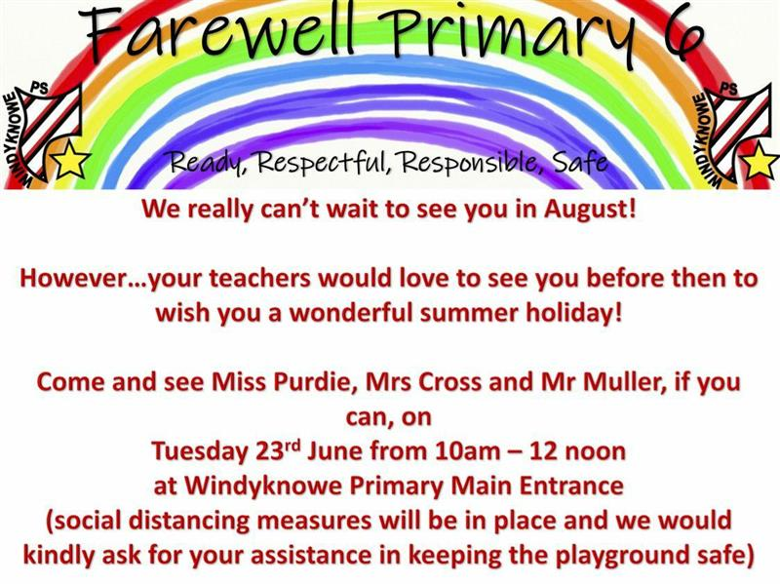

  
  
**Disney Trip! - Check out the PowerPoint attached with this document that includes some fun activities for the second day of our Disney Trip!**

|  |
| --- |
| **Writing – Dear P7 Teacher** **LI: to write a letter about yourself**   For today’s writing, you are going to write a letter for your teacher next year. In your letter you could include:   * A sketched picture of yourself * Introduce yourself * Your hobbies * Your favourite subject at school * A school subject you think you are good at * A good school memory from P6 * Something you are looking forward to in P7 * Any extra information you think your teacher should know!   This letter will be read by your P7 teacher so try to include as much detail as you can! |

**Numeracy**

**L.I-To be able to answer questions quickly and accurately**



**Take Part in the West Lothian Sumdog Competition. You have been entered as a class so we need as many people as possible to take part. All of your scores will be added together. At least half of the class need to take part to qualify. Login and join in.**

***Other Optional Tasks***

* Active Learn Games- select from the games allocated to you. You can select your own level of difficulty in each game.
* Sumdog
* Explore games on Topmarks. There are different categories to choose from. You can choose the level of difficulty on most of these.

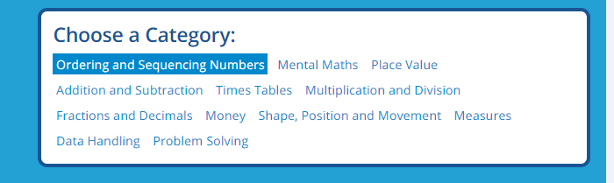

Topic

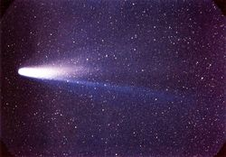

LI – to research facts about Halley’s Comet.

Use the following website to research for information and create a PowerPoint or a poster.

<https://kids.kiddle.co/Halley%27s_Comet#:~:text=Halley's%20Comet%20(Comet%20Halley)%20is,who%20predicted%20the%20comet's%20return.>

Mild - to find 3 key facts about Halley’s Comet.

Spicy- to find 5 key facts about Halley’s Comet.

Hot- to find 7 key facts about Halley’s Comet.