Monday 22.6.20

**Try out your daily challenge as part of our health and fitness fortnight!**

Here are your jobs for today:  
  
Four our final week together, we are going to go on a virtual trip to Walt Disney World! Every day this week there will be a range of different activities to do on our trip!  
 It will be in a PowerPoint document which will be attached with this assignment!   
**Make sure you select ’Starts Slideshow’ to get the full effect of the different music and videos included!**   
Good luck and have fun **😊**

**Health**

**L.I- To create a safety poster**

**1.Choose a topic:**

* **Sun Safety- PowerPoint in TEAMS-FILES-Safety Folder**
* **Water Safety- PowerPoint in TEAMS-FILES-Safety Folder**
* **Road Safety-** <https://roadsafety.scot/learning-zone/second/>

**2.** Once you have chosen your topic look at the PowerPoint or follow the given link to find out more. If you are happy with your choice of topic move to step 3.

**3.** Create a leaflet, poster, PowerPoint or SWAY sharing facts and information about how to keep safe relating to your chosen subject. You may need to do some research first, make a plan using notes and then think carefully about your design.

Success Criteria

* It must include at least 3 safety tips
* It must have appropriate and relevant pictures
* It must have some writing

4. Please share your finished work on TEAMS if you can.

**Numeracy**

**L.I- To be able to solve problems**

**\*Choose Mild or Hot\***

Mild

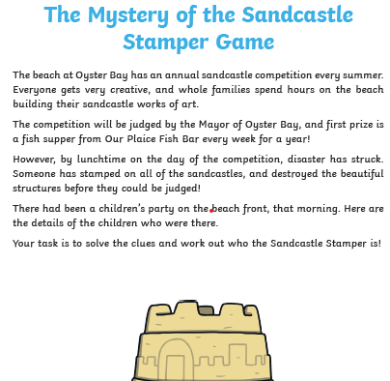

Hot

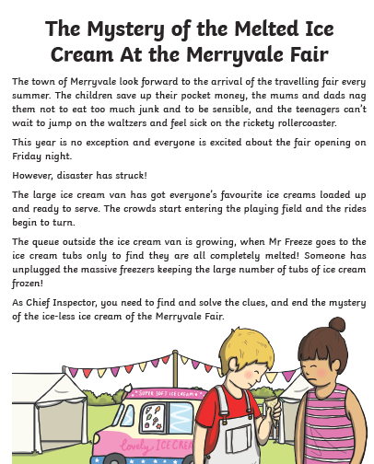

1. Go to the Files section on your class Team and find the Mystery Maths folder.
2. Click into the folder and choose Mild or Hot (there is no spicy this week).
3. You will see a table with a list of suspects and information about them. You will need to look at this table after you have solved each clue to work out who did not melt the ice cream/stomp on the sandcastles until only one person is left i.e. the thief!

**Tip-** Note down the list of names and score off the people it can’t be as you solve each clue. You will need to carefully check the list after each clue is solved. You need to pay attention to the people you have not yet scored off your list each time.

**Important Note**: **You will find the answers to each clue at the end of each document (hot) OR on a separate document (MILD) only look at these after you have tried to solve each clue. If you're stuck on a clue post a message on Teams to ask for help and either your teacher or a friend will help you. You can help each other.**

Music Monday



• Short videos that tell the story of *Fever!*  
*• Lyrics and teaching guides for pupils to practise each of 5 songs*  
*• New videos that help teach the accompanying choreography*  
*• A Curriculum for Excellence-based creative writing and science activities*  
*• Tips to make simple props and costumes*

[**www.scottishopera.org.uk/fever**](https://scottishopera.us14.list-manage.com/track/click?u=e22f567381737e921e1f0663e&id=54b7ecf400&e=6ebd889d3b)