Friday 19.6.20
11.00- Mrs cross & Miss Purdie will be going LIVE! Come join us for a chat J

Problem Solving
L.I. To use ‘draw a diagram’ strategy
Mild- Choose at least 1 problem
Spicy- Choose at least 2 problems
Hot- Choose at least 3 problems
*You can choose any problem and complete in any order. Answers will be posted later today.
**Draw a ‘diagram’ means draw a picture using the information that you have.
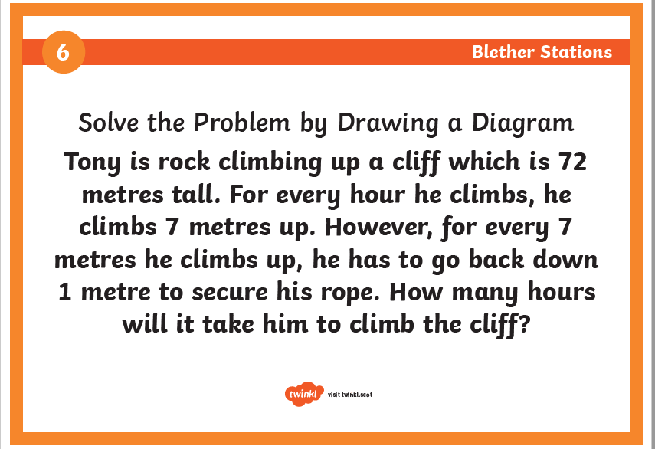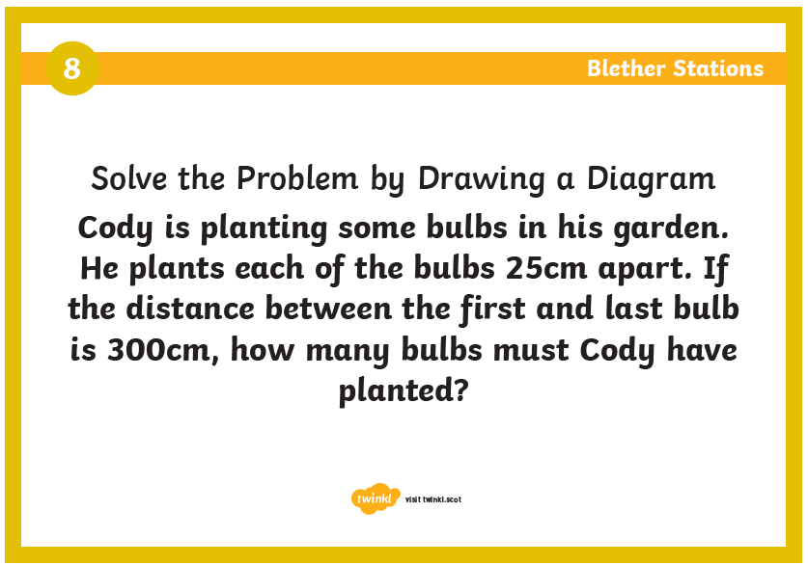
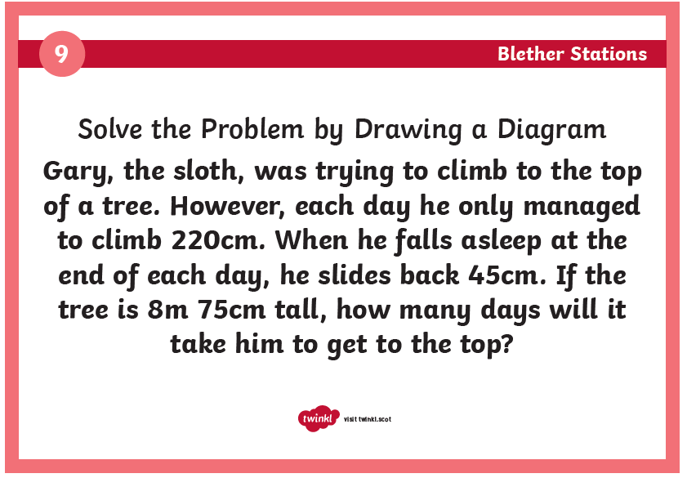
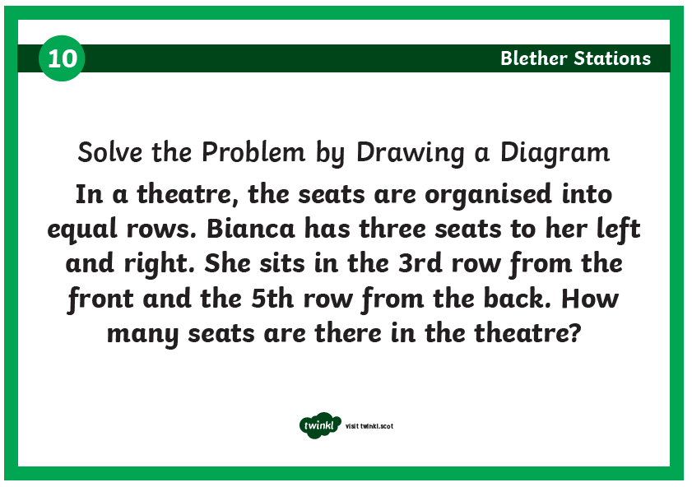

SPANISH SPEAKING COUNTRIES’ CHALLENGE
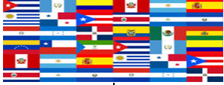
Can you find the correct Spanish speaking country for each question?
Good luck!
- Country where the beautiful flamenco dance comes from. | E…
- Country where they celebrate the colourful Día de los Muertos festival. | M…
- This country is territory of United Estates. | P…(2 words)
- Impressive Machu Picchu is located in this country. | P…
- This country is named after the equator, which runs through the country. | E…
- Famous Shakira comes from this country. | C…
- This is the only African Spanish speaking country. | G…(2 words)
- This exciting dance called Tango comes from this country. | A…
- The capital of this country is Caracas. | V…
- The flag of this country is red, white and green. | B…
- Poroto (bean dish) is the most typical dish from this country. | C…
- This country is located between Guatemala and El Salvador to the west and Nicaragua to the south and east. | H…
- This country has several beautiful nicknames: The most famous are 'the heart of South America', 'the land of water' and 'the island surrounded by mainland'. | P…
- This country is literally translated in English as Rich Coast. | C…(2 words)
- This country is the only place in the world where you can see the sunrise on the Pacific and set on the Atlantic. | P…
- The famous tourist destination called Punta Cana is located in this country. | R… (2 words)
- This country is the smallest Spanish speaking country in South America. | U…
- This country is known as the “Land of Volcanoes” because there are more than twenty volcanoes. Two of which are active. | E… (2 words)
- In this country you can see more stars than anywhere else - of the 88 constellations that exist in the night sky, a whopping 86 of them can be seen vividly if you are in this country! | N…
- The first ever chocolate bar was invented in this country. | G…
- The birthplace of the famous cocktail mojito made with rum, lime juice and mint leaves. | C…

Reward Time
L.I. to rest and play
After a hard working week it is time to do something that you enjoy doing in your free time. Please share in the digital classroom what you are doing. 😊 By sharing your activity, it will give other people ideas on what they could do; please make sure it is sensible and appropriate though.

