Thursday 18.6.20
Good morning everyone! Here are your tasks for today
LI: to apply knowledge of punctuation and grammar.

You will need to use your jotter or paper where you can keep notes and show working out!
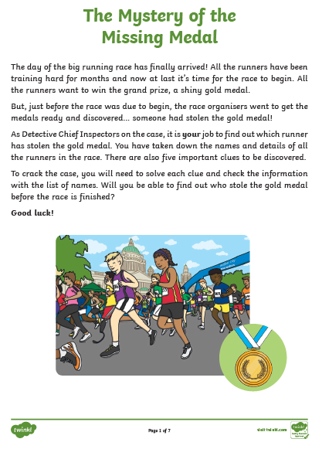
Attached with this assignment is the mystery challenge, if you are unable to print you may need to make a list of suspects and their features. Follow through the clues to see if you can find the culprit! The answers are at the end of the document (no peeking until you have completed the task!)

Maths – LI – to work out time intervals accurately.

SC
I can use a time line
I can find a start time and an end time

Starter - https://www.youtube.com/watch?v=0aOfUsBaQyU

Then look at Mr Muller’s examples...

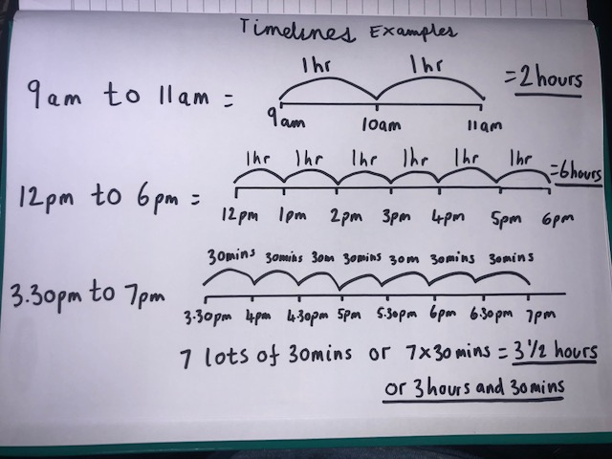

Main (draw a timeline for each question like Mr Muller has drawn above to work out the answer)

Circles -
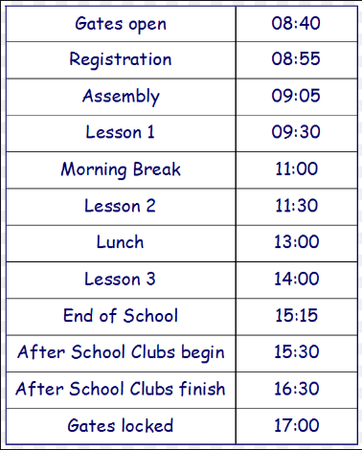
What is the time interval from Gates Open to assembly ?
What is the time interval from Lesson 1 until morning break?
What is the time interval from lesson 2 to lunch?
What is the time interval from end of school to after school club begins?

Triangles
What is the time interval from Gates Open to registration?
What is the time interval from Registration to lesson 2?
What is the time interval from Assembly to end of school?
What is the time interval from Morning Break to lunch?
What is the time interval from lunch to gates locked?
What is the time interval from Lesson 3 to after school clubs finish?

Rectangles

What is the time interval from Gates Open to lesson 2?
What is the time interval from Lesson 1 lesson 2?
What is the time interval from Registration to lesson 2?
What is the time interval from Assembly to end of school?
What is the time interval from Morning Break to lunch?
What is the time interval from after school club begins to after school clubs finish?
Let’s think about our school at Windyknowe...
What is the time interval from Windyknowe break (10.30am) to lunch (12.30pm)?
What is the time interval from Windyknowe break finishing (10.45am) to the end of the day (3.15pm)?

RRS – Health Lesson
LI: To develop understanding of beliefs and free thoughts.

Music

Mr Muller has placed activities in your charanga inbox
This can be access here https://www.charangascotland.co.uk/yumu/login
If you are unable to access charanga and you don’t have a username or password, let Mr Muller know

