Wednesday 10.6.20
Good morning everyone! Here are your jobs for today. Remember to check out the next teacher daily challenge on the blog!
Literacy Comprehension
LI: to read for information about Tanni Grey-Thompson
Today’s comprehension is focusing on the Paralympian Tanni Grey-Thompson
*Mild
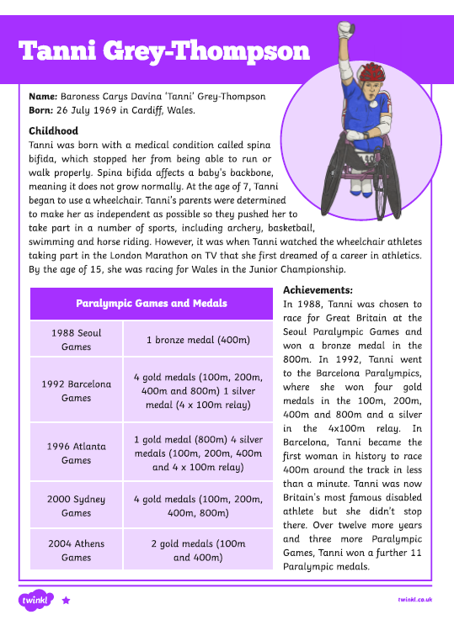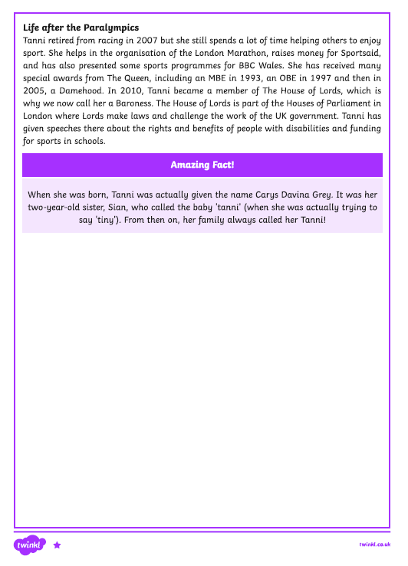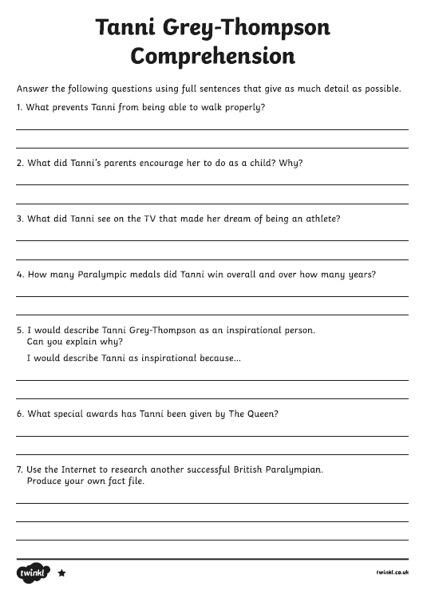
**Spicy
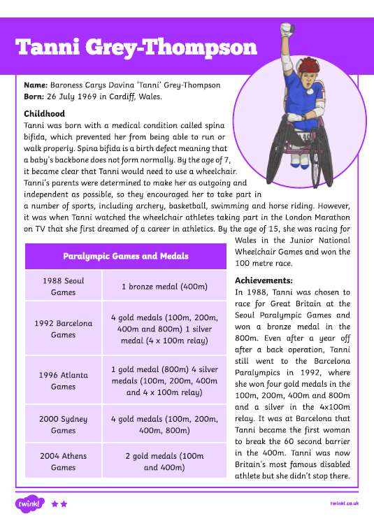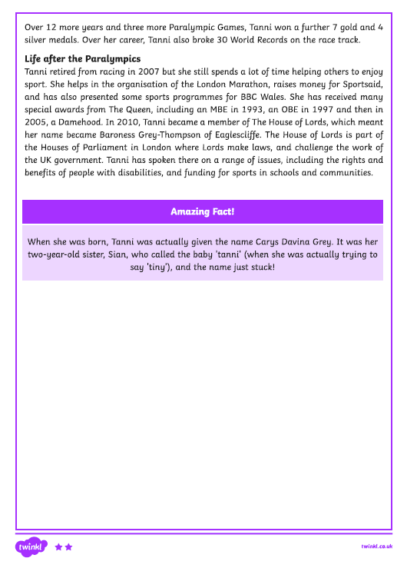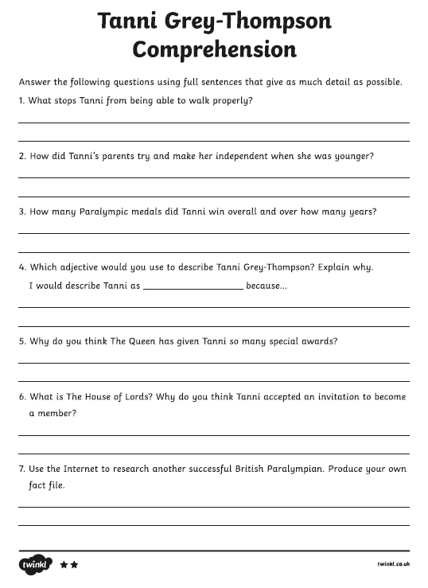

***Hot
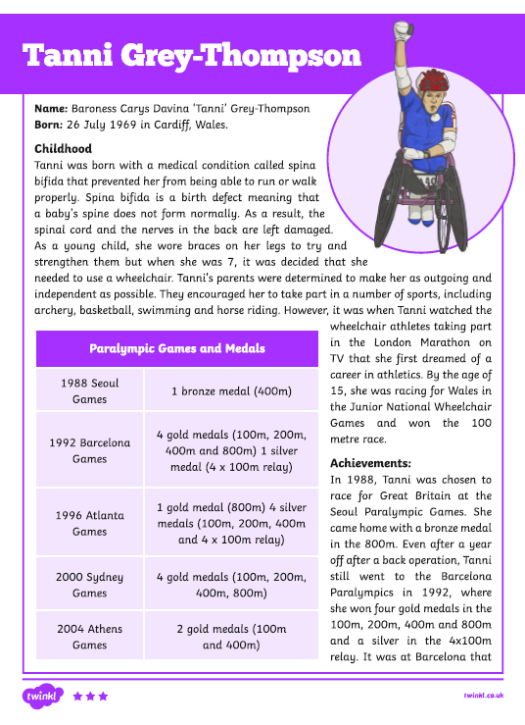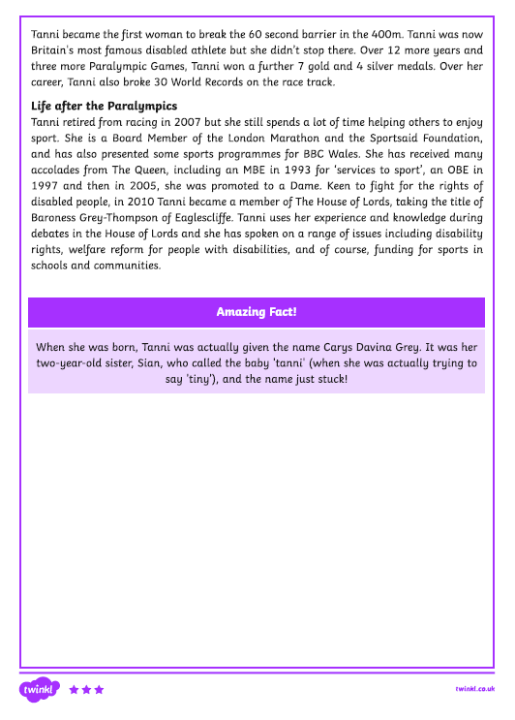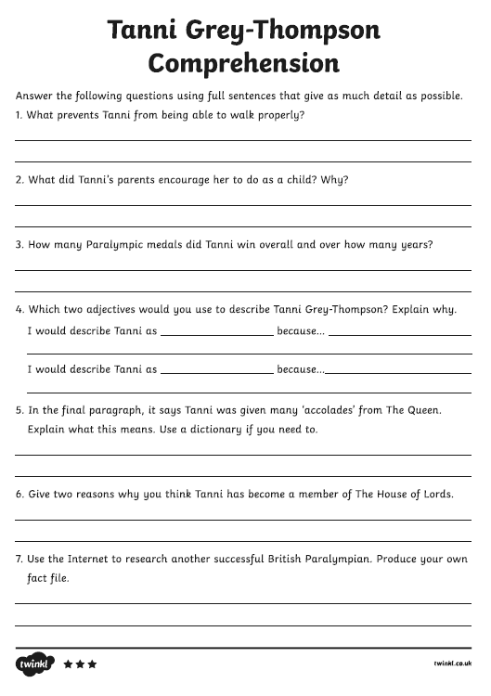

Numeracy
Rectangles: L.I- To be able to calculate improper fractions
Starter - https://www.youtube.com/watch?v=-imFslMIN1g
1) 14/2 2) 30/6 3) 36/3 4) 45/5 5) 52/4 6) 102/2
7) 90/5 8) 70/2 9) 36/3 10) 110/2 11) 18/2 12) 250/5
13) 155/5 14) 580/58 15) 32/4

Triangles: L.I- To be able to calculate a percentage
1) 50% of 60 2) 50% of 160 3) 50% of 160
4) 25% of 120 5) 25% of 140 6) 25% of 100
7) 75% of 88 8) 75% of 120 9) 75% of 140
10) 10% of 30 11) 10% of 70 11) 10% of 400
12) 5% of 200 (find 10%, then half it) 13) 5% of 600 (find 10%, then half it)

Circles: L.I- To be able to find simple percentages
1) 50% of 6 2) 50% of 22 3) 50% of 26
4) 50% of 66 5) 50% of 70 6) 50% of 68
7) 50% of 102 8) 50% of 160 9) 25% of 100 (find 50% then half it)
10) 25% of 1000 (find 50% then half it)

Optional Tasks
- SumDog
- Active Learn Games

Art Task
L.I. To draw a still life picture
Before you begin you will need:
- some paper (or use your jotter)
- Something to draw with e.g. pens, pencils
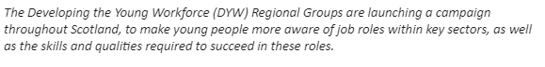Art Activity - Design (draw, paint sculpt) a key worker.
Label by listing their skills and qualities and their job role.
This could be based on any key worker of your choice here are a few suggestions:
- Doctor/nurse
- Cleaner
- Refuse Collector
- Carer
- Cleaner
- Supermarket worker

PE – continue with your sports day/ fitness fortnight tasks, remember to add them to the form emailed out to you and return by Monday 22nd June. If you have finished try the Tokyo Ten activity below!
Use: https://www.youtube.com/watch?v=XrEH5JLljDI ‘Radio Taiso’ with task below.
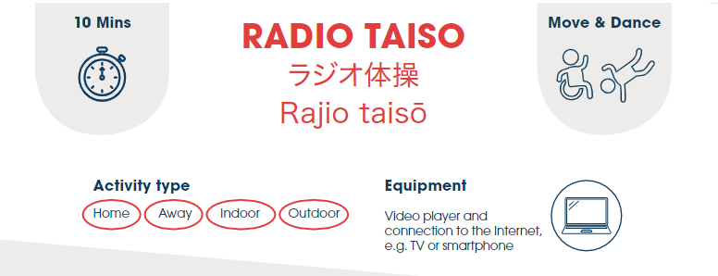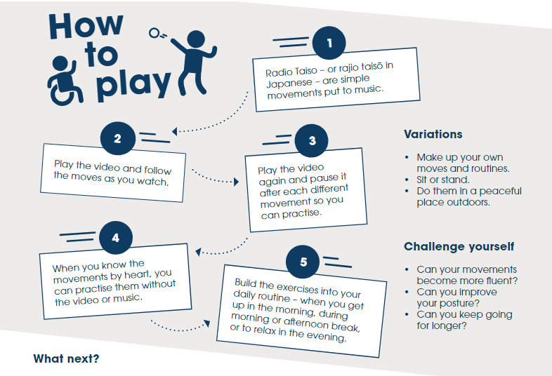

Music
Mr Muller has placed new activities in your charanga inbox
This can be access here https://www.charangascotland.co.uk/yumu/login
If you are unable to access charanga and you don’t have a username or password, let Mr Muller know

