Tuesday 16th June
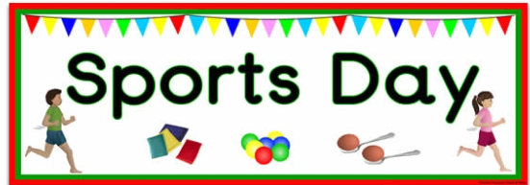

Daily Challenge 3: Check the blog!
Make sure to take part in the various sporting activities available online, remember to read the sports day info shared by Mrs Howard very carefully! Try the Tokyo Ten activities down below and let your teacher know how got on 😊
TOKYO TEN!
Duster dodge – requires 2+ people to play, if you don’t have that you can do the second one; House Workout!
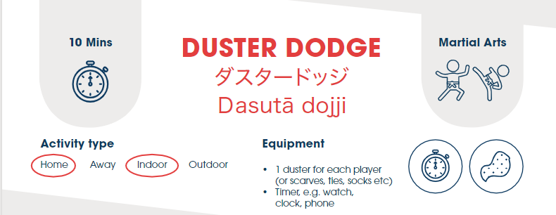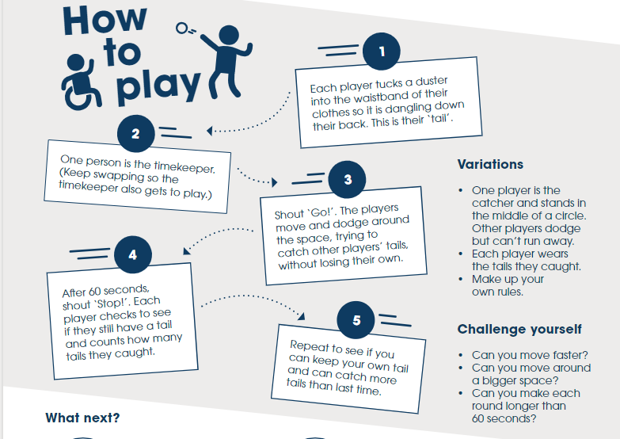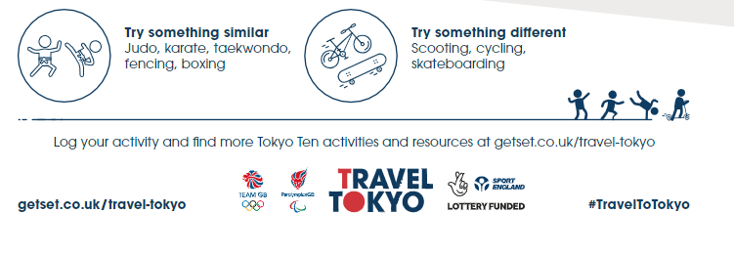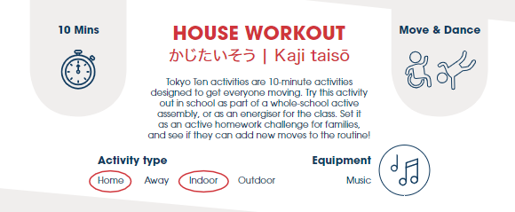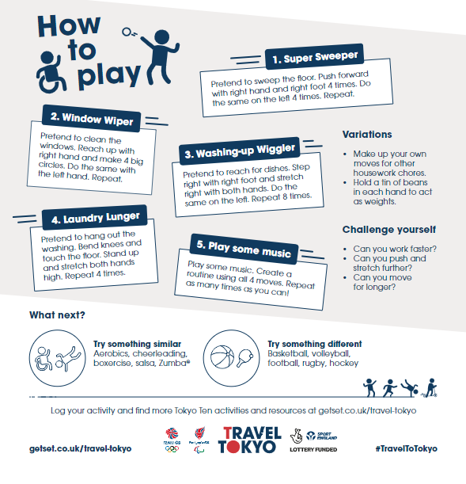
Writing – To write about a Paralympian
In today’s writing, you are going to research and write about a Paralympian. You are going to create a poster profile of your chosen Paralympian from the list below, writing in interesting facts and information about them. Remember you can download Microsoft Office from your glow account which will give you access to Microsoft applications such as power point and word! P.s if you can’t use ICT then you can draw your poster. P.P.S You don’t have to print it out, just take a photo or screen shot of your work and send it in! 😊
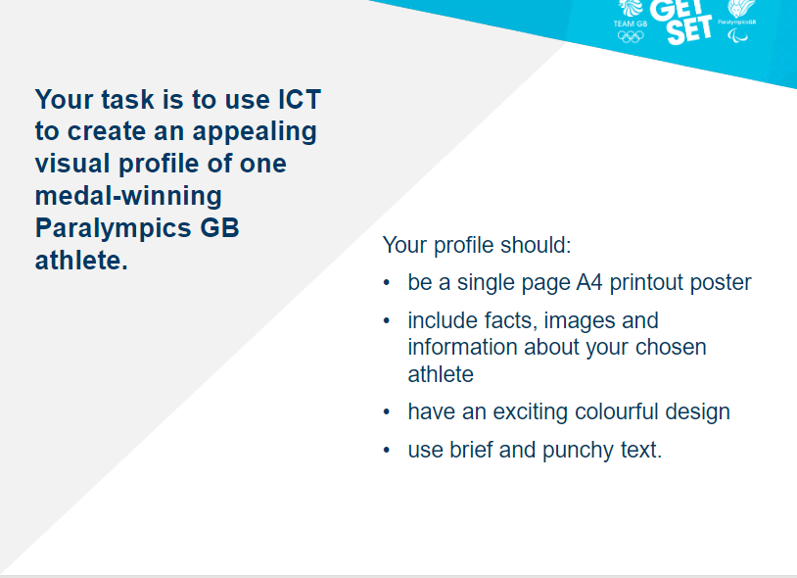
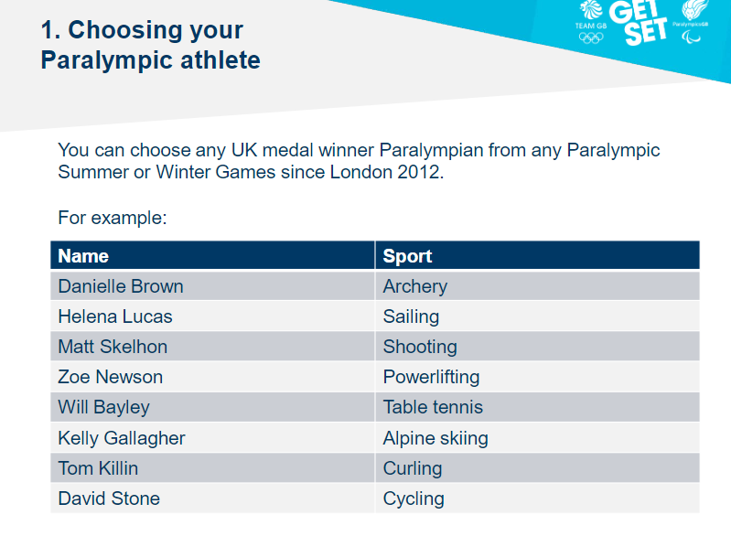
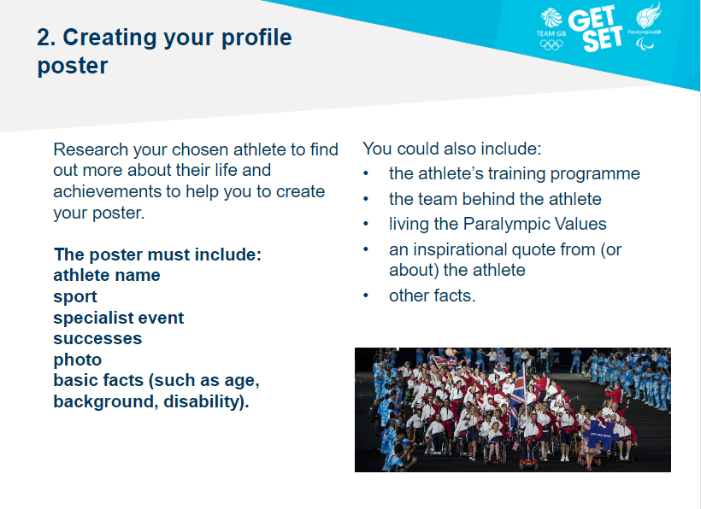

Numeracy
L.I-To be able to create and answer questions accurately
Challenge: Make A Numeracy Game
- You will need: some paper or card (take a page out of your jotter if you need to) and something to write/draw with.
Make a numeracy game based on multiplication. It could be a matching game based on pairs/snap (question on one card and answers on another) or a game you know like ‘snakes and ladders’. Maybe if you land on a snake you don’t need to slide down it if you can answer a multiplication question correctly? Be as creative as you want. You could add flaps that you lift to reveal questions or answers. Add illustrations to make it look fun! You could have a theme for your game e.g. Unicorn Snap, Superhero Pairs, Sport. You could have little tasks people need to do if they get an answer wrong e.g. 10 star jumps, run on the spot for one minute.
You make the rules. If you can try playing your game with someone at home (you may need to wait until a suitable time to do this, remember people might be busy helping other or working themselves). You will need good communication skills to explain your game and any rules that are needed.
Mild- Include 2,5,10 timestable.
Spicy- 2,5,10 timestable plus at least 2 more of your choice.
Hot- All tables from 2-12.
Extra Hot- Can you inlcude multiplication of decimals?

Other Optional Tasks
- Active Learn Games- select from the games allocated to you. You can select your own level of difficulty in each game.
- Sumdog
- Exploregames on Topmarks. There are different categories to choose from. You can choose the level of difficulty on most of these.
