Monday 15.6.20
Try out your second daily challenge as part of our health and fitness fortnight!
Daily challenge 2 is posted on the blog 😊

Here are your jobs for today:
Literacy – Spelling
Spelling – Sports vocabulary
LI: to read and spell sports vocabulary.
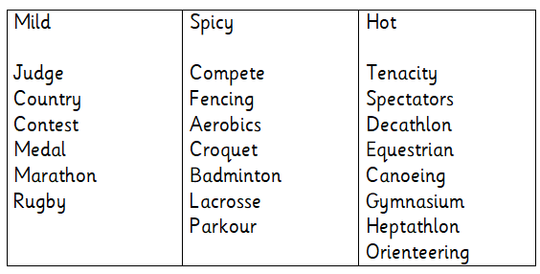
Task 1) Read cover and write your words 3 times in your jotter
Task 2) Draw a medal or trophy and decorate it with your spelling words. Make it colourful and detailed with your words!

Health
L.I- To be able to recognise the qualities of a good friend
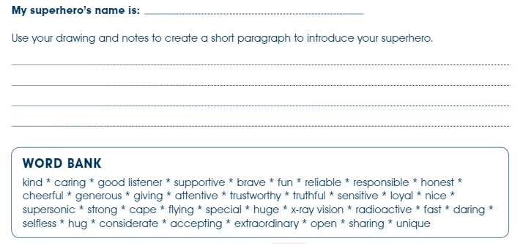

Numeracy
L.I- To be able to solve problems
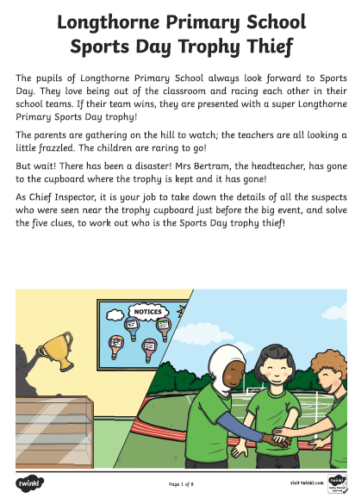
- Got to the Files section on your class Team and find the Sports Day Maths folder.
- Click into the folder and choose Mild, Spicy or Hot.
- You will see the page above and on the next page a table with a list of suspects and information about them. You will need to look at this table after you have solved each clue to work out who did not steal the trophy until only one person is left i.e. the thief!
Tip- Note down the list of names and score off the people it can’t be as you solve each clue. You will need to carefully check the list after each clue is solved. You need to pay attention to the people you have not yet scored off your list each time.
Important Note: You will find the answers to each clue at the end of each document (mild, spicy or hot) only look at these after you have tried to solve each clue. If you're stuck on a clue post a message on Teams to ask for help and either your teacher or a friend will help you. You can help each other.

Music Monday
• Short videos that tell the story of Fever!
• Lyrics and teaching guides for pupils to practise each of 5 songs
• New videos that help teach the accompanying choreography
• A Curriculum for Excellence-based creative writing and science activities
• Tips to make simple props and costumes
www.scottishopera.org.uk/fever

