Monday 15th June
FITNESS FORTNIGHT

LIVE ON TEAMS TODAY
*11am – INspire challenge with Miss Norquoy*
*3pm – The Bolds to the Rescue with Miss Hesp/Miss Melrose*

Literacy
L.I. To read for information
Attached is a fact sheet about Scotland's landscape, along with some questions for you to answer in your green jotters.
Alliteration – complete the sheet with three stars at the bottom
Metaphor – complete the sheet with two stars at the bottom
Personification – complete the sheet with one star at the bottom
Simile – complete the sheet with one star at the bottom. Some of the works are quite tricky so you may want to ask a member of your household to help you read the text.

HWB
L.I. To improve flexibility
As children you are more flexible than adults. Flexibility means you can bend and stretch without much trouble.
Try out these flexibility exercises with an adult:
- Touch your toes
- Side stretches to the right and left
- Forward roll
- Star jumps
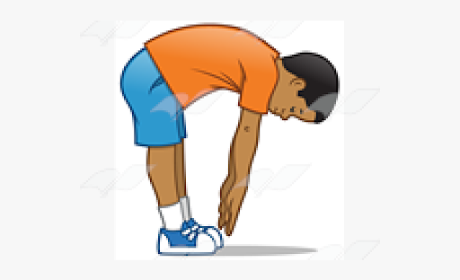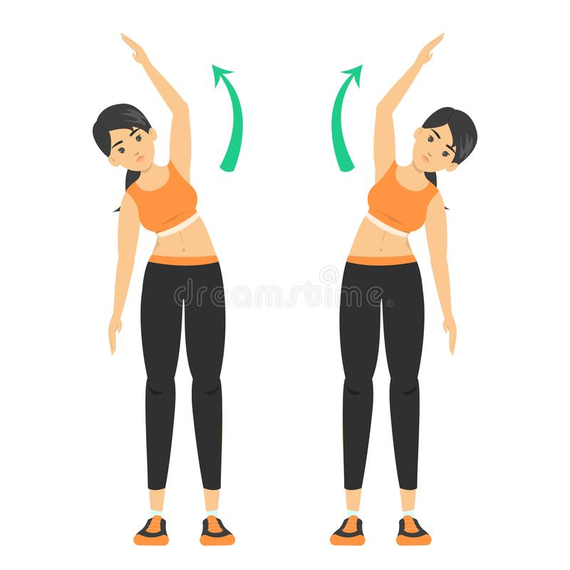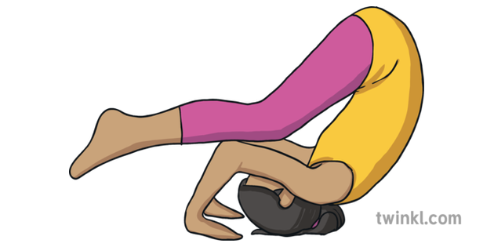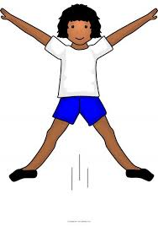

Choose your favourite, do it regularly and encourage an adult to join in with you!

Numeracy
L.I. To apply a range of problem-solving skills
ALGEBROS/MATHLETES - There has been a murder at the movies. Put your detective hat on and help to solve the mystery in this problem-solving challenge!
NINJAS/MAGICIANS - The potions teacher has been locked in the ghost tower! It is up to you to figure out who would do such a thing!
You have until Wednesday to complete the challenge (you could answer 2 clues a day)

