Friday 12.6.20
10.00- the launch of fitness fortnight! Mrs Howard will be going LIVE on teams and videos will be posted on the blog giving you all the fun details!
11.00- Mrs cross & Miss Purdie will be going LIVE! Come join us for a chat J

Problem Solving
L.I. To use ‘draw a diagram’ strategy
Mild- Choose at least 1 problem
Spicy- Choose at least 2 problems
Hot- Choose at least 3 problems
*You can choose any problem and complete in any order. Answers will be posted later today.
**Draw a ‘diagram’ means draw a picture using the information that you have. For Problem 1 you would draw 39 teddies and count every 5th teddy to find the answer. If you can’t draw a teddy it doesn’t matter, this is not the important part. What you could do instead is draw 39 small circles and count every 5th circle to find the answer.
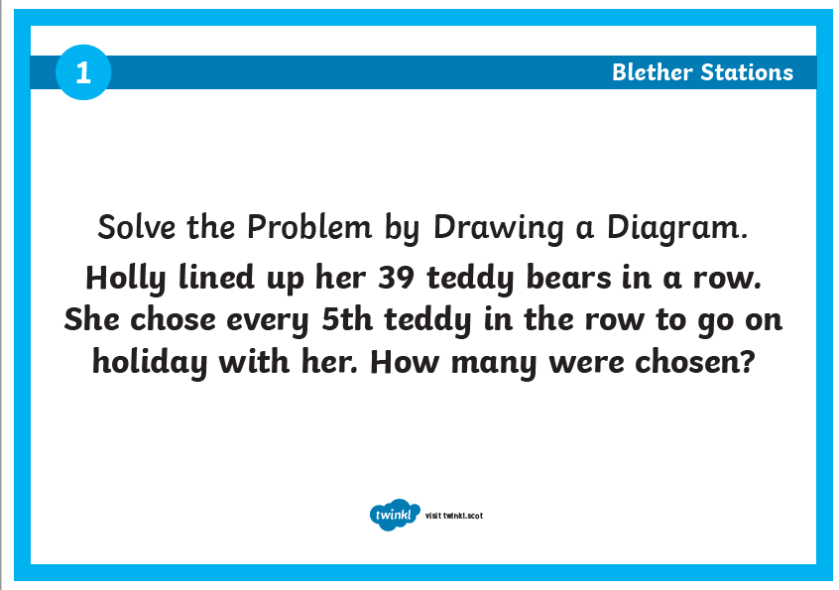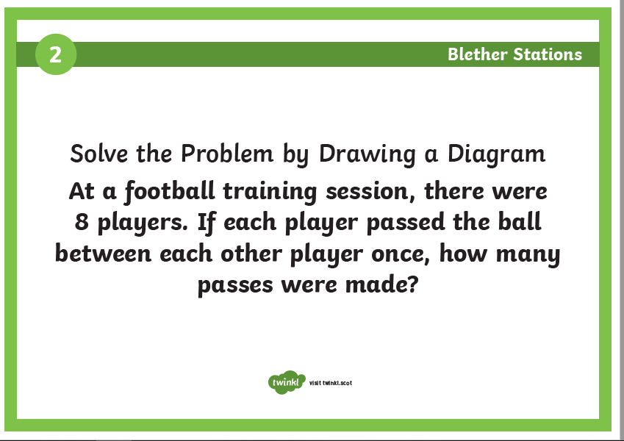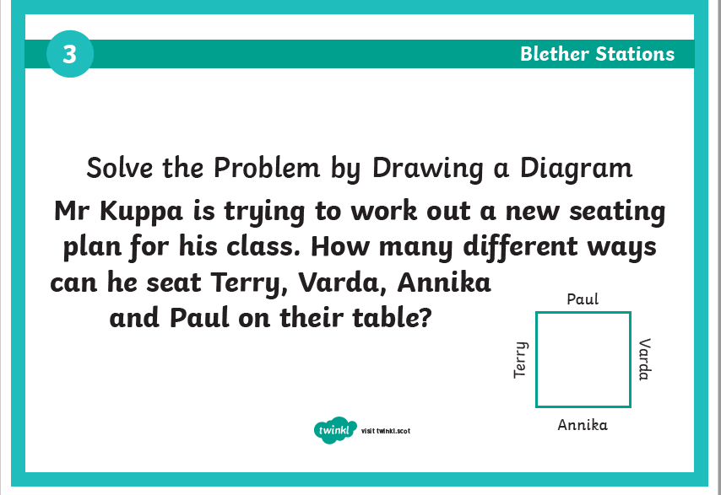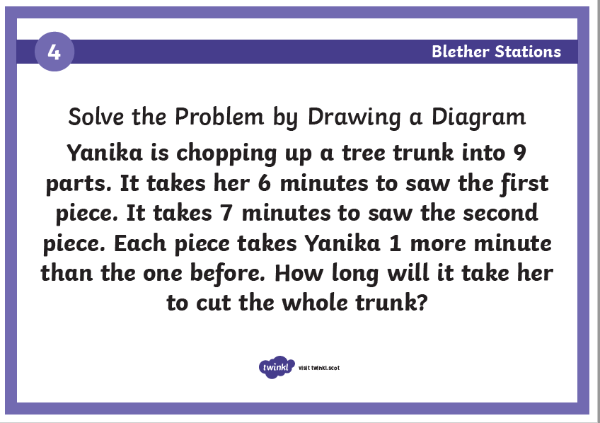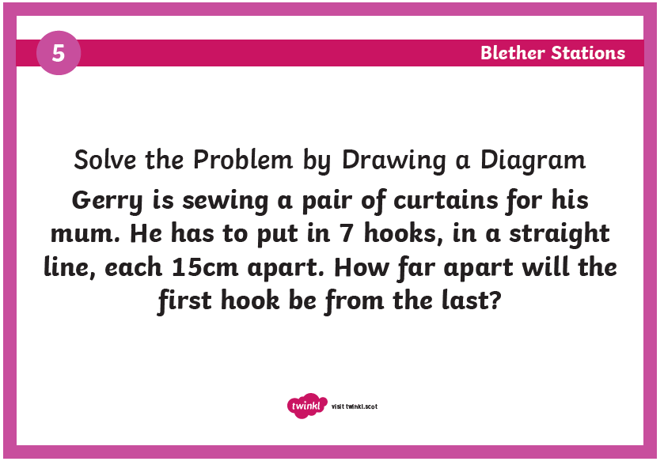

Skills Academy
LI: to build skills around the house
Continue to help someone around the house today. You could do jobs such as:
- Wash the dishes
- Help with clothes washing/ hang out washing (weather permitting!)
- Help /prepare cook a meal
- Help tidy a room in the house
- Help clean an area of the house
Ask an adult in case they have an idea too!

Español - El Tiempo!
LI: to understand and use Spanish vocabulary to talk about the weather
Here is a catchy song called ‘QUe Tiempo Hace Hoy?’ Which means what is the weather today? https://www.youtube.com/watch?v=amh8Sovhn5g
Step 1) Access: https://www.linguascope.com/
Username: windyknowe
Password: learner
Step 2) Select beginner section, clicking on the Spanish flag

Step 3) Select ‘Mi Mundo’ (the Purple tab) and then select ‘El Tiempo’ Explore the first collumn of tasks to help you learn Spanish vocabulary for different types of weather!
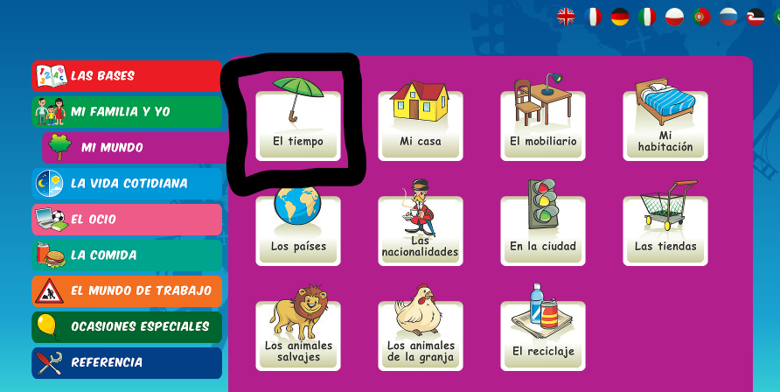

Reward Time
L.I. to rest and play
After a hard working week it is time to do something that you enjoy doing in your free time. Please share in the digital classroom what you are doing. 😊 By sharing your activity, it will give other people ideas on what they could do; please make sure it is sensible and appropriate though.

