Thursday 11.6.20
Good morning everyone! Here are your tasks for today
Greens – LI: To extend a sentence using adjectives, nouns and verbs.
Can you edit these sentences to make them sound more interesting?
1) The road ran past the field.
2) The stalls were full of items.
3) The dog played in the garden.
4) The boy ate an ice lolly.
5) The house was dark,
6) The sky was sparkling with stars.
7) The pizza was nice.
8) The teacher spoke to the class.

Blues and Reds - Subordinate clauses
LI: to use and identify subordinate clauses
Remember – clause means phrase/ the main part of a sentence.
Today we are going to learn about subordinate clauses in sentences. A subordinate clause (or phrase) contains both a subject and a verb. It complements a sentence providing more information.
A subordinate clause must be attached to a main clause as it would not make sense on its own.
For example "I was hungry because I missed breakfast". In this sentence "because I missed breakfast" is the subordinate clause to the main clause "I was hungry". The two clauses are joined together with the connective "because".

Here is another example:
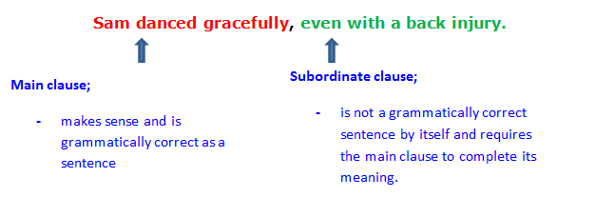Further explanations - http://icosa.hkbu.edu.hk/grammar/sentence-structure/subordinate-clauses/index.htm

Read the task instructions and examples very carefully. You are going to practise writing a sentence 3 times, adding in a subordinate clause at the beginning, middle and end of it.
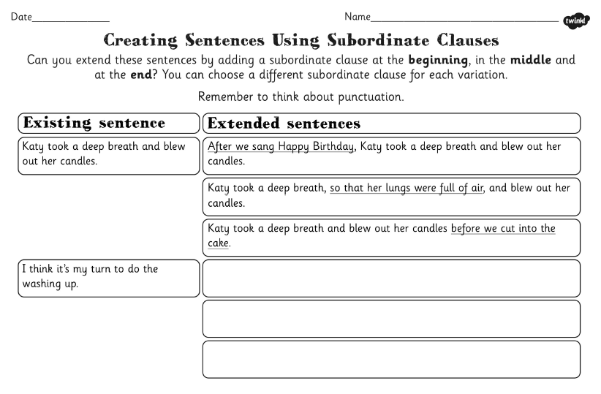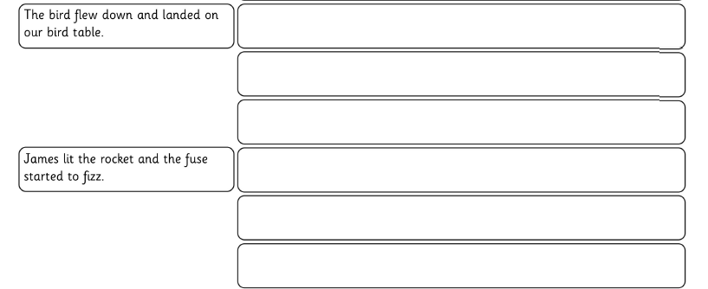

Maths – LI – to work out time intervals accurately.

SC
I can use a time line
I can find a start time and an end time

Starter - https://www.youtube.com/watch?v=0aOfUsBaQyU

Then look at Mr Muller’s examples...

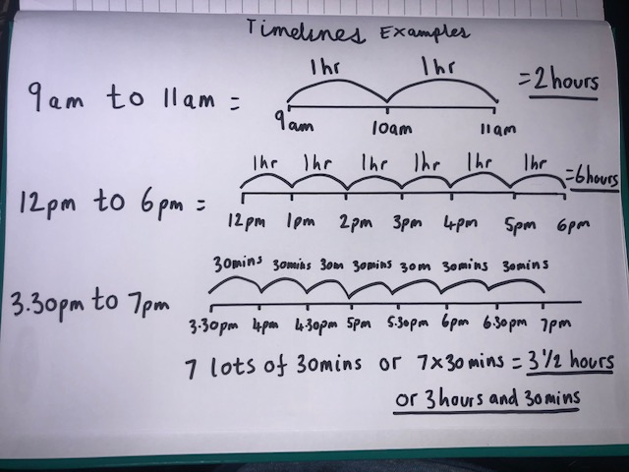

Main (draw a timeline for each question like Mr Muller has drawn above to work out the answer)

Circles -
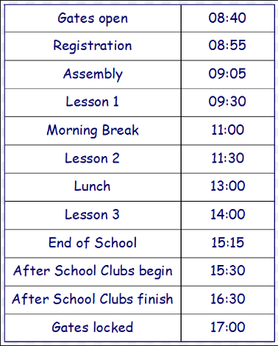
What is the time interval from Gates Open to lesson 1 ?
What is the time interval from Lesson 1 until lesson 2?
What is the time interval from lesson 2 to lesson 3?
What is the time interval from end of school to gates locked?

Triangles
What is the time interval from Gates Open to morning break?
What is the time interval from Registration to lunch?
What is the time interval from Assembly to Lesson 3?
What is the time interval from Morning Break to after schools clubs finish?
What is the time interval from lunch to after school clubs begin?
What is the time interval from Lesson 3 to Gates Locked?

Rectangles

What is the time interval from Gates Open to lesson 1?
What is the time interval from Lesson 1 to morning break?
What is the time interval from Registration to lesson 3?
What is the time interval from Assembly to Lesson 3?
What is the time interval from Morning Break to end of school?
What is the time interval from End of School to after school clubs finish?
What is the time interval from Lesson 3 to Gates Locked?
What is the time interval from gates open to gates locked?

RRS – Health Lesson
LI: To develop understanding of learning.
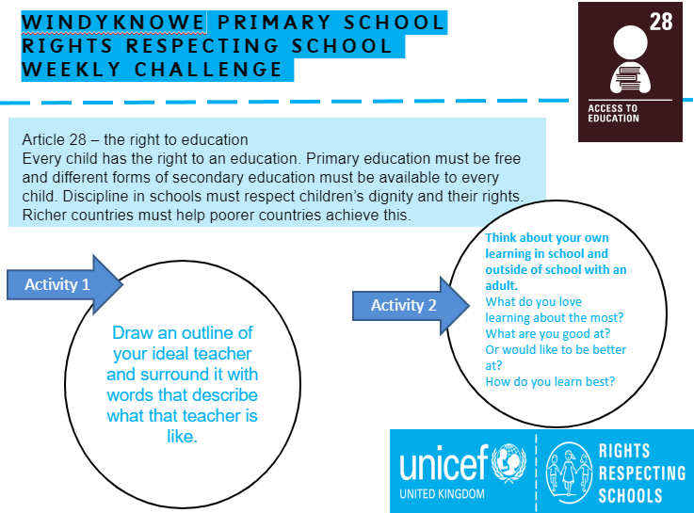

Music

Mr Muller has placed activities in your charanga inbox
This can be access here https://www.charangascotland.co.uk/yumu/login
If you are unable to access charanga and you don’t have a username or password, let Mr Muller know

