Wednesday 10.6.20
Here are your jobs for today:
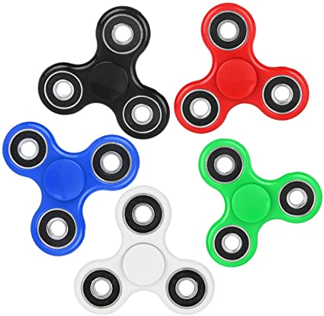
Literacy Comprehension
LI: to read for information about fidget spinners
On teams with this assignment document there are 3 other files (Mild,Spicy and Hot). Select the correct file for your literacy group, read the passage carefully and answer the questions. 😊 Answers will be posted later today!
****Fast finisher – Log onto Espresso
Select second level > News >News bites
Watch and answer the quiz questions. Remember to tell your teacher your score!
https://central.espresso.co.uk/espresso/primary_uk/home/index.html

Numeracy
Rectangles: L.I- To be able to calculate improper fractions
Starter - https://www.youtube.com/watch?v=-imFslMIN1g
1) 10/2 2) 24/6 3) 39/3 4) 55/5 5) 48/4 6) 100/2
7) 70/5 8) 84/2 9) 36/6 10) 68/2 11) 12/4 12) 25/5
13) 115/5 14) 580/10 15) 84/21

Triangles: L.I- To be able to calculate a percentage
1) 50% of 80 2) 50% of 260 3) 50% of 190
4) 25% of 60 5) 25% of 120 6) 25% of 92
7) 75% of 92 8) 75% of 140 9) 75% of 84
10) 10% of 20 11) 10% of 50 11) 10% of 500
12) 5% of 180 (find 10%, then half it) 13) 5% of 500 (find 10%, then half it)

Circles: L.I- To be able to find simple percentages
1) 50% of 12 2) 50% of 18 3) 50% of 24
4) 50% of 60 5) 50% of 80 6) 50% of 88
7) 50% of 62 8) 50% of 140 9) 25% of 60 (find 50% then half it)
10) 25% of 100 (find 50% then half it)

Optional Tasks
- SumDog
- Active Learn Games

Art Task
L.I. To draw a still life picture
Before you begin you will need:
- some paper (or use your jotter)
- Something to draw with e.g. pens, pencils
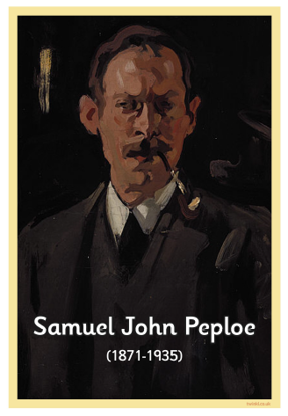
Samuel John Peploe was a Scottish artist. Below are examples of his work.
These images are examples of ‘still life’.
Definition: A still life is a work of art depicting mostly inanimate (not living) subject matter, typically objects which are either natural (food, flowers, plants, rocks, shells, etc.) or man-made (drinking glasses, books, vases, jewellery, coins, etc.).
Your Task: Can you draw a still life image of something around your home or garden. A still life can include a few objects or just one. If you can add some colour to your drawing to give the effect of light and shade.
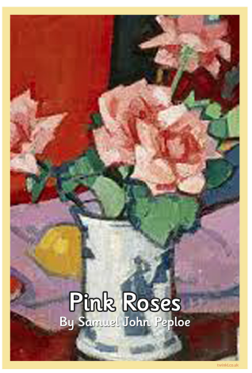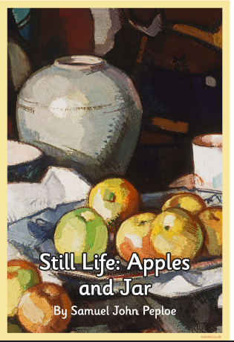

Optional Extension Task: Use the internet to research and then create a fact file about Samuel John Peploe. You could do this on paper or create a PowerPoint.

P.E - Superhero Training Academy!
*Pick a new selection of workouts, different from last week!
Have fun and remember to drink plenty of water
Let your teacher know what superhero workouts you tried!
Last week Miss Purdie tried – Batman and Ironman
Today I am going to do– Captain America and Spiderman!
Avengers TABATA workout! - https://www.youtube.com/watch?v=jyWyBern6q4
Spiderman - https://www.youtube.com/watch?v=YC_V8hnU2PY
Thor - https://www.youtube.com/watch?v=c3oeoVsM95s
Star Lord - https://www.youtube.com/watch?v=H186QQvWXKw
Supergirl - https://www.youtube.com/watch?v=TGex6z_t4Mk
Tony Stark (Ironman) https://www.youtube.com/watch?v=udK_PRSeVPI
Black Panther - https://www.youtube.com/watch?v=9SDWArXm4mA
Captain America - https://www.youtube.com/watch?v=QL2C0X3Gx1U
Batman - https://www.youtube.com/watch?v=8dLNbAcMqzc

Music
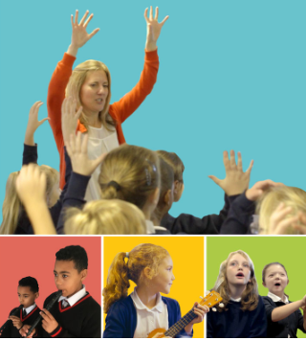
Mr Muller has placed new activities in your charanga inbox
This can be access here https://www.charangascotland.co.uk/yumu/login
If you are unable to access charanga and you don’t have a username or password, let Mr Muller know

