Monday 8.6.20
Please remember!
- Work can be completed in your green jotter or on a device/laptop
- Your teacher will only be available between 8.45 – 3.15, if you post after that time we will get back to you in the morning. Break and lunch times still apply
- Do not put too much pressure on yourself to finish things quickly, these can be done throughout the day.
- Remember you have access to apps and links such as Sumdog, Go Noodle, Study Ladder and Activelearn. You can play these any time!
- If you finish all the tasks that we have set you can read, or decide what else to do with the rest of your day
- Try to post work in ‘assignments’ or ‘class notebook’ if you can’t do this, don’t panic. You can always upload a photo to the live chat... but you don’t have to!

Numeracy
Squares
Triangles
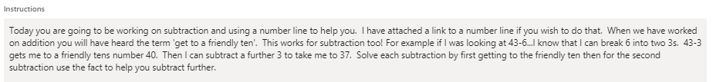
http://www.eduplace.com/cgi-bin/schtemplate.cgi?template=/kids/mw/manip/mn_popup.thtml&filename=nmbl_prim&title=Number%20Line&grade=1
Circles
Rectangles

Literacy All Groups

Health and Wellbeing
French
Have a go at lesson 5.
Learn a Language: French for Families The PowerLanguage team would like to offer their support to children and their families whilst they wait out the reopening of schools. Why not take this opportunity to learn French together as a family? We have opened up our successful French for Families course with no subscription fee until the end of June 2020!
Go to powerlanguage.courses/forfamilies to start learning! Amusez-vous bien !
For Families - PowerLanguage Courses
powerlanguage.acemlnc.com

