Monday 8.6.20
Hello Primary 6! Today we have Literacy, Numeracy and Health. Remember Mrs Howard will also be posting tasks for today in your P.E channel on TEAMS.
Here are your jobs for today:
Literacy (Spelling & Reading)
LI:to identify and spell vocabulary from Star Wars
Read the next chapter in your reading book or a book of your choice for around 30minutes. (If you are unsure what chapter you are on contact your teacher)
Optional
Read a book of your choice.
Spelling – Star Wars! Vocabulary and characters
Mild  Sith  Anakin  Stormtrooper  Empire  Yoda | Spicy  Alderaan  Skywalker  Vader  Imperial  Wookie | Hot  Tatooine  Palpatine  Chewbacca  Obi Wan Kenobi  Awakening
Task – Write your spelling words once forwards and once backwards! You can decorate your words, write them in bubble writing or colour them but you must write once forwards and once backwards! 😊
Task 2 – Can you unscramble these Star Wars words/names below? Try your best!
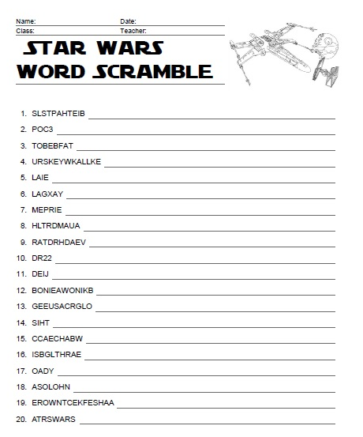

Health
L.I- To be able to express my thoughts and opinions
- Below are two inspirational quotes. Read each one carefully and take time to think about what it means.
- You can discuss with someone at home or post on Teams what you think.
- Answer the questions below each quote in your jotter and remember to write in sentences.

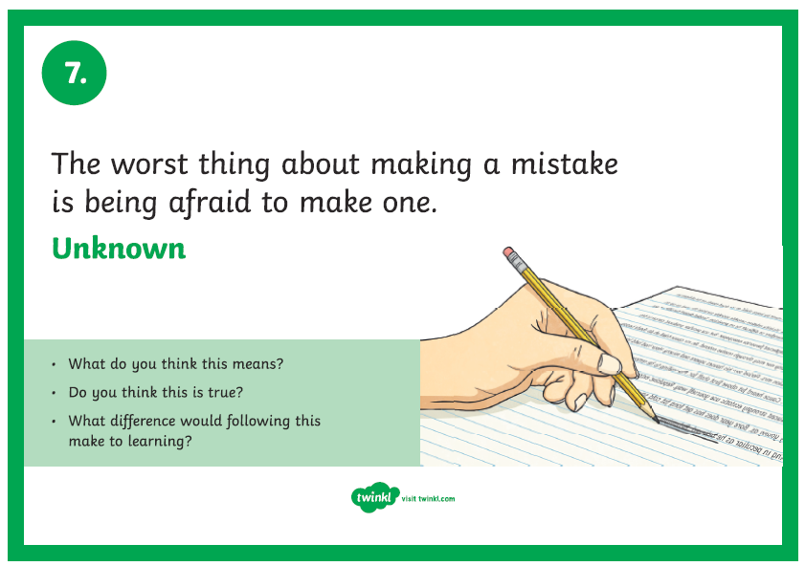
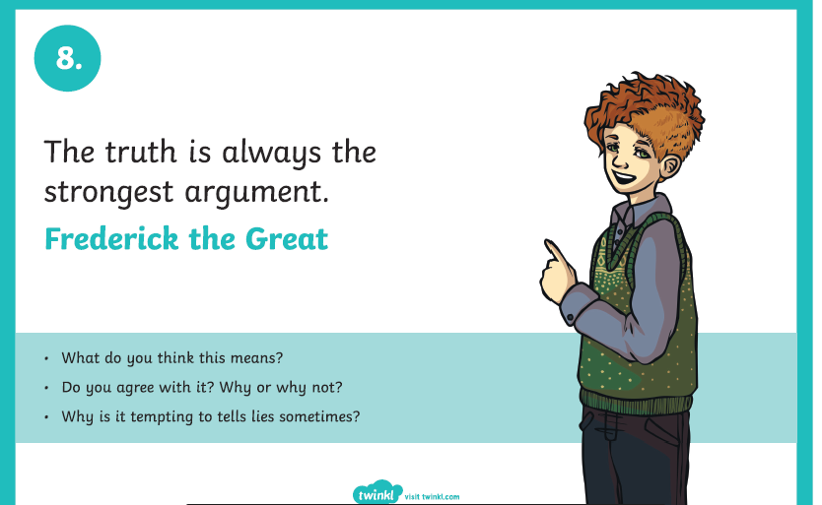

Optional Extension Task
- Research: Who was Frederick the Great?
Can you find three facts about them?
- Make up your own Inspirational quote and post on Teams. Write your quote and what it means.

Numeracy
L.I- To revise number concepts
Rectangles
- Write the following in figures:
- Six hundred and fifty two thousand six hundred and thirty
- Eight hundred and ninety thousand two hundred and four

- Put these numbers in order starting with the smallest:

630306 633066 610026 658646 652036 653376

- Find (mentally) the following:
a) 1236+451= b) 2359 - 257= c) 3547+321=
d) 4819+250= e) 6310-4305= f) 2450-2410=

- Find (mentally) the following:
a) 48 x 4= b) 34 x 7= c) 433 ÷100=
d) 917.3x10= e) 235.3 ÷100= f) 213.9÷100=

5. Round these numbers to the nearest 1000
a) 31299 b) 45 967 c) 322 543 d) 924 076

6. Write down the next three numbers in each of the following patterns:
a) 2000,4000,8000,16 000 b) 42,82,122,162
Optional Challenge: Make up your own number pattern and post on Teams to see if anyone can find the next three numbers.

L.I- To revise number concepts
Triangles
- Write the following in figures:
- Forty three thousand three hundred and three
- Seventy seven thousand six hundred and sixteen

- Put these numbers in order starting with the smallest:

10106 18060 10025 11640 11037 11370

- Find (mentally) the following:
a) 17+41= b) 68 - 33= c) 54+32=
d) 34+25= e) 550-320= f) 850-430=

- Find (mentally) the following:
a) 76 x10= b) 100 x 330= c) 555 x100=
d) 56.6 ÷10= e) 340 ÷100= f) 52.7÷10=

5. Round these numbers to the nearest 10
a) 188 b) 444 c) 2465 d) 972

6. Write down the next three numbers in each of the following patterns:
a) 11,22,44,88 b) 30, 70, 110, 150
Optional Challenge: Make up your own number pattern and post on Teams to see if anyone can find the next three numbers.

L.I- To revise number concepts
Circles
- Write the following in figures:
- Seven thousand three hundred and thirty three
b) Nine thousand four hundred and one
- Put these numbers in order starting with the smallest:

3465 3647 3693 3600 3610

- Find (mentally) the following:
a)32+45= b) 45-31= c) 60+39=
d) 20+50= e) 311-100= f) 570-170=

- Find (mentally) the following:
- 41 x10= b) 10 x 58= c) 10 x 66=
d) 20 ÷10= e) 40 ÷10= f) 35÷5=

5. Round these numbers to the nearest 10
a) 431 b) 328 c) 415 d) 66

6. Write down the missing number in each of the following patterns:
a) 4,8,__,16,20 b) 14,17,20,___, 26
c) ___, 40, 70,100,130 d) 45, __, 35, 30, 25

Music Monday
• Short videos that tell the story of Fever!
• Lyrics and teaching guides for pupils to practise each of 5 songs
• New videos that help teach the accompanying choreography
• A Curriculum for Excellence-based creative writing and science activities
• Tips to make simple props and costumes
www.scottishopera.org.uk/fever

