Friday 5.6.20

**10.00- Mrs cross & Miss Purdie will be going LIVE! Come join us for a chat J**

**Creative Thinking Skills**

**L.I. To use my creative thinking skills**

**Challenge: Invent Your own National Holiday**

Recently there was a national bank holiday to celebrate VE Day. Many people will have had a Spring bank holiday. Imagine you could invent your own national holiday.

1. Think of something you love. Itcould be something you love to do, a place you like to go or a thing you like to eat or play with. Anything!
2. Now build your own celebrations around this. Think of what you might do, what you might wear, what you would see? Are there decorations? Who would you celebrate with?

If you get stuck keep trying. You are using your curiosity and imagination skills.

1. Record you ideas in your jotter or if you want to you could create a PowerPoint, SWAY or poster to promote your national holiday.

Here are a few ideas:

National Friends Day

National Donut Day

National Dance Day

We are looking forward to seeing all of your ideas!

Skills Academy   
LI: to build skills around the house

Help someone around the house today. You could do jobs such as:

* Wash the dishes
* Help with clothes washing/ hang out washing (weather permitting!)
* Help /prepare cook a meal
* Help tidy a room in the house
* Help clean an area of the house

Tell your teacher how you built up a skill in the house 😊

Spanish  
LI: to understand and use Spanish vocabulary places in the house

We have an exciting new resource you can use to develop your confidence in Spanish. Today, we are going to learn different words for places in the home!

Step 1) Access: <https://www.linguascope.com/>

Username: windyknowe   
Password: learner

Step 2) Select beginner section, clicking on the Spanish flag

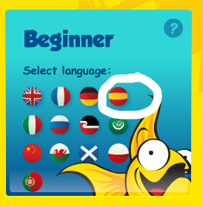

Step 3) Select ‘Mi Mundo’ (the Purple tab) and then select ‘Mi Casa’. Explore the first 2 blocks! Let your teacher know what tasks you have done 😊

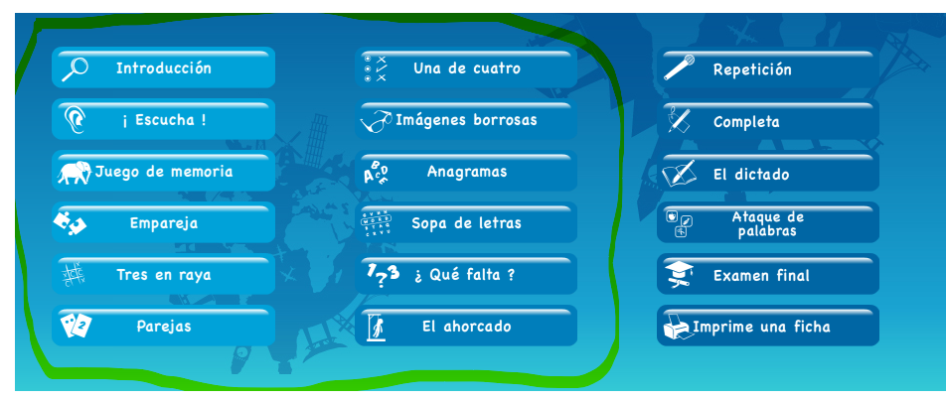

**Reward Time**

**L.I. to rest and play**

**After a hard working week it is time to do something that you enjoy doing in your free time. Please share in the digital classroom what you are doing. 😊 By sharing your activity, it will give other people ideas on what they could do; please make sure it is sensible and appropriate though.**