**Bathgate Procession**

**Dinosaur Handprints**

Since our 2020 Windyknowe float theme is Jurassic park, we have created a dinosaur activity to mark the Procession date.

This is an optional activity but it would be great to see as many children joining in as possible!

**Create a dinosaur handprint:**

* This can be a paint print of your hand or a drawing with pens or pencil – anything you choose!
* You can copy one from the idea page or create your own.

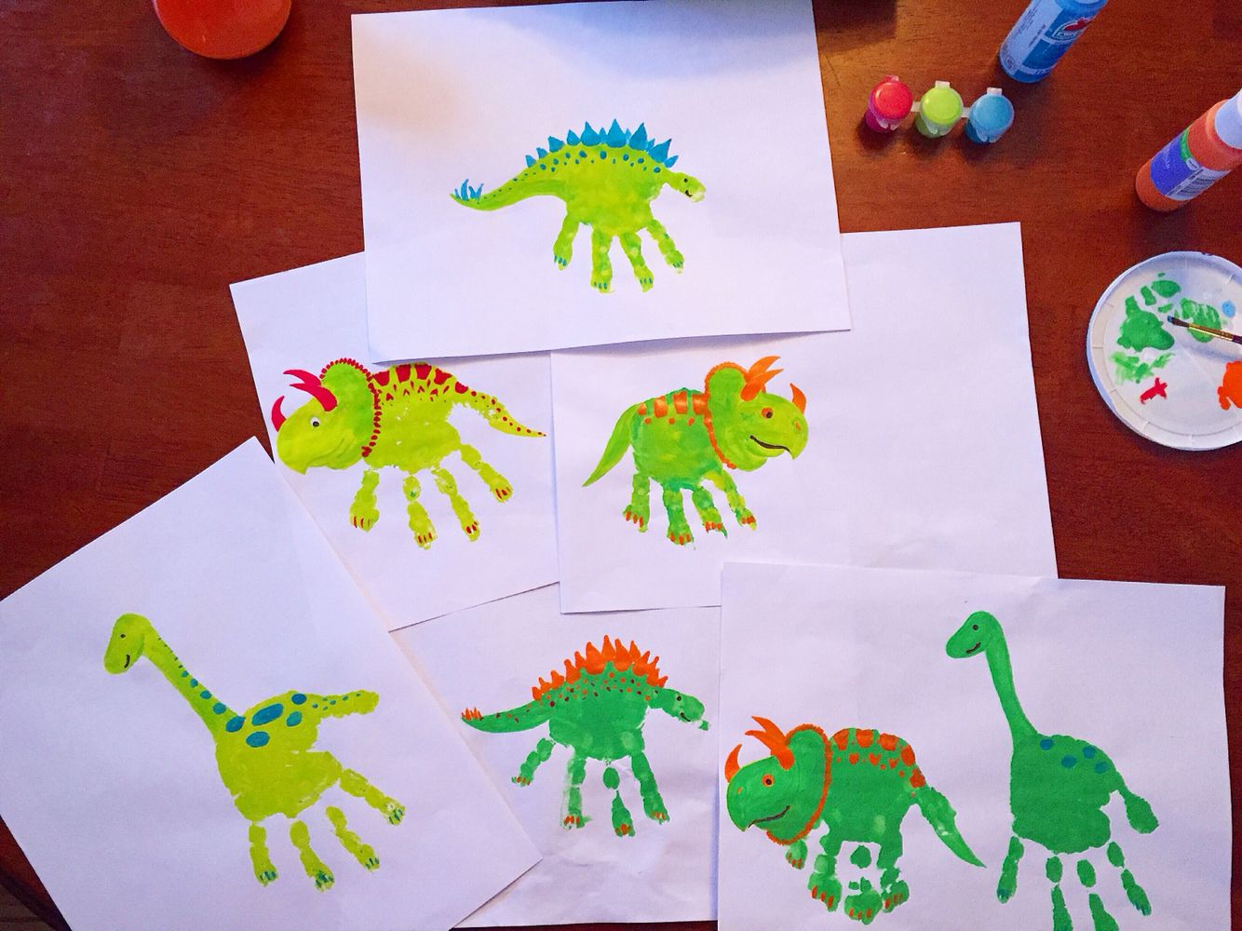

**Display your image:**

You can do both of these or choose one:

* Email a picture of your handprint to us and we will collate the images to make a collage of your lovely artwork to share.

Send images by Friday 5th June at 11am to:

P1: [jenna.dowie@westlothian.org.uk](mailto:jenna.dowie@westlothian.org.uk)

P2: [arlene.white@westlothian.org.uk](mailto:arlene.white@westlothian.org.uk)

P3 & P4: [evelynstewart@icloud.com](mailto:evelynstewart@icloud.com)

P5 & P6: [kirsti_riddell@hotmail.com](mailto:kirsti_riddell@hotmail.com)

P7: [linz.walker@hotmail.co.uk](mailto:linz.walker@hotmail.co.uk)

Nursery: [emma.douglas@westlothian.gov.uk](mailto:emma.douglas@westlothian.gov.uk)

* Hang your handprint up at the School gates to ceate a colourful display – if you are doing this, please consider putting your handprint into a poly pocket/sandwich bag or something that will prevent the rain from damaging it!

**Hip Hip Hooray!!**

**Can you copy one of these?**

**Or maybe you can create your own!**

**We can’t wait to see your amazing creations!**

