Thursday 4.6.20
Good morning everyone! Here are your tasks for today 😊

Punctuation and grammar
LI: Greens :to identify and write a correct homophone
Blues & Reds : to select the correct homophone in different contexts
Warm up - Play this fun homophone matching game from last week:
https://www.learninggamesforkids.com/vocabulary-games/homophones-games/homophones.html
See your tasks below for your groups!
Greens
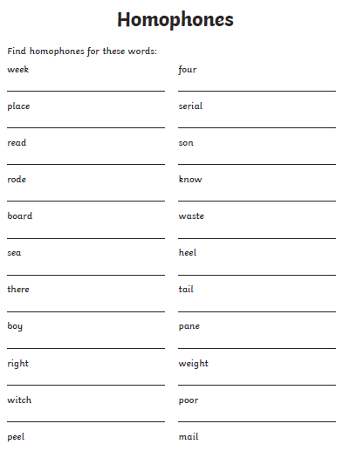
Blues & Reds
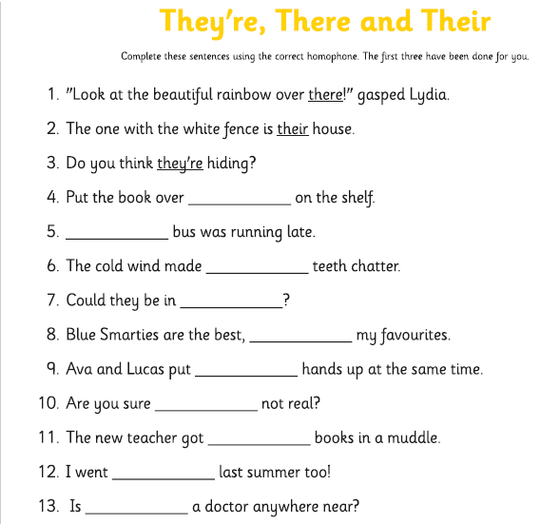
Optional tasks –
- Make a wordsearch using homophone words!
- Make a powerpoint all about homophones!
- Create a poster that helps you remember the rules for using to, two, too, there, their and they’re (see below)
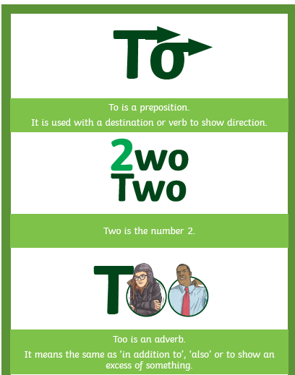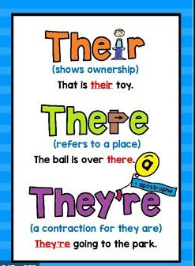

Maths – LI – to work out time intervals accurately.

SC
I can use a time line
I can find a start time and an end time

Starter - https://www.youtube.com/watch?v=0aOfUsBaQyU

Then look at Mr Muller’s examples...

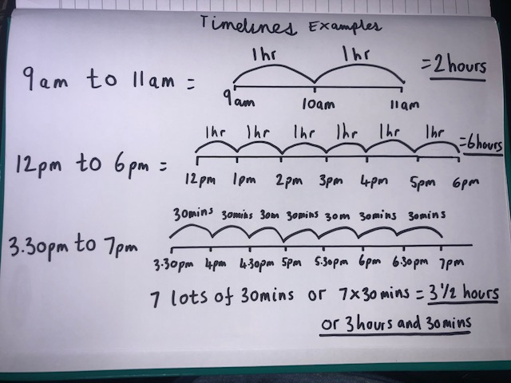

Main (draw a timeline for each question like Mr Muller has drawn above to work out the answer)

Circles -
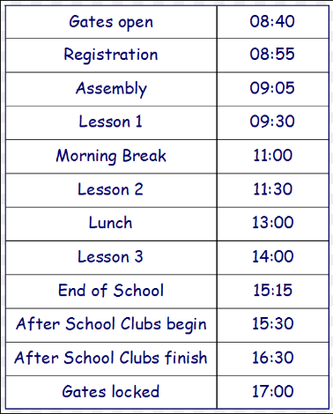
What is the time interval from Gates Open to Registration?
What is the time interval from Lesson 1 until Morning Break?
What is the time interval from End of School to After School Clubs finish?
What is the time interval from Lunch to Gates Locked?

Triangles
What is the time interval from Gates Open to Registration?
What is the time interval from Registration to Assembly?
What is the time interval from Assembly to Lesson 3?
What is the time interval from Morning Break to End of School?
What is the time interval from End of School to Gates Locked?
What is the time interval from Lesson 3 to Gates Locked?

Rectangles

What is the time interval from Gates Open to Registration?
What is the time interval from Lesson 1 to Gates Locked?
What is the time interval from Registration to Assembly?
What is the time interval from Assembly to Lesson 3?
What is the time interval from Morning Break to End of School?
What is the time interval from End of School to Gates Locked?
What is the time interval from Lesson 3 to Gates Locked?
What is the time interval from Lesson 2 to After School clubs finish?

RRS – Health Lesson
LI: To develop understanding of organisations and associations that contribute to our well-being.
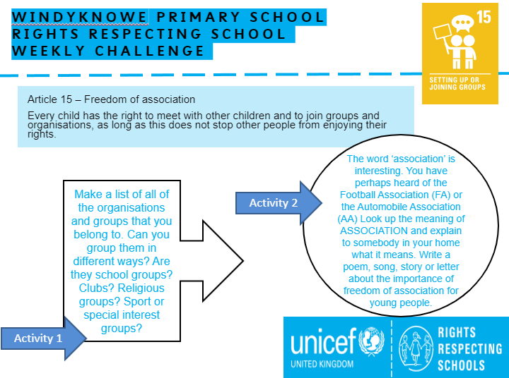

Music

Mr Muller has placed activities in your charanga inbox
This can be access here https://www.charangascotland.co.uk/yumu/login
If you are unable to access charanga and you don’t have a username or password, let Mr Muller know

