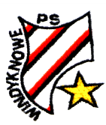

**Windyknowe**

**Primary School**

**Here are the things that I am a**

**little worried about:**

**Here are the things that my adults are concerned about:**

**Here are the things I am good at: **

**Nursery to Primary**

**Transition Passport**

***Name –***

***What I like to be called -***

***Nursery School –***

***Primary School -***

***Date of Birth –***

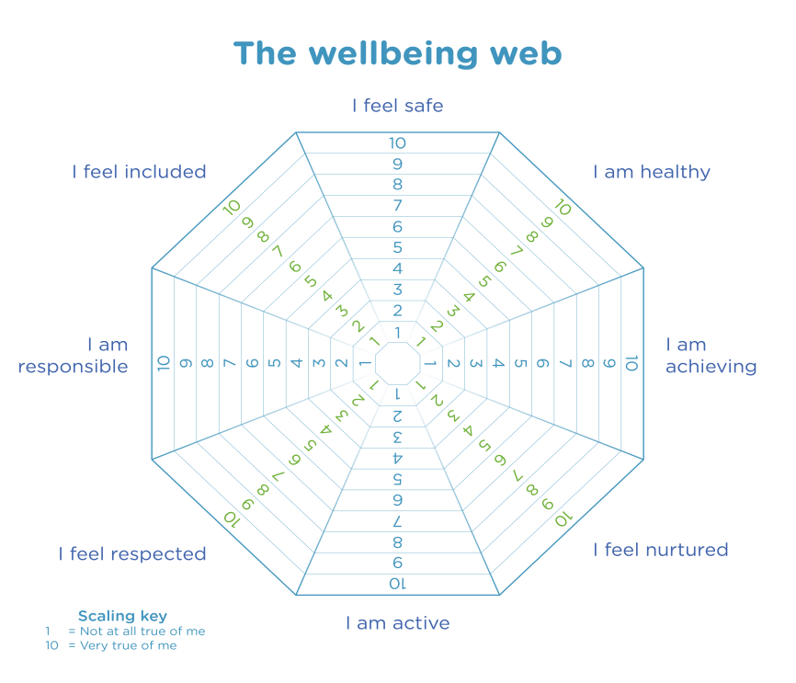

**I can do these things confidently** 

**by myself: (please tick or circle)**

* Use the toilet
* Open my snack and drink
* Change my shoes
* Fasten my coat
* Wipe/ blow my nose
* Use a knife and fork
* Ask for help

**These are things that would help me**

**if I am upset or worried:**

**My favourite activities at **

**Nursery: (please tick or circle)**

* Construction
* Water
* Sand
* Playdough
* Story Time / Books
* Outside Area
* Drawing
* Numbers
* Letters
* Art and Craft
* Role Play
* Playing with Small World
* Games and puzzles
* Music
* _____________________

***-***

**While I was learning at home I enjoyed….**

**While I was learning at home I did not enjoy…**

**These are the people and pets who** 

**live with me:**

**My medical information (if any):** 