Windyknowe Home Learning Tasks Date issued: Wednesday 3rd June 2020
Class P2 Maths
Maths Task 1 | Maths Task 2 | Maths Task 3
L.I. To display and read information on a pictogram  Click on the link below and have a go of creating your own pictogram online.  You can use the templates there or edit a template by clicking on the different headers and labels.  https://primaryschoolict.com/pictograph/#  You may wish to draw your pictogram instead of doing it online.  Here is one I created!  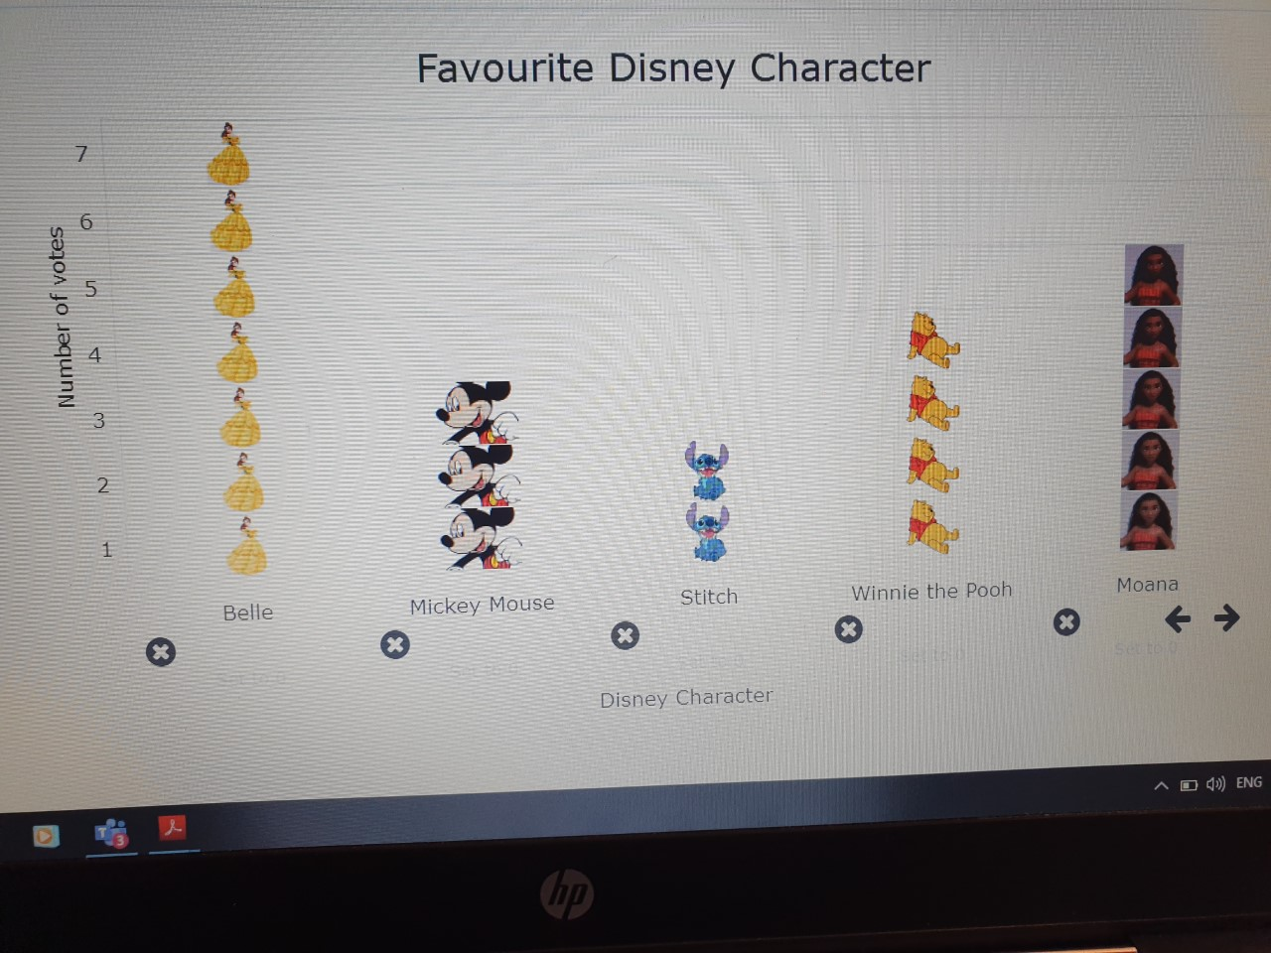  Who was the most popular Disney character? Who was the least popular?  How many people voted for Stitch?  How many more people voted for Moana than Mickey Mouse? | L.I. To create questions to find out information  Using the pictogram you have just created online or on paper, create questions you could ask about it.  Have a look at the questions I asked about my ‘Favourite Disney Character’ pictogram to help you.  Can you create 5 questions about your pictogram? Ask a family member your questions and see if they get the answers correct. | L.I. To begin to describe and plot basic grid references  Click on the link below and have a go of locating different places on a grid map. Think about the key language used over the past couple of weeks.  http://www.scootle.edu.au/ec/viewing/L350/index.html  Key Vocabulary might include: direction, turn, straight, forwards, backwards,  left, right, whole turn, half turn, move, journey

