Windyknowe Home Learning Tasks Date issued: Wednesday 3rd of June 2020
Class _________ Literacy
Literacy Task 1 | Literacy Task 2 | Literacy Task 3
We are learning to write an imaginative story about a castle adventure.  Your adventure must take place in a castle. When writing remember to have a clear beginning middle and end.  Before you begin make sure you have made a picture plan of what will happen in your story. Remember to include your character and castle which you wrote about in previous weeks.  Mrs Smyth’s group  You can also choose to do the activity below if you want to. You can choose to write your story using the template below. Remember to draw a picture to match each part of your story too! There is also a word bank to help you. | We are learning to write a castle adventure story with a clear beginning, middle and end.  Beginning- who is the story about? Is there any other characters involved? Where does it take place?  Middle- Something happens, maybe a mission or a problem comes about. Describe what happens what do the characters do? Where do they go?  End: How does the problem get solved/ mission end? Remember to come up with an exciting story to leave the reader wanting more! | Check back over your writing to make sure it makes sense.  Make sure you have included these things in your writing:

Story Frame

Title
First
Next
Then
Finally

Castle  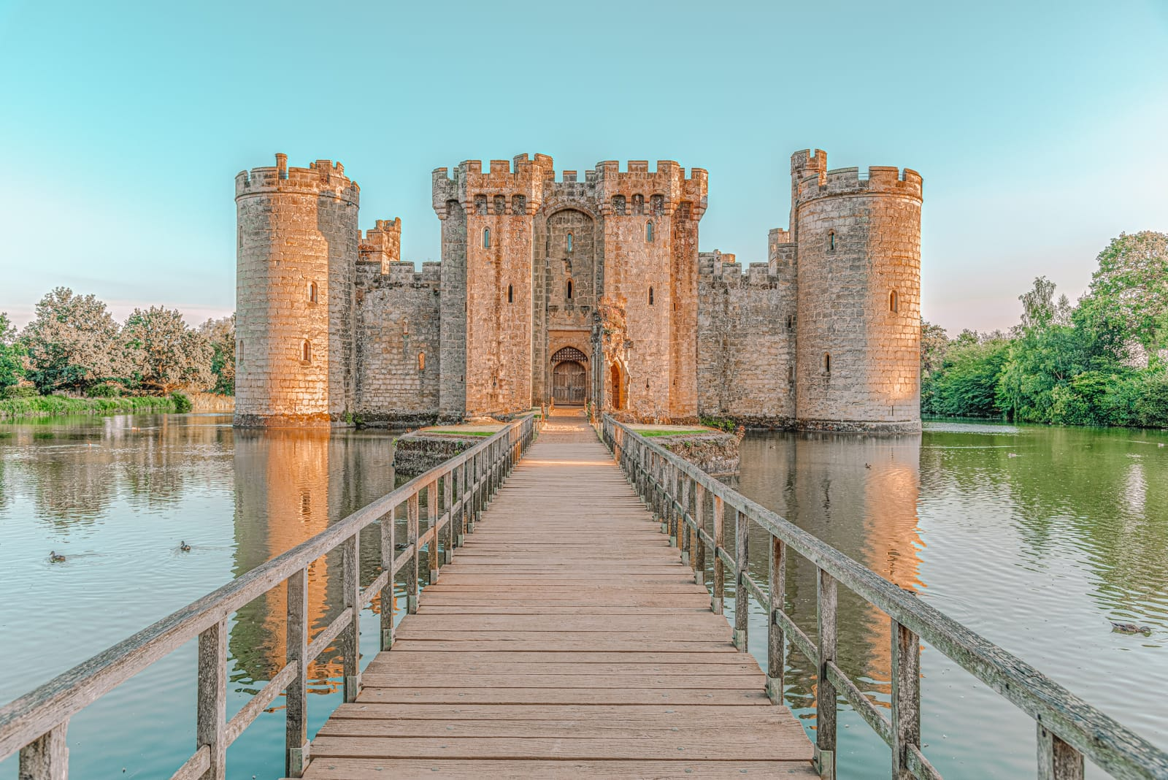 | Knight  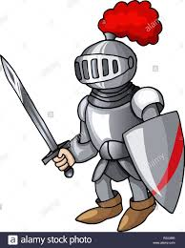 | Dragon  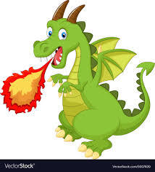
Princess  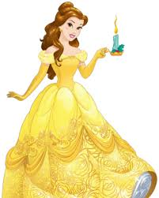 | Moat  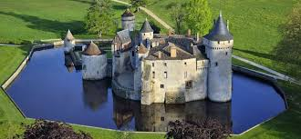 | Drawbridge  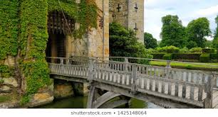
King  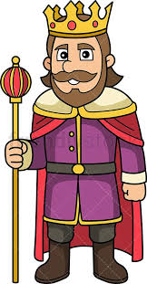 | Queen  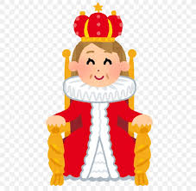 | Prince  