Wednesday 3.6.20
Here are your jobs for today:
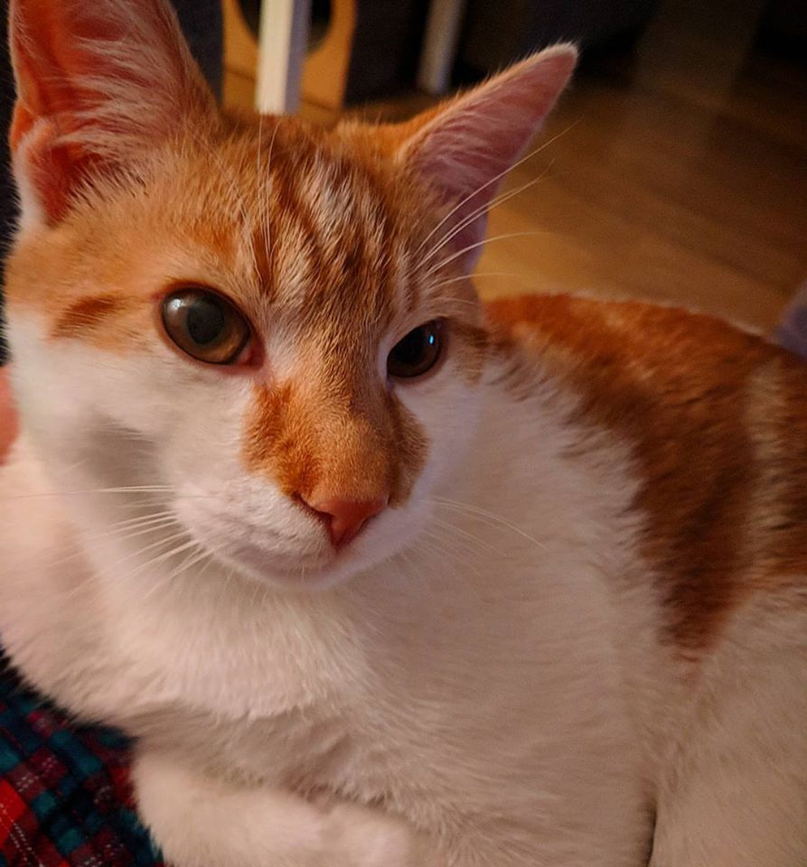
Literacy Comprehension
LI: to read for information about looking after a cat
Here is a passage all about cats! Read your group’s passage very carefully and answer the questions.
*Mild Passage & Questions
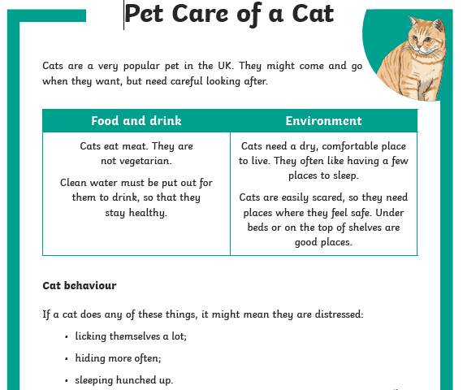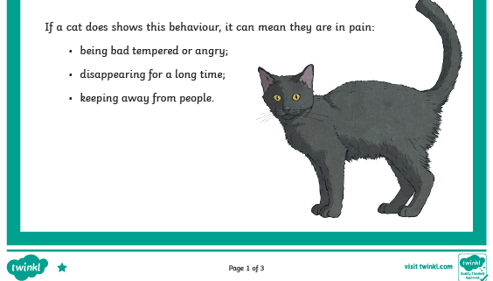

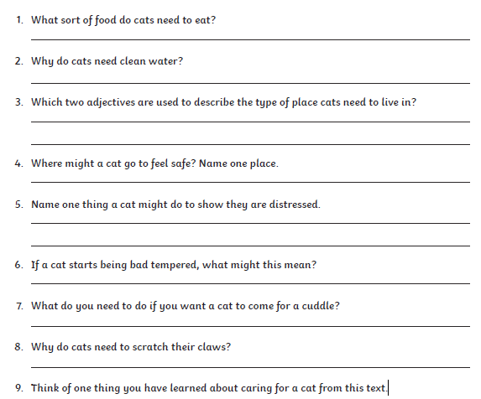

**Spicy
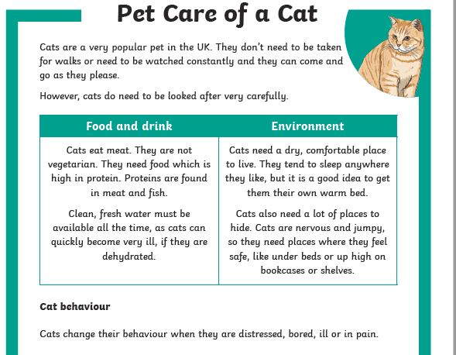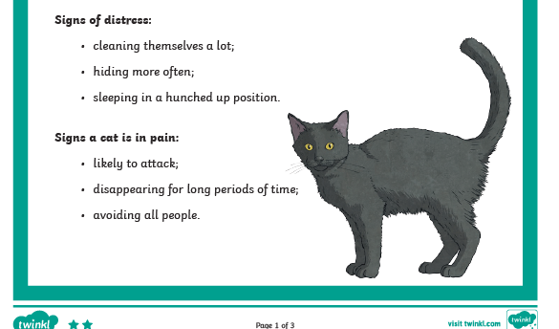
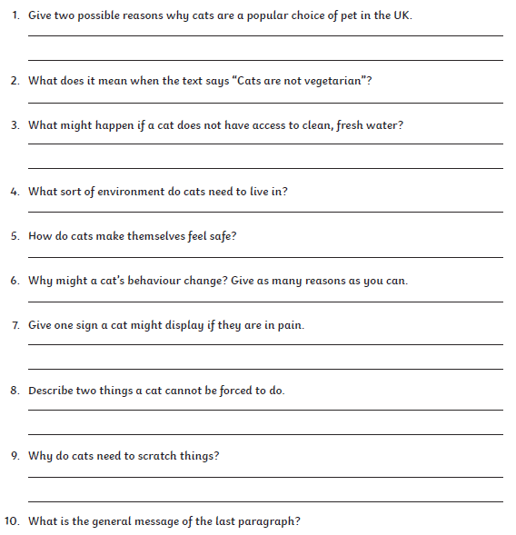***Hot
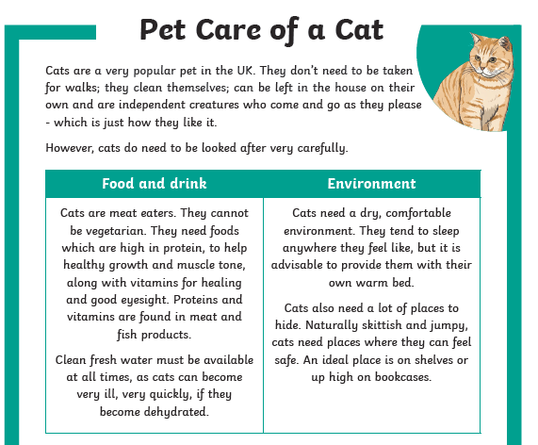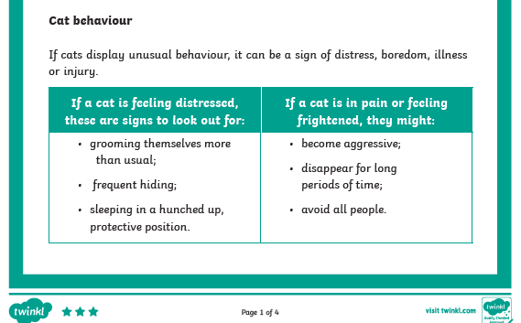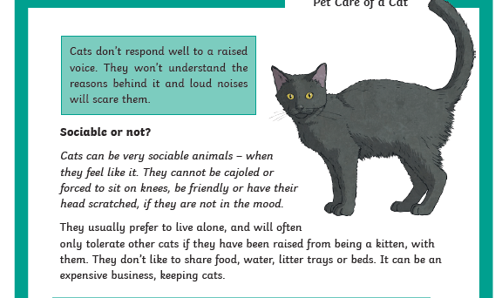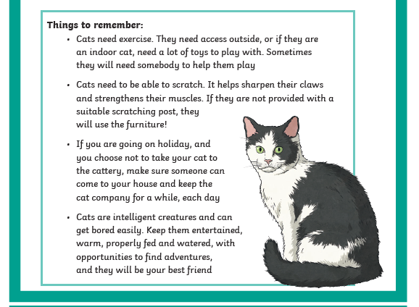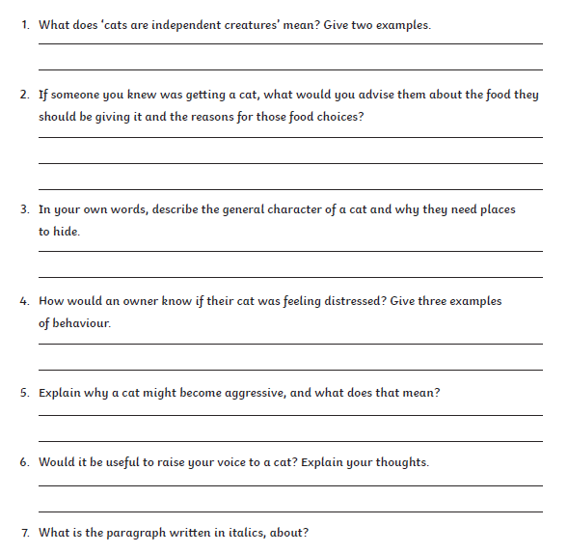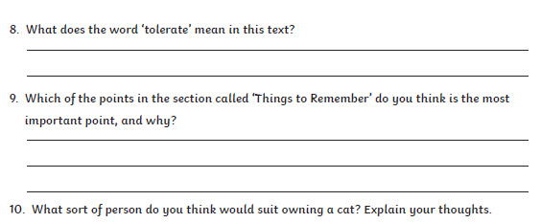
Numeracy
Rectangles: L.I- To be able to calculate improper fractions
Starter - https://www.youtube.com/watch?v=-imFslMIN1g
1) 4/2 2) 18/6 3) 15/3 4) 15/5 5) 44/4 6) 10/2
7) 25/5 8) 80/2 9) 30/6 10) 62/2 11) 48/4 12) 250/25
13) 105/5 14) 50/10 15) 70/14

Triangles: L.I- To be able to calculate a percentage
1) 50% of 60 2) 50% of 220 3) 1) 50% of 140
4) 25% of 40 5) 25% of 88 6) 25% of 80
7) 75% of 100 8) 75% of 1000 9) 75% of 20
10) 10% of 30 11) 10% of 40 11) 10% of 50
12) 5% of 120 (find 10%, then half it)

Circles: L.I- To be able to find simple percentages
1) 50% of 4 2) 50% of 10 3) 50% of 20
4) 50% of 30 5) 50% of 40 6) 50% of 42
7) 50% of 60 8) 50% of 150 9) 25% of 12
10) 25% of 40

Optional Tasks
- SumDog
- Active Learn Games

Art Task
L.I. To design an outfit
Before you begin you will need:
- some paper (or use your jotter)
- Something to draw with e.g. pens, pencils

Saturday the 6th of June is John Newlands Day (Bathgate Gala Day). Unfortunately the usual celebrations have had to be cancelled this year. Normally lots of people like to have new ‘Gala Day’ clothes to wear on this day, dress up or wear their best clothes.
Your Task: Design a ‘Lockdown’ Galaday outfit. It could be a just a t-shirt or a full outfit. Think about how we will know it is especially for this year. Will it include rainbows? Will your t-shirt have a slogan?

Optional Extension Task:
- Find out about John Newland and the history of the procession.
- Design and make lockdown Gala Day bunting.
- Design a fairground ride.

P.E - Superhero Training Academy!
*Pick a new selection of workouts, different from last week!
Have fun and remember to drink plenty of water
Let your teacher know what superhero workouts you tried!
Last week Miss Purdie tried – Supergirl and Thor!
Today I am going to try – Batman and Ironman! 😊
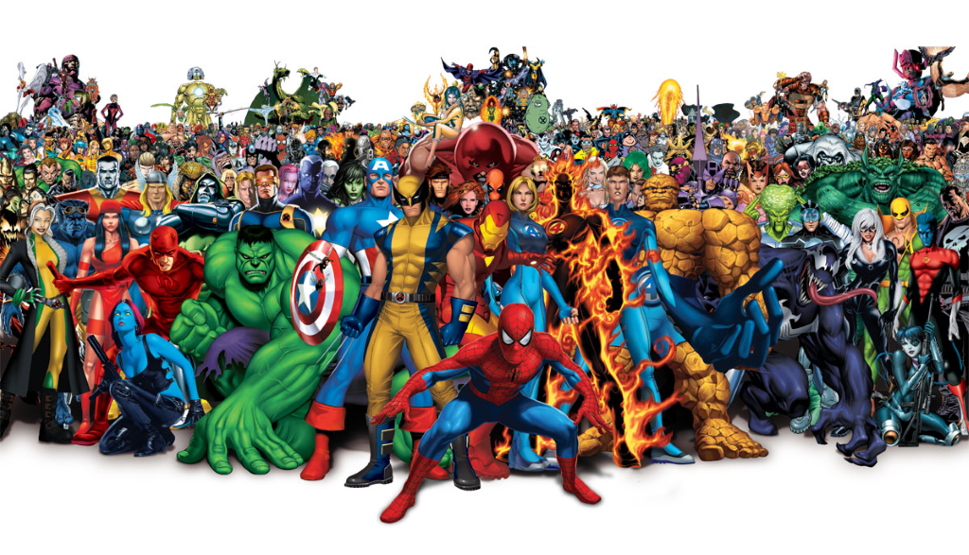
Avengers TABATA workout! - https://www.youtube.com/watch?v=jyWyBern6q4
Spiderman - https://www.youtube.com/watch?v=YC_V8hnU2PY
Thor - https://www.youtube.com/watch?v=c3oeoVsM95s
Star Lord - https://www.youtube.com/watch?v=H186QQvWXKw
Supergirl - https://www.youtube.com/watch?v=TGex6z_t4Mk
Tony Stark (Ironman) https://www.youtube.com/watch?v=udK_PRSeVPI
Black Panther - https://www.youtube.com/watch?v=9SDWArXm4mA
Captain America - https://www.youtube.com/watch?v=QL2C0X3Gx1U
Batman - https://www.youtube.com/watch?v=8dLNbAcMqzc

Music
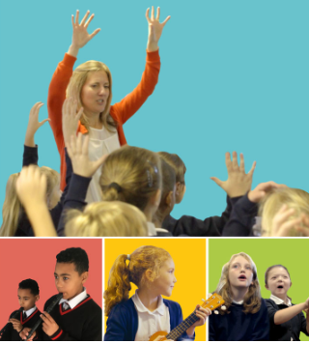
Mr Muller has placed new activities in your charanga inbox
This can be access here https://www.charangascotland.co.uk/yumu/login
If you are unable to access charanga and you don’t have a username or password, let Mr Muller know

