Monday 1.6.20   
Hello Primary 6! Today we have Literacy, Numeracy and Health. Remember Mrs Howard will also be posting tasks for today in your P.E channel on TEAMS.

Here are your jobs for today:

**Literacy (Spelling & Reading)**   
**LI:to identify and spell homophones**

Read the next chapter in your reading book or a book of your choice for around 30minutes. (If you are unsure what chapter you are on contact your teacher)

Optional  
Read a book of your choice.

**Spelling – homophones**  
Your main task is set below your common words for this week.  
  
If finished, you can also access: <https://www.topmarks.co.uk/english-games/7-11-years/spelling-and-grammar> and choose from a wide range of fun spelling activities and games! (Some may require flash to work)

|  |  |  |
| --- | --- | --- |
| **Mild** **due** **dew** **queue** **cue** **genes** **jeans** **made** **maid** | **Spicy**  **lesson** **lessen** **their** **there** **current** **currant** **duel** **dual** | **Hot** **principle** **principal**  **leased**  **least**  **aisle** **isle**  **accept**  **except** |

Task – Write a sentence for each set of homophone words including both in the one sentence.  
Example – **whole/hole**  
**The hunger felt like there was a hole in my tummy so I ate the whole pizza!**

**Health**

**L.I- To be able to express my thoughts and opinions**

* **Below are two inspirational quotes. Read each one carefully and take time to think about what it means.**
* **You can discuss with someone at home or post on Teams what you think.**
* **Answer the questions below each quote in your jotter and remember to write in sentences.**

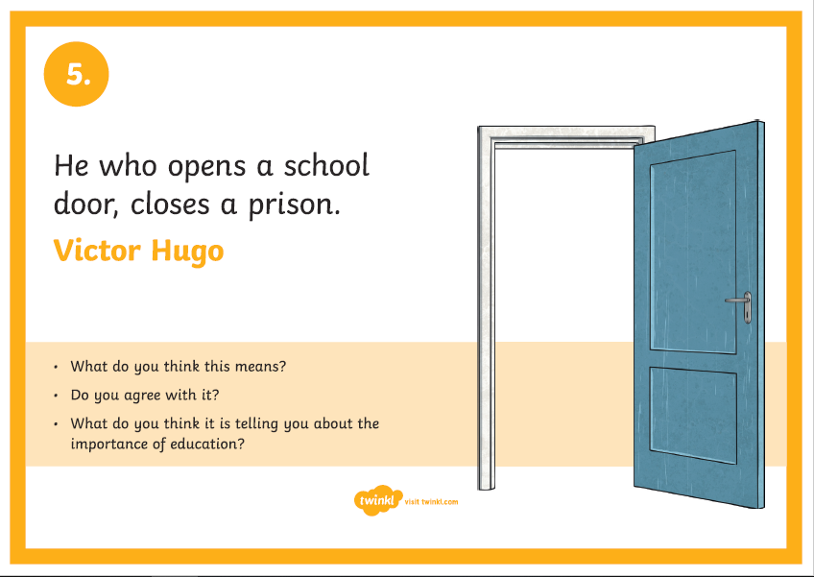

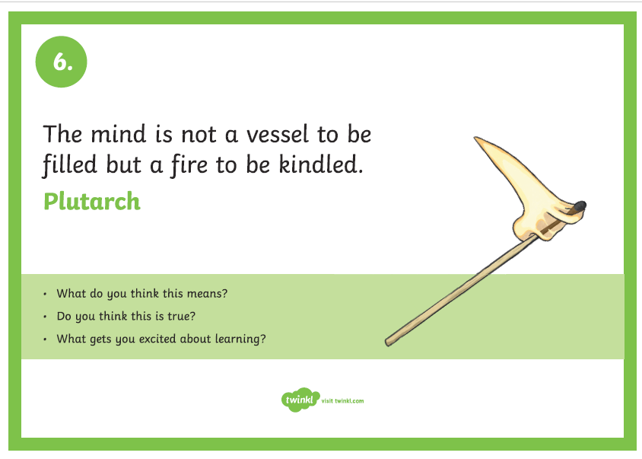

**Optional Extension Task**

1. **Research: Who was Victor Hugo and Plutarch?**

**Can you find three facts about each person?**

1. **Make up your own Inspirational quote and post on Teams. Write your quote and what it means.**

**Numeracy**

**L.I- To revise number concepts**

**Rectangles**

1. **Write the following in figures:**
2. Three hundred and forty one thousand six hundred and ten
3. Four hundred and sixty thousand one hundred and three

1. **Put these numbers in order starting with the smallest:**

530306 533060 510021 358640 452037 353370

1. **Find (mentally) the following:**
2. 136+461= b) 359 - 217= c) 547+321=
3. 819+250= e) 6310-1305= f) 2450-1410=

1. **Find (mentally) the following:**
2. 39 x 4= b) 29 x 7= c) 255 ÷100=

d) 197.1x10= e) 225.4 ÷100= f) 123.6÷100=

**5. Round these numbers to the nearest 100**

a) 3299 b) 45 367 c) 232 343 d) 924 376

**6. Write down the next three numbers in each of the following patterns:**

a) 100,200,400,800 b) 33,73,113,153

c) 309,315,321,327 d) 1000,930,860,790

**L.I- To revise number concepts**

**Triangles**

1. **Write the following in figures:**
2. Fifty six thousand four hundred and three
3. Seventy nine thousand six hundred and four

1. **Put these numbers in order starting with the smallest:**

20 206 18060 20025 18640 21037 21 370

1. **Find (mentally) the following:**
2. 37+72= b) 58 - 21= c) 74+22=
3. 89+45= e) 610-270= f) 450-310=

1. **Find (mentally) the following:**
2. 56 x10= b) 100 x 220= c) 145 x100=

d) 35.1 ÷10= e) 560 ÷100= f) 24.6÷10=

**5. Round these numbers to the nearest 10**

a) 88 b) 344 c) 2145 d) 673

**6. Write down the next three numbers in each of the following patterns:**

a) 1,2,4,8 b) 3,7,11,15

c) 9,15,21,27 d) 100,93,86,79

**L.I- To revise number concepts**

**Circles**

1. **Write the following in figures:**
2. Two thousand seven hundred and three

b) Six thousand six hundred and six

1. **Put these numbers in order starting with the smallest:**

2455 3547 6493 3700 2210

1. **Find (mentally) the following:**
2. 32+25= b) 55-31= c) 60+37=
3. 80+70= e) 320-100= f) 390-190=

1. **Find (mentally) the following:**

a) 32 x10= b) 10 x 43= c) 10 x 36=

d) 90 ÷10= e) 70 ÷10= f) 40÷5=

**5. Round these numbers to the nearest 10**

a) 271 b) 639 c) 214 d) 77

**6. Write down the missing number in each of the following patterns:**

a) 5,10,__,20,25 b)14,16,18,___, 22

c) ___, 60, 90,120,150 d) 41, __, 33, 29, 25

Music Monday



• Short videos that tell the story of *Fever!*  
*• Lyrics and teaching guides for pupils to practise each of 5 songs*  
*• New videos that help teach the accompanying choreography*  
*• A Curriculum for Excellence-based creative writing and science activities*  
*• Tips to make simple props and costumes*

[**www.scottishopera.org.uk/fever**](https://scottishopera.us14.list-manage.com/track/click?u=e22f567381737e921e1f0663e&id=54b7ecf400&e=6ebd889d3b)