**Friday 29.5.20**

**Literacy**

**Typing**

**L.I. To learn the position of each letter on a keyboard**

**Laptops:**

We’ve progressed onto Level 2 of Dance Mat Typing! Have a go at number 5 ‘w and o’ <https://toybox.tools.bbc.co.uk/activities/id/activity-dance-mat-typing-level2/exitGameUrl/http%3A%2F%2Fwww.bbc.co.uk%2Fguides%2Fz3c6tfr>

Make sure you have completed level 1 before you continue with level 2. Here is the link for level 1 if you need it:

<https://toybox.tools.bbc.co.uk/activities/id/activity-dance-mat-typing/exitGameUrl/http%3A%2F%2Fwww.bbc.co.uk%2Fguides%2Fz3c6tfr>

**Devices:**

<https://typetastic.com/learn2.html>

Begin with the home row activities in Unit 2. Make sure you press the keys with the correct fingers! These are colour coded for you. Happy typing!

ERVIC (Everyone reading virtually in class)

**LI - to identify key information from a written text.**

**SC – I can skim and scan my book for information.**

**Step 1:** Read a book at home (fiction or non-fiction) for at least 30 minutes.

**Step 2:** Answer the following questions in your green jotter. These questions focus on your ability to analyse a text.

1. What is the book about?
2. From whose point of view is the story being told?
3. What is happening in the story?
4. Which part of the story do you like best so far and write down why? For example, is the character different or unusual?

**Problem Solving**

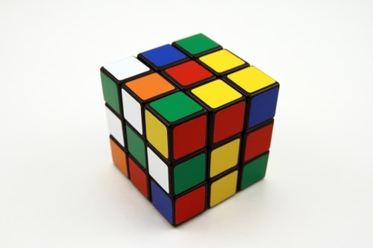

**L.I To draw a picture/diagram or L.I To act out a situation**

Today’s problem solving may cross 1 or 2 Learning Intentions (depending on what strategy you choose). Perhaps you used another of our strategies, please let me know!

Open your problem solving for the day and read the instructions carefully.

Mike has been baking and decorating biscuits. When adding the decorations, he has lined them up and added them in sequence.

Can you work out how many cookies had no decorations on them?

How many had all 3?

*Extension:*

*What times tables does this problem link to?*

*Make and decorate these cookies at home and see how your problem plays out in real-life!*