**Thursday 28.5.20**

**Literacy – Grammar**

**L.I. To identify verbs and adverbs**

Play verbs and adverbs charades with a member of your household. If there are more than three of you in your home, you may want to split into teams to make your game a bit more competitive!

**Instructions**

First, choose a verb and act it out for a member of your household. Once the verb has been guessed, then add an adverb.

E.g. *clean frantically*

Act out the verb *‘clean’* first of all. Once the guesser has answered this, then act out ‘*cleaning frantically*’.

**One point** for guessing the correct **verb**, and **two points** for guessing the correct **adverb**.

If you have forgotten what an adverb is, here is a video to remind you: <https://www.youtube.com/watch?v=StyV3acYm0g>

Here are some verbs and adverbs to choose from. You can use this list to give you some ideas, or you can come up with some of your own.

**Verbs**

|  |  |  |  |
| --- | --- | --- | --- |
| argue | attack | carry | celebrate |
| clean | climb | count | cry |
| cut | dig | drink | drive |
| drop | eat | enjoy | examine |
| fall | fight | fold | grab |
| jump | kick | kiss | knock |
| laugh | lead | leave | listen |
| open | paint | perform | play |
| point | pray | run | scream |
| search | shout | shake | shut |
| sing | sleep | speak | step |
| study | sweep | talk | taste |
| teach | think | threaten | throw |
| touch | walk | wash | wave |
| wipe | work | worry | write |

**Adverbs**

|  |  |  |  |
| --- | --- | --- | --- |
| accidentally | angrily | anxiously | badly |
| blindly | bravely | briefly | busily |
| calmly | carelessly | cautiously | courageously |
| doubtfully | easily | elegantly | enthusiastically |
| fiercely | foolishly | frantically | gently |
| gladly | gracefully | greedily | happily |
| hastily | hungrily | innocently | inquisitively |
| lazily | loudly | madly | merrily |
| mysteriously | neatly | nervously | noisily |
| obnoxiously | politely | quickly | quietly |
| rapidly | recklessly | reluctantly | rudely |
| sadly | selfishly | seriously | shyly |
| silently | sleepily | slowly | solemnly |
| speedily | suspiciously | swiftly | thoughtfully |
| victoriously | violently | wearily | wildly |

**Have fun!**

**Maths**

Number Ninjas / Maths Magicians

L.I To calculate half price

Watch this video first. It revises how to find a half of a number

<https://youtu.be/eruIqB1SUx0>

Look over your group’s worksheet. All the items on the page have been reduced in a sale to half price! Can you calculate their new price?

**Extension: Log in to Sumdog and play the Maths Challenge I have set you. You have 30 questions focused on Money to answer. This will earn you 30 coins for your house!**

**Mathletes**

**L.I To estimate the price of goods**

**Look over your group’s worksheet PPM 150. Today you are being asked to estimate the cost of items in everyday life and draw them. If you are unsure of how much something may cost, use the internet to guide your research.**

**Read carefully the descriptions of what you have to draw inside the boxes and then draw an item that you think would fit. E.g. Draw an item worth about £1000 that people keep outside – a car has been drawn but there are lots of answers! You may even draw a couple of things.**

**Draw your answers in your green jotter**

**Extension: Have a go at any of these money games** <https://www.topmarks.co.uk/maths-games/7-11-years/money>

**Algebros**

**L.I To compare special offers**

**Look over your group’s worksheet PPM153. It has lots of special offers on it, however some may not be as good as they seem at first! Use your skills to calculate the actual price of each item and select what is actually the best offer (and cheaper!).**

**Extension: Log in to Sumdog and play the Maths Challenge I have set you. You have 30 questions focused on Money to answer. This will earn you 30 coins for your house!**

**Art**

**L.I. To follow instructions carefully**

Have a go at making origami monster bookmarks!

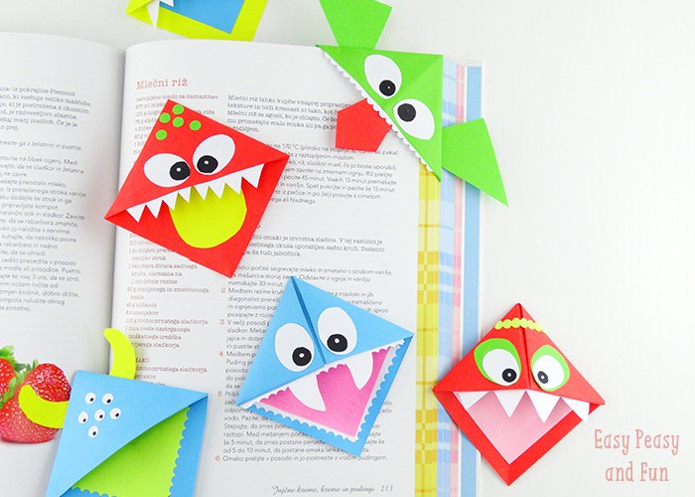

You will need:

You will need a sheet of paper (preferably origami paper), scissors and decorations and glue to make the monster or any other creature your heart desires. The decorations can be made from paper.

**Instructions:**

Start by folding the paper in half .

Fold the left and right corner to the centre point. Cut off the excess part and cut through the middle so that you get two triangles.

Unfold them – you’ve gotten yourself two squares that will soon turn into two monster bookmarks!

Fold the square in half – you’ll get a rectangle – fold in half again and you’ll get a smaller square. Unfold it.

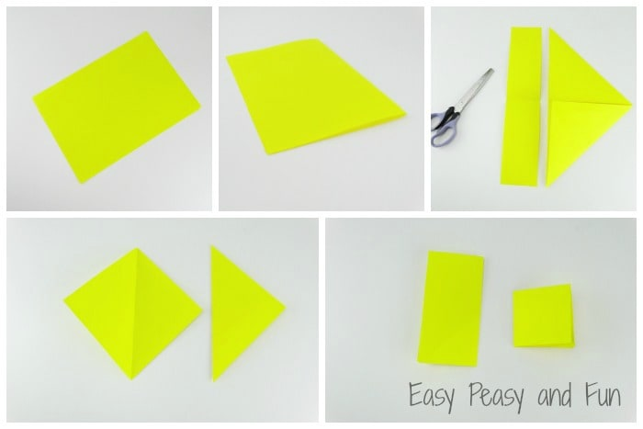

As you’ve unfolded the small square you’ll see 4 small squares inside the unfolded square – cut one out as shown on the picture bellow.

Now cut the adjacent two squares from the one you’ve cut out as shown on the picture (diagonally through the square).

Fold the little triangles inward – apply some glue to the inner one and you’re done!

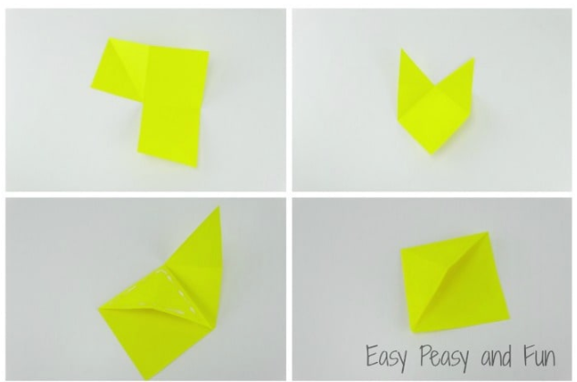

All that’s left to do is to cut some eyes, tongues, teeth, tentacles, horns… And glue them onto your monster!

If you would rather follow the instructions from a video instead, you can watch this: <https://www.youtube.com/watch?v=YVkJPCp_1UQ>

I can’t wait to see your finished monsters!