**Thursday 28.5.20**

**Good morning everyone! Here are your tasks for today 😊**

**Punctuation and grammar**

LI: to develop understanding of homophones  
  
**Warm up - Play this fun homophone matching game from last week:**   
<https://www.learninggamesforkids.com/vocabulary-games/homophones-games/homophones.html>   
  
**See your tasks below for your groups!**

**Greens**  
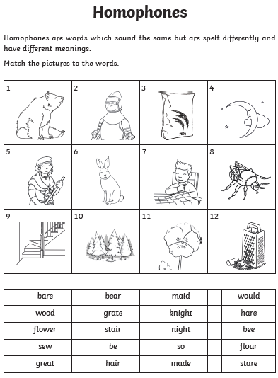

**Blues & Reds**  
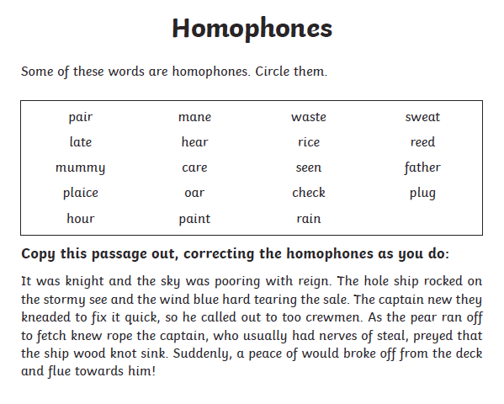Optional tasks –

* Have a look at your reading book or book of choice at home, can you spot any homophones? Note them down in your jotter!
* Make a wordsearch using homophone words!
* Complete the wordsearch below (You can print or just spot them on the screen!)   
  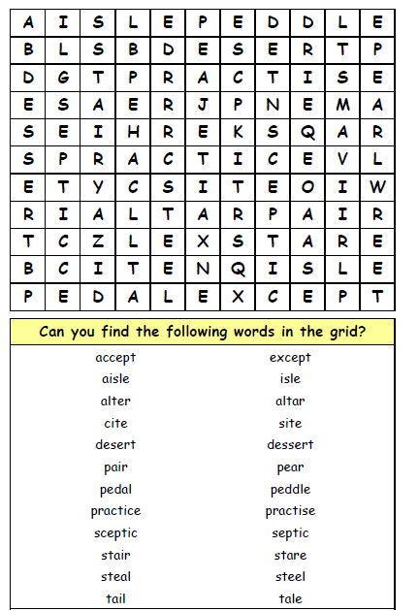

**Maths – LI – to work out time intervals accurately.**

**SC**

**I can use a time line**

**I can find a start time and an end time**

**Starter -** <https://www.youtube.com/watch?v=0aOfUsBaQyU>

Then look at Mr Muller’s examples...

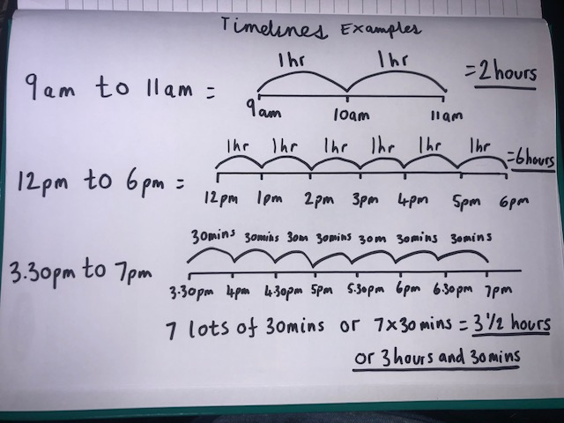

**Main** (draw a timeline for each question like Mr Muller has drawn above to work out the answer)

**Circles -**

**9am to 12pm**

**7am to 11am**

**6am to 2pm**

**11am to 4.30pm**

**6pm to 9.30pm**

**Triangles**

**8am to 11.30am**

**7pm to 1.30pm**

**2.30pm to 3.30pm**

**6am to 12.45pm**

**2.30pm to 6.30pm**

**1.30pm to 7.45pm**

**Rectangles**

**1.15pm to 7.45pm**

**1.30pm to 6.30pm**

**8.15am to 12.30pm**

**12.15pm to 6.30pm**

**2pm to 10.45pm**

**9.15pm to 00.15am (quarter past midnight)**

**1.45am to 11.45am**

|  |
| --- |
| **RRS – Health Lesson**  LI: To understand the importance of healthy diet and exercise |

**Music**



**Mr Muller has placed activities in your charanga inbox**

This can be access here <https://www.charangascotland.co.uk/yumu/login>

If you are unable to access charanga and you don’t have a username or password, let Mr Muller know