Wednesday 27.5.20

Good morning Primary 6!   
Here are your jobs for today.

**Literacy Comprehension**  
**LI: to read for information about looking after a dog**

Have you got a dog? Do you want a dog? Here is a passage all about dogs and how to take care of them! Read your group’s passage very carefully and answer the questions.  
*Mild passage & questions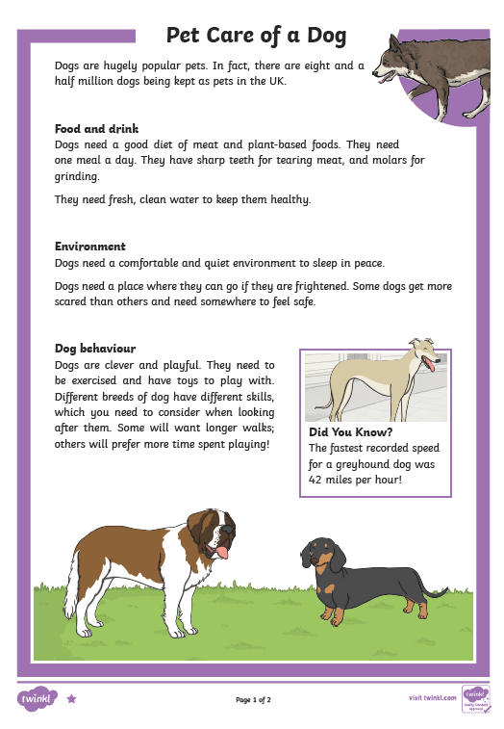

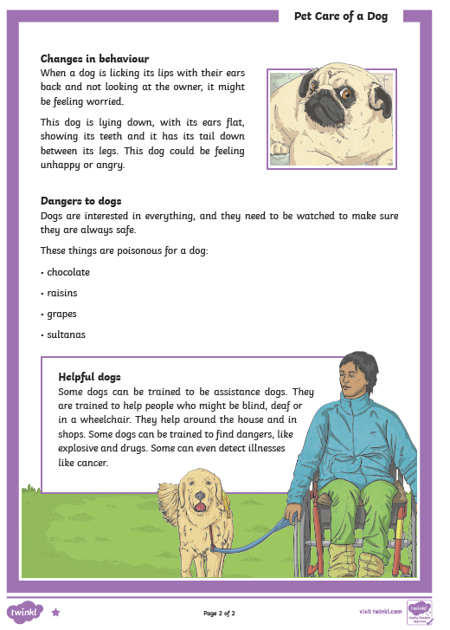

|  |
| --- |
| 1. How many dogs are kept as pets in the UK? 2. What do dogs have to help them eat meat? 3. Which two adjectives describe the type of environment dogs need to be able to sleep well? 4. Why might some dogs need a safe place to go to? 5. Name three activities that dogs need to be able to do to stay happy and healthy. 6. Describe two things an unhappy or angry dog might do.  7. Why should you not give a dog raisins or grapes?  8. Name two jobs that dogs could be trained to do to help people.  9. Which fact has surprised you the most? |

** Spicy passage and questions 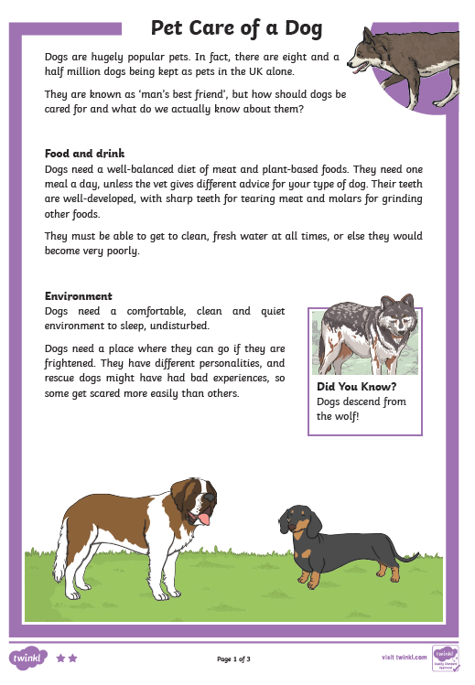

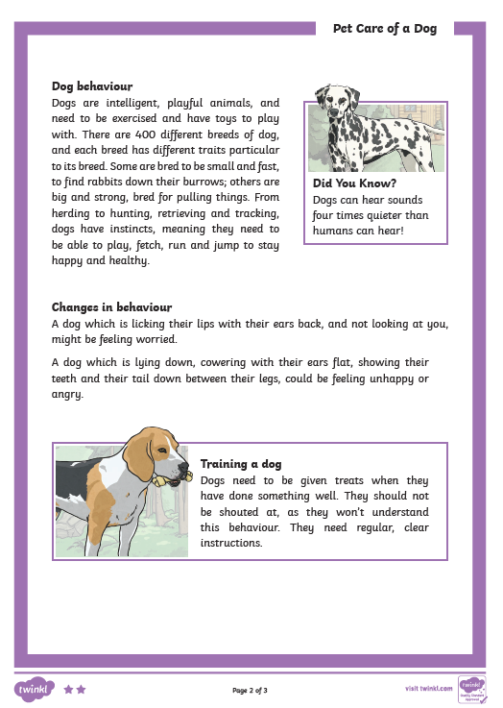 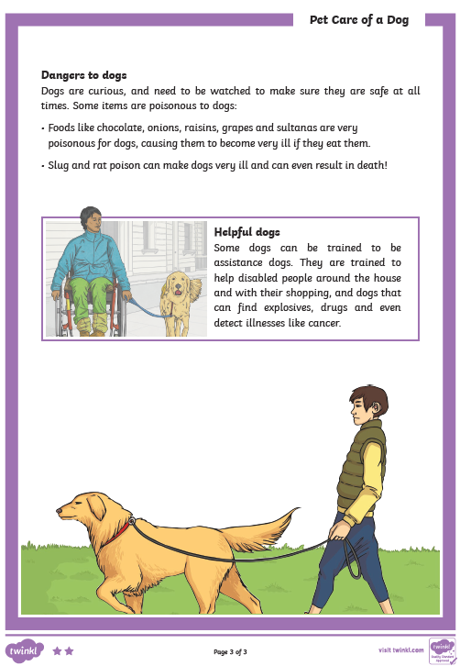

|  |
| --- |
| 1. How do we know dogs are a popular pet in the UK? 2. Describe what and how you would feed a dog. 3. Name two factors which might contribute to why some dogs might get scared. 4. What might a dachshund have the right characteristics for, and why? 5. Imagine you are a vet. An owner brings their dog in and says the dog keeps looking around, lies down a lot and is licking its lips more than usual. What might be wrong with it and how do you know?   6. Which two points in the section Training a Dog do you think are the most important, and why?  7. What word has the author used which means that dogs are interested in things?  8. Why should you not feed a dog chocolate buttons?  9. How could a dog help a person in a wheelchair in their home?  10. Instead of this text being called “Pet Care for Dogs”, think of a different title. |

***Hot Passage and questions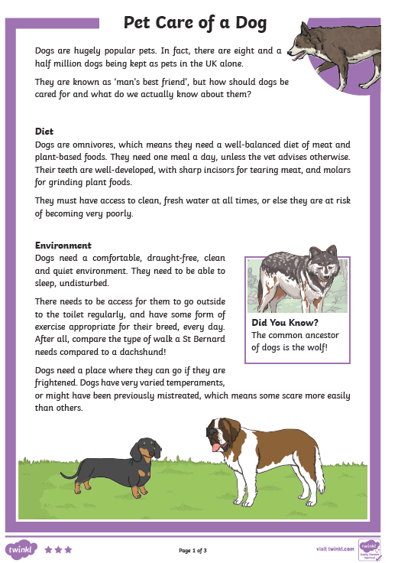

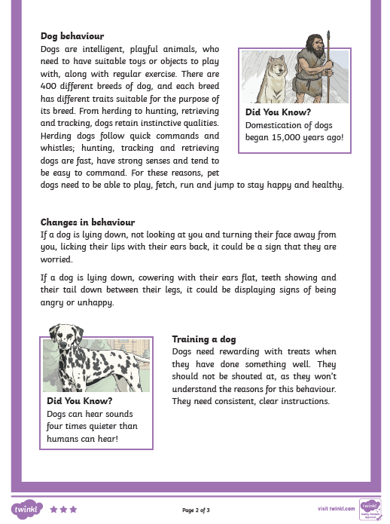 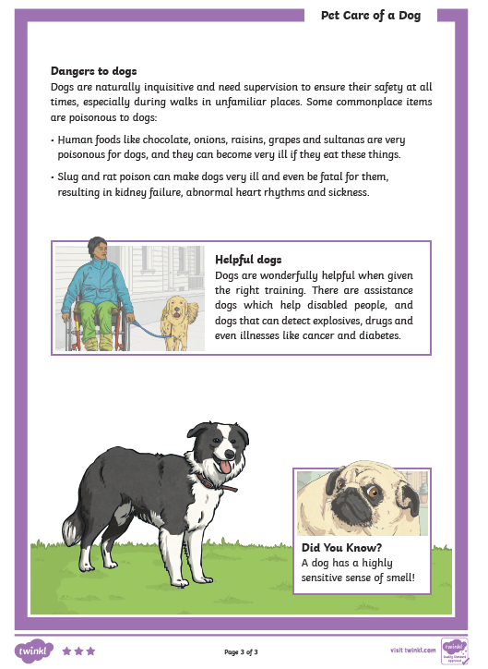

|  |
| --- |
| 1. Explain how a dog’s teeth suit the diet it needs. 2. What other word could have been used instead of ‘undisturbed’? 3. Why does the exercise a dog has need to be ‘appropriate to their breed’? 4. In your own words, explain why some dogs might get scared more easily than others.   5 For how long have dogs been kept as pets?  6 Describe what sort of traits you might expect a dog bred for hunting, might have, and why. 7. Give three main instructions on how someone should train their dog.  8. Explain in detail why dogs need watching carefully if taken on a walk in an area they haven’t been before.  9. If you were a vet and someone brought their dog in which had been sick, what three questions would you ask the owner to try to establish why the dog is ill? |

**Numeracy**

**Rectangles**: L.I- To be able to calculate improper fractions

Starter - <https://www.youtube.com/watch?v=-imFslMIN1g>

1) 10/5 2) 12/6 3) 14/10 4) 12/2 5) 40/10 6) 10/1

7) 150/15 8) 80/2 9) 27/3 10) 16/4 11) 30/5 12) 250/2

13) 15/200

**Triangles**: L.I- To be able to calculate a percentage

1) 50% of 40 2) 50% of 190 3) 1) 50% of 1800

4) 25% of 12 5) 25% of 4000 6) 25% of 600

7) 75% of 3000 8) 75% of 2000 9) 75% of 1000

10) 10% of 120 11) 10% of 450 11) 10% of 760

12) 5% of 500

**Circles**: L.I- To be able to find simple percentages

1) 50% of 16 2) 50% of 34 3) 50% of 66

4) 50% of 102 5) 50% of 168 6) 50% of 222

7) 50% of 184 8) 50% of 5000 9) 25% of 20

10) 25% of 80

**Optional Tasks**

* SumDog
* Active Learn Games

**Art Task**

**L.I. To be able to design a sculpture**

**Before you begin you will need:**

* **some paper (or use your jotter)**
* **Something to draw with e.g. pens, pencils**

**Your task today is to design a sculpture in the style of Andy Scott**

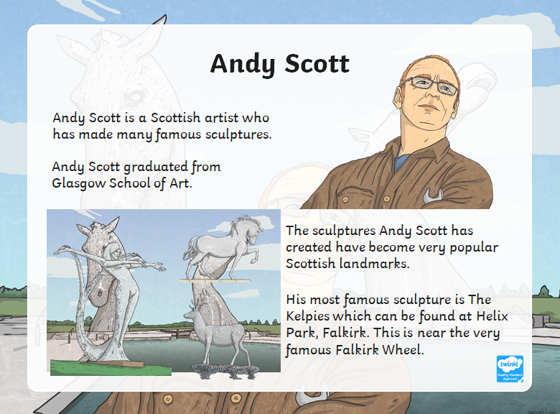

1. **Read through the Andy Scott PowerPoint saved in TEAMS-Files Section-Art Folder.**
2. **Imagine you have to design a Sculpture for our school playground. The title is ‘The Windyknowe Way’ and it needs to include an animal or a person. What would it look like? What would it be made of?**

**Optional Extension Task:** Create a fact file about Andy Scott.

|  |
| --- |
| P.E - Superhero Training Academy! Choose from the following selection of workouts! Have fun and remember to drink plenty of water  Let your teacher know what superhero workouts you tried!  Avengers TABATA workout! - <https://www.youtube.com/watch?v=jyWyBern6q4>Spiderman - <https://www.youtube.com/watch?v=YC_V8hnU2PY>Thor - <https://www.youtube.com/watch?v=c3oeoVsM95s>Star Lord - <https://www.youtube.com/watch?v=H186QQvWXKw>Supergirl - <https://www.youtube.com/watch?v=TGex6z_t4Mk>  Tony Stark (Ironman) <https://www.youtube.com/watch?v=udK_PRSeVPI>Black Panther - <https://www.youtube.com/watch?v=9SDWArXm4mA>Captain America - <https://www.youtube.com/watch?v=QL2C0X3Gx1U>Batman - <https://www.youtube.com/watch?v=8dLNbAcMqzc> |

**Music**



**Mr Muller has placed new activities in your charanga inbox**

This can be access here <https://www.charangascotland.co.uk/yumu/login>

If you are unable to access charanga and you don’t have a username or password, let Mr Muller know