**Tuesday 26.5.20**

Hello Primary 6! Here are your jobs for today:

|  |
| --- |
| **Writing - LI: to write a short autobiography** Task 1) You are going to write a piece all of you! You will include information about your life and stories you want to share, this is also known as an autobiography. **Please do not include any surnames or addresses**! In your autobiography you could include:   * Your name (any middle names) * Where you were born * Your hobbies and interests * Your school life (favourite subjects, highlights of school life that you have enjoyed so far like the Queen show etc.) * Your aspirations for the future   Task 2) Draw the front cover of what your autobiography would look like. What would the title of your autobiography be? Here are some examples to get you thinking! |

**Numeracy - L.I-To be able to answer multiplication, division and percentage questions quickly and accurately**

***Play Loop Cards*** <https://www.topmarks.co.uk/Flash.aspx?f=loopcardsv6>

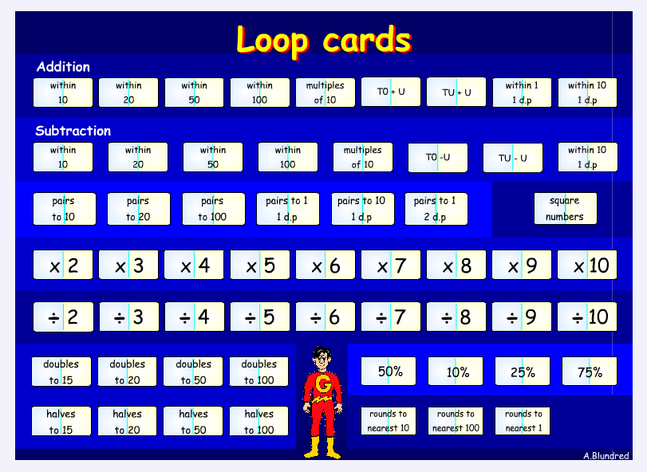

**Rectangles**- Complete 4 division tasks, 3 multiplication tasks and 2 percentage tasks

**Triangles**- Complete 3 division tasks, 2 multiplication tasks and 1 percentages tasks.

**Circles-** Complete 2 divisions tasks, 2 multiplication tasks and finding 50% tasks.

**** Try to play each game at least twice to see if you can improve your score. You can play as many times as you like.

If you can please post your best score on Teams to let us know how you do.

***Please Note: You may need to allow Flash for this game to work.***

***Optional*** *Additional Tasks*

* Active Learn Games- select from the games allocated to you. You can select your own level of difficulty in each game.
* Sumdog
* Explore other games on Topmarks. There are different categories to choose from. You can choose the level of difficulty on most of these.

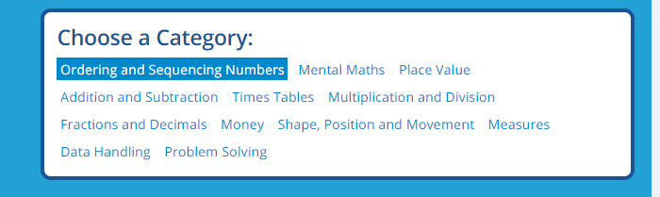

Topic

LI – to research key facts about the ‘Pink exoplanet’.

Starter – can you click on the following link and spot where the International Space Station is? Which country or ocean is it over? Write answers in your green jotter. <https://spotthestation.nasa.gov/tracking_map.cfm>

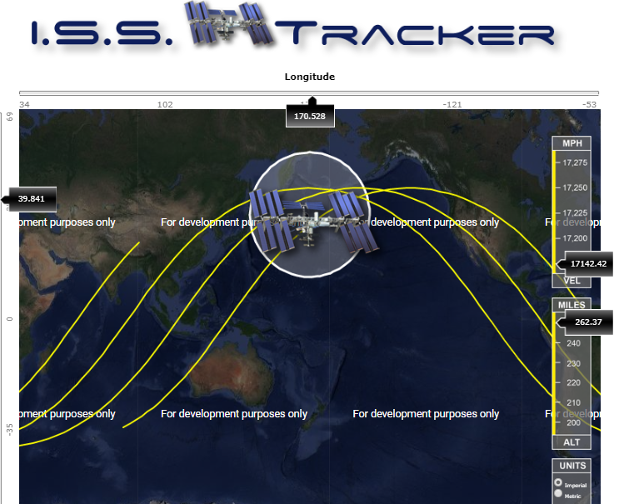

**Topic Task**

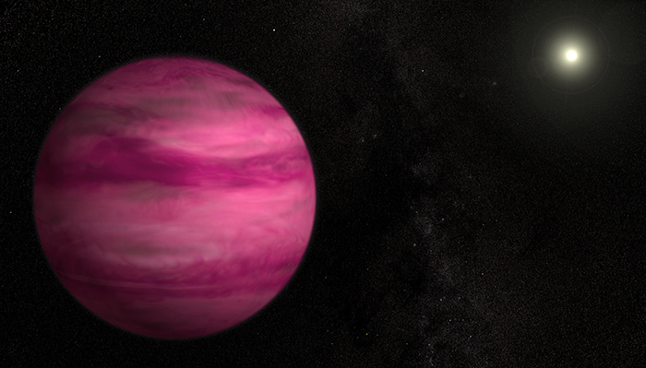

**Starter** – use a dictionary to find out these key words and write them down in your green jotter.

*Spherical -*

*Lightyear -*

**Main** – watch this clip detailing the key features of the ‘Pink exoplanet’

<https://www.youtube.com/watch?v=b08ozD77yvo>

Use this website also

<https://www.natgeokids.com/uk/>

Mild – find 5 key facts about the Pink exoplanet’

Spicy - find 7 key facts about the Pink exoplanet’

Hot - find 10 key facts about the Pink exoplanet’

**Plenary** – think of 4 ways this planet is different to ours. Type your answers on Microsoft Teams so Mr Muller and Miss Purdie can see your answers.

Music



• Short videos that tell the story of *Fever!*  
*• Lyrics and teaching guides for pupils to practise each of 5 songs*  
*• Videos that help teach the accompanying choreography*  
*• A Curriculum for Excellence-based creative writing and science activities*  
*• Tips to make simple props and costumes*

[**www.scottishopera.org.uk/fever**](https://scottishopera.us14.list-manage.com/track/click?u=e22f567381737e921e1f0663e&id=54b7ecf400&e=6ebd889d3b)