**Accessing Espresso Coding**

Our technology block for the next few weeks will be focusing on Coding. Coding is a way of giving instructions to a computer to perform a task. You may have also heard called “software programming” or “computer programming.” These instructions are communicated using a “computer language” that computers can understand and this what we will be learning to do.

To learn how to Code we will be using the Espresso website. You should already have a note of the username and password. Follow the instructions to log on to the website

<https://www.discoveryeducation.co.uk/what-we-offer/discovery-education-espresso>

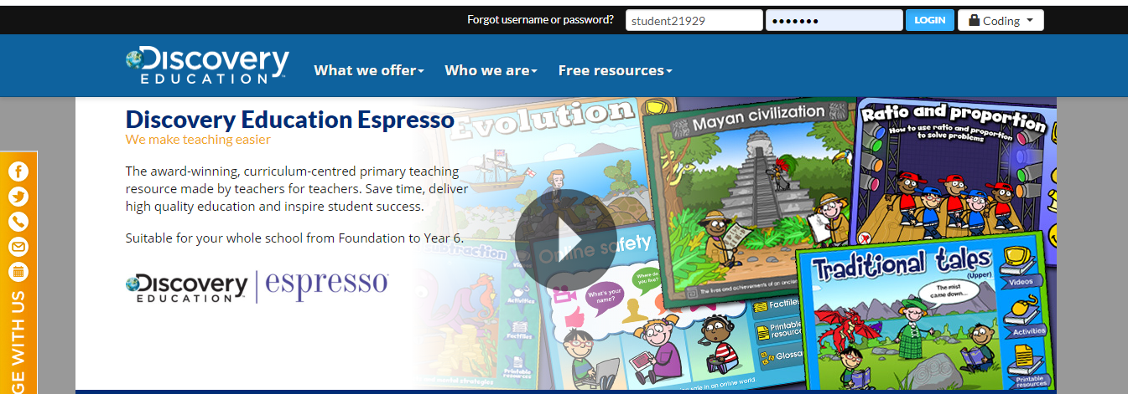

1/ Click on the link above and select “Coding” from the drop down menu in the top right corner. Complete the user name and password given

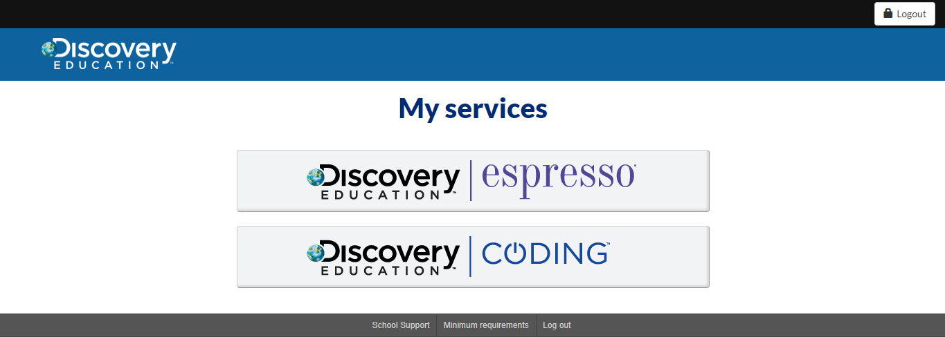

2/ On the next screen, select Discovery Education Coding

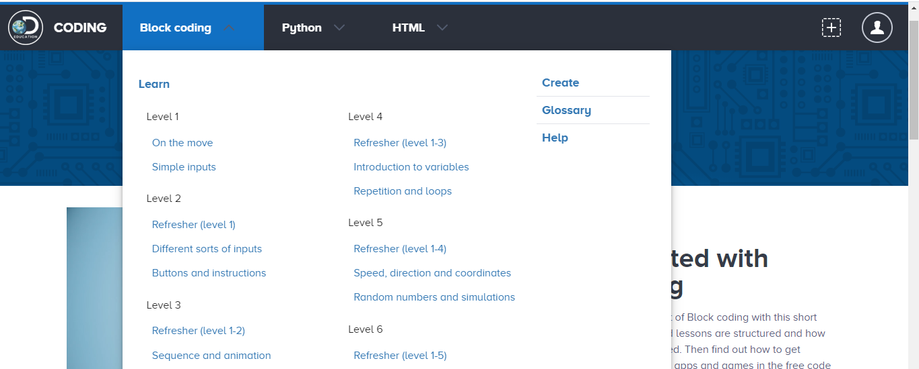

3/ On the next Screen, Click Block Coding from the Drop Down box at the top of the screen and choose Level 1 – On the Move