Monday 25.5.20   
Hello Primary 6! Today we have Literacy, Numeracy and Health. Remember Mrs Howard will also be posting tasks for today in your P.E channel on TEAMS.

P6p – Miss Purdie will be going LIVE at 1.30 today for more Harry Potter and the Philosopher’s Stone

Here are your jobs for today:

**Literacy (Spelling & Reading)**   
**LI:to identify and spell common words**

|  |
| --- |
| Read the next chapter in your reading book or a book of your choice for around 30minutes. (If you are unsure what chapter you are on contact your teacher)  *Optional Read a book of your choice. |

Spelling – common words   
Your main task is set below your common words for this week.  
  
If finished, you can also access: <https://www.topmarks.co.uk/english-games/7-11-years/spelling-and-grammar> and choose from a wide range of fun spelling activities and games! (Some may require flash to work)

|  |  |
| --- | --- |
| **Mild**  little  work  know  place  years | **Spicy & Hot** atmosphere  convenience enquire  inference  participation |

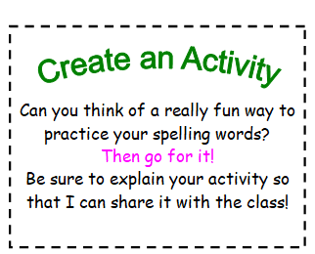 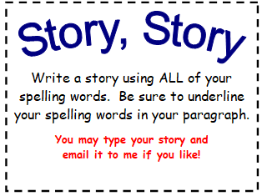

**Health**

**L.I- To be able to express my thoughts and opinions**

* **Below are two inspirational quotes. Read each one carefully and take time to think about what it means.**
* **You can discuss with someone at home or post on Teams what you think.**
* **Answer the questions below each quote in your jotter and remember to write in sentences.**

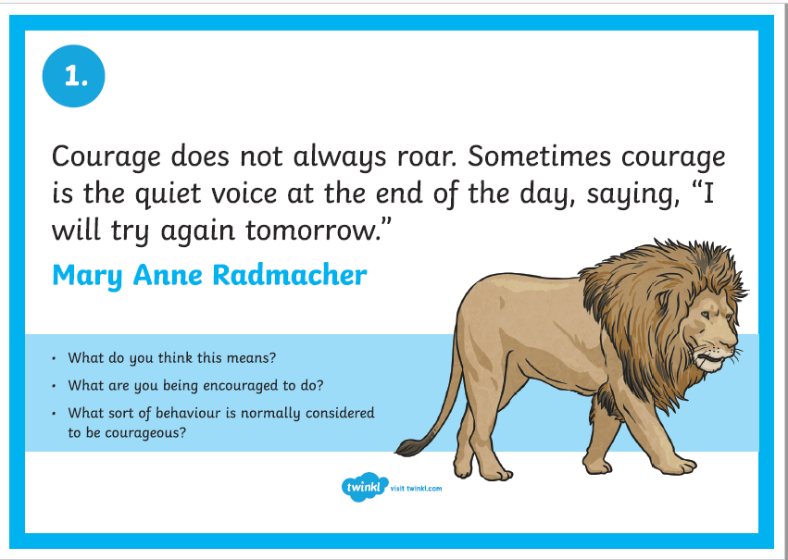

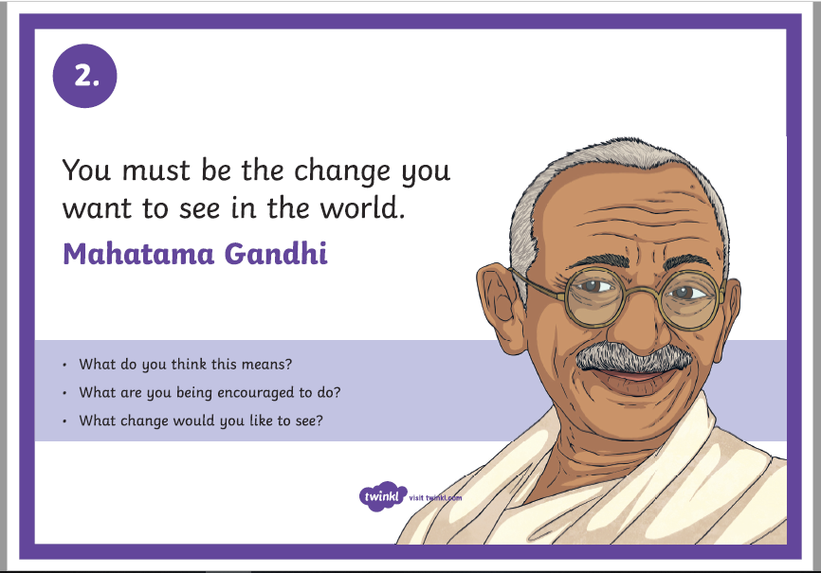

**Optional Extension Task**

1. **Research: Who was Mahatama Gandhi?**

**Can you find three facts about him? The link below will help you:**

<https://www.ducksters.com/biography/mohandas_gandhi.php>

(at the bottom of this page you can choose for the passage to be read to you and there is a quiz you can complete)

1. **Make up your own Inspirational quote and post on Teams. Write your quote and what it means.**

**Numeracy**

**L.I- To revise number concepts**

**Rectangles**

1. **Write the following in figures:**
2. Six hundred and sixty three thousand four hundred and one
3. Nine hundred and seventy nine thousand six hundred and thirty four

1. **Put these numbers in order starting with the smallest:**

120206 122060 210025 218640 212037 213370

1. **Find (mentally) the following:**
2. 237+472= b) 358 - 121= c) 574+222=
3. 189+450= e) 3610-270= f) 4450-1310=

1. **Find (mentally) the following:**
2. 56 x 4= b) 19 x 8= c) 145 ÷100=

d) 35.1x10= e) 5.6 ÷100= f) 24.6÷100=

**5. Round these numbers to the nearest 100**

a) 3288 b) 54344 c) 222145 d) 324673

**6. Write down the next three numbers in each of the following patterns:**

a) 11,22,44,88 b) 233,237,241,245

c) 49,58,67, 76 d) 1100,1030,960,890

**L.I- To revise number concepts**

**Triangles**

1. **Write the following in figures:**
2. Forty two thousand and eighteen
3. Eighty nine thousand three hundred

1. **Put these numbers in order starting with the smallest:**

20105 19000 20009 19780 21000 19 099

1. **Find (mentally) the following:**
2. 73+27= b) 85-23= c) 47+57=
3. 99+85= e) 510-370= f) 590-420=

1. **Find (mentally) the following:**
2. 23 x10= b) 100 x 340= c) 102 x100=

d) 25.2 ÷10= e) 650 ÷100= f) 34.5÷10=

**5. Round these numbers to the nearest 10**

a) 72 b) 396 c) 4125 d) 376

**6. Write down the next three numbers in each of the following patterns:**

a) 2,4,6,8 b)13,15,17,19

c) 3, 6, 9,12 d)160, 80, 40, 20

**L.I- To revise number concepts**

**Circles**

1. **Write the following in figures:**
2. Three thousand five hundred and 4
3. Five thousand and sixty

1. **Put these numbers in order starting with the smallest:**

3456 4537 7893 4900 3219

1. **Find (mentally) the following:**
2. 23+26= b) 45-21= c) 40+57=
3. 90+80= e) 510-300= f) 290-120=

1. **Find (mentally) the following:**
2. 23 x10= b) 10 x 34= c) 10 x 63=

d) 70 ÷10= e) 60 ÷10= f) 35÷5=

**5. Round these numbers to the nearest 10**

a) 172 b) 396 c) 412 d) 37

**6. Write down the missing number in each of the following patterns:**

a) 2,4,__,8,10 b)13,15,17,___, 21

c) ___, 6, 9,12,15 d) 2, __, 8, 16, 32

Music



• Short videos that tell the story of *Fever!*  
*• Lyrics and teaching guides for pupils to practise each of 5 songs*  
*• New videos that help teach the accompanying choreography*  
*• A Curriculum for Excellence-based creative writing and science activities*  
*• Tips to make simple props and costumes*

[**www.scottishopera.org.uk/fever**](https://scottishopera.us14.list-manage.com/track/click?u=e22f567381737e921e1f0663e&id=54b7ecf400&e=6ebd889d3b)