Friday 22.5.20

**11.30 – Mrs cross & Miss Purdie will be going LIVE! Come join us for a chat J**

Problem Solving

**L.I. To use a variety of calculations to solve a problem**

**Rectangles**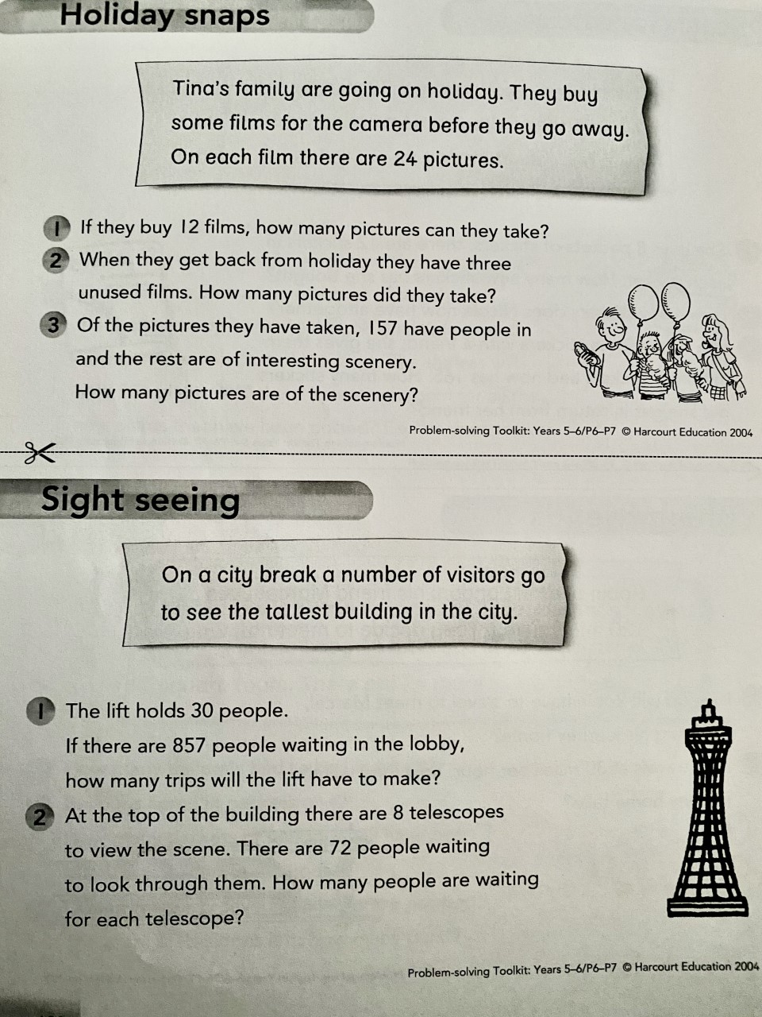

**Triangles** 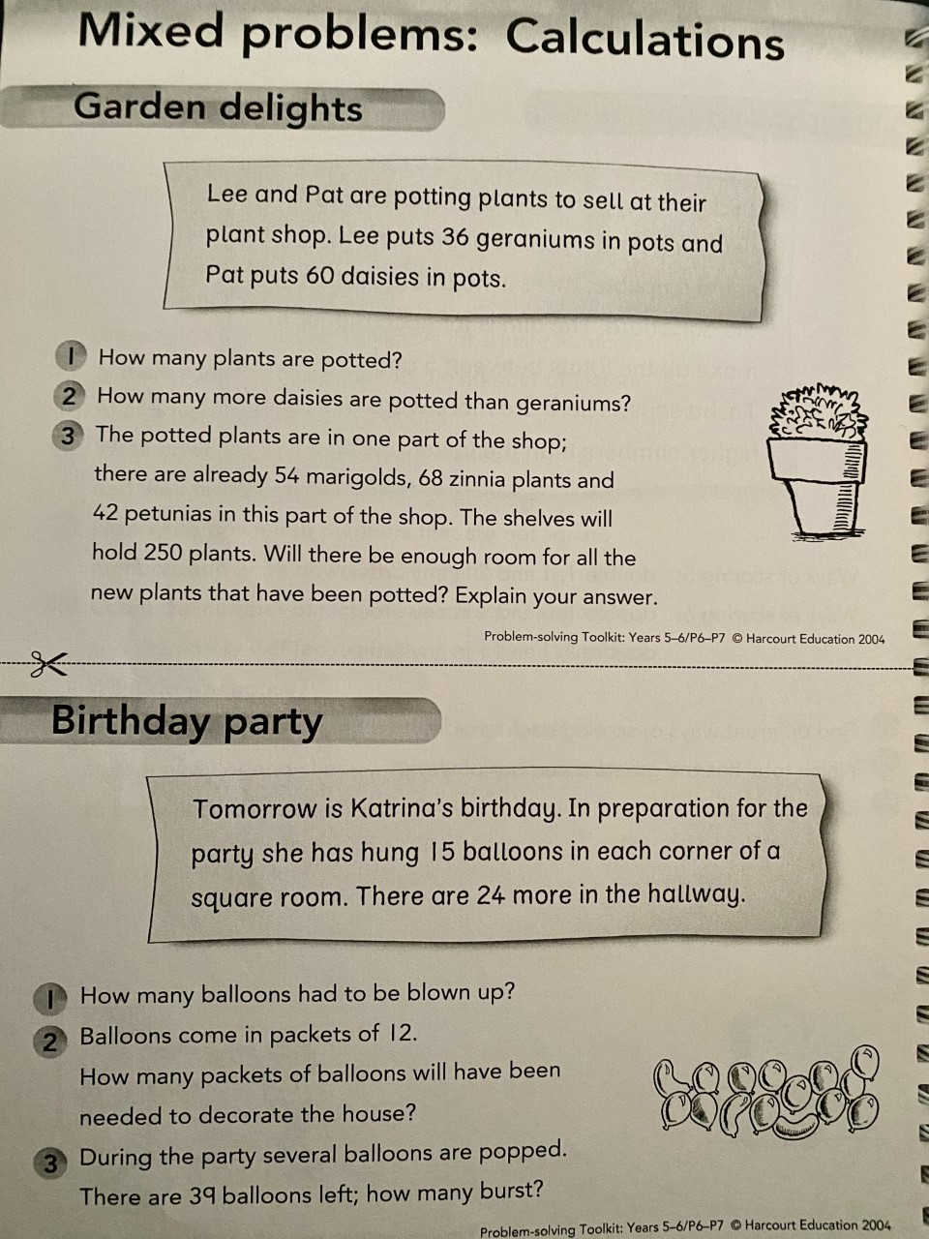

**Circles**

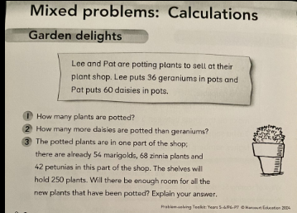

Skills Academy   
LI: to capture an image (new themes)



Using your photography skills, you are going to find and take photos of things relevant to the themes given below. If you are unable to take photos, draw them in your green jotter! Get creative; happiness doesn’t just have to be someone smiling, it can be something that brings you happiness. Share your learning with your teacher on TEAMS if you can! Please refrain from taking photos of yourselves.

* Colour
* Determination
* Learning
* Food & drink

Spanish  
LI: to understand and use Spanish vocabulary for different animals

We have an exciting new resource you can use to develop your confidence in Spanish. Today, we are going to learn different words for a variety of different animals!

Step 1) Access: <https://www.linguascope.com/>

Username: windyknowe   
Password: learner

Step 2) Select beginner section, clicking on the Spanish flag

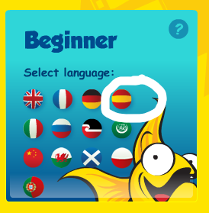

Step 3) Select ‘Mis animales’

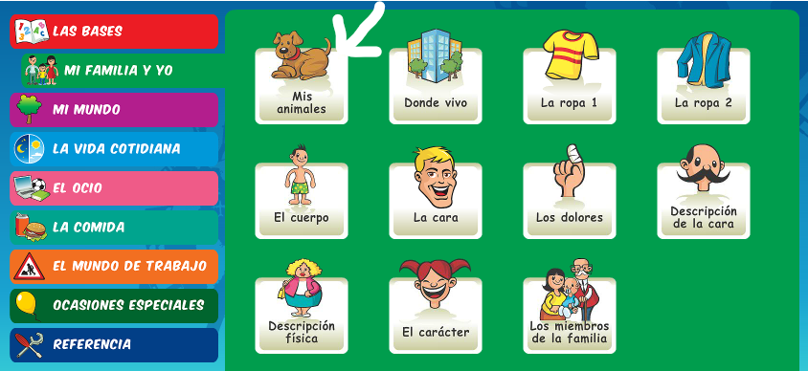

Step 4) Work through the first column of tabs where you will learn words for different animals and play a listening game and matching game! Making notes of your learning in your jotter will help you retain the information. Let your teacher know how you get on 😊

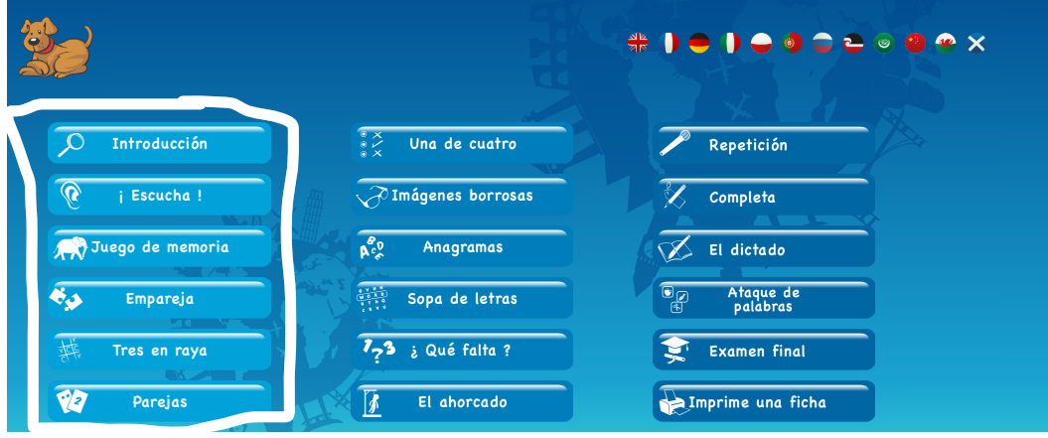

**Reward Time**

**L.I. to rest and play**

**After a hard working week it is time to do something that you enjoy doing in your free time. Please share in the digital classroom what you are doing. 😊 By sharing your activity, it will give other people ideas on what they could do; please make sure it is sensible and appropriate though.**