**Friday 22.5.20**

**Typing**

**L.I. To learn the position of each letter on a keyboard**

We’ve progressed onto Level 2 of Dance Mat Typing! Have a go at number 4 ‘t and y’. <https://toybox.tools.bbc.co.uk/activities/id/activity-dance-mat-typing-level2/exitGameUrl/http%3A%2F%2Fwww.bbc.co.uk%2Fguides%2Fz3c6tfr>

Make sure you have completed level 1 before you move on to level 2. Here is the link for level 1 if you need it.

<https://toybox.tools.bbc.co.uk/activities/id/activity-dance-mat-typing/exitGameUrl/http%3A%2F%2Fwww.bbc.co.uk%2Fguides%2Fz3c6tfr>

Remember this activity only works if you are on a **laptop**.

If you are on a **device**, try this activity instead:

**Mild - Hot**: <https://www.turtlediary.com/game/typing-race-beginner.html>

You can choose your level depending on how confident you are about typing. See if you can manage a harder level than last week.

**Extra Hot**: <https://www.typerush.com/> (you can play the boat or the car race)

**Problem Solving**

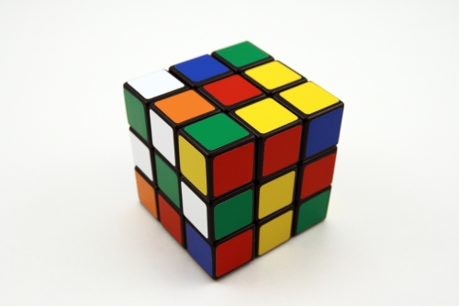

L.I To try a simpler case

S.C. I can try a simpler case

I find a number pattern

I can continue a number pattern

Open your problem solving for the day and read the instructions carefully. You may want to read them a couple of times or write it simpler in note form (tip!).

The problem is asking you to find out how many ways he can come down 12 stairs. Using the try a simpler case method, try it out with a staircase with 3 steps, then 4 steps, then 5steps... can you spot a pattern? Could this pattern be continued to see what the answer is for 12 stairs?

I can’t wait for you to share your answers!

ERVIC (Everyone reading virtually in class) Mr Muller

**LI - to identify key information from a written text.**

**SC –**

**I can use my memory to recall information.**

**I can skim and scan my book for information.**

**I can say what a cliffhanger is.**

**Step 1:** Read a book at home (fiction or non-fiction) for at least 30 minutes.

**Step 2:** Answer the following questions in your green jotter. These questions focus on your ability to remember.

1. When and where did the story take place?
2. Who are the main characters in the story?
3. What does the main character look like?
4. How does the book begin?
5. Where in the book would you find an example of a cliffhanger?