**Thursday 21.5.20**

**Punctuation and grammar – Homophones**  
Today we are going to practise our knowledge of homophones. Homophones are words that sound the same that have different meanings.

Here is a video that explains homophones too! : <https://www.youtube.com/watch?v=BSLj9S2vMSw>

**Play this fun homophone matching game:**   
<https://www.learninggamesforkids.com/vocabulary-games/homophones-games/homophones.html>   
  
**See your tasks below for your groups!**

**Greens**  
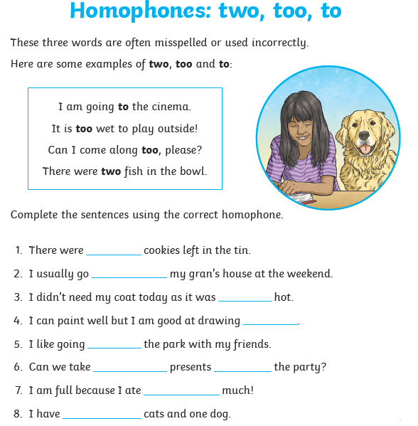

**Blues & Reds**  
  
**Please write/type the sentences in full when selecting the right homophone.**  
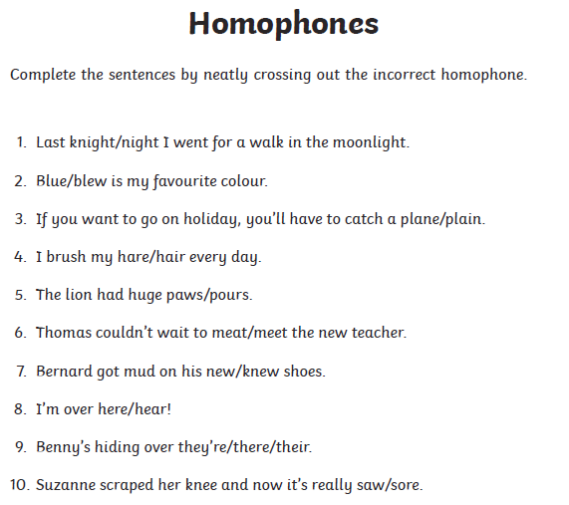

Optional tasks –

* can you think of any other homophones that are not included in the sheets? Note them down in your jotter & share them with your teacher!
* Make a homophone poster with cool illustrations explaining homophones! See below for an example 😊   
  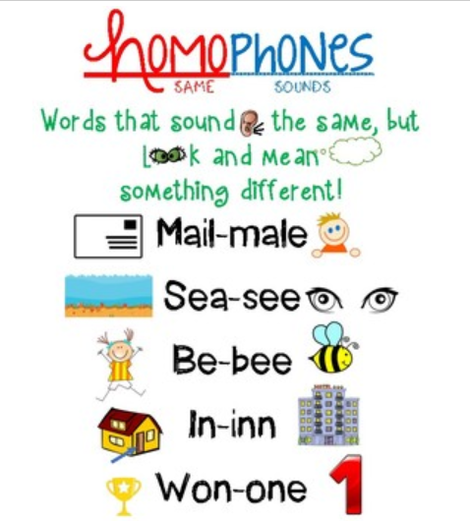

**Maths – LI – to work out time intervals**

**SC**

**I can use a time line**

**I can find a start time and an end time**

**Starter -** <https://www.youtube.com/watch?v=0aOfUsBaQyU>

Then look at Mr Muller’s examples...

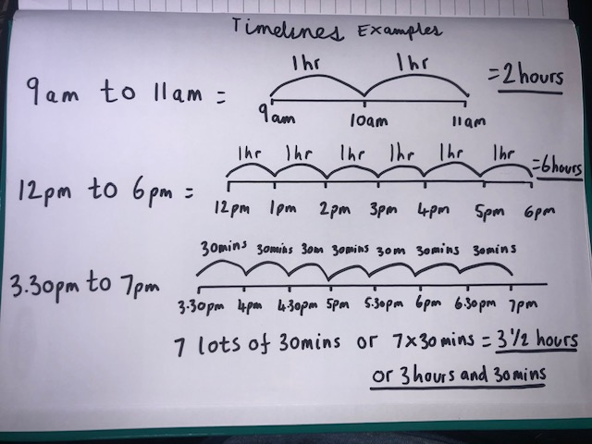

**Main** (draw a timeline for each question like Mr Muller has drawn above to work out the answer)

**Circles -**

**9am to 11am**

**7am to 10am**

**5am to 11am**

**6am to 12pm**

**1pm to 9pm**

**Triangles**

**8am to 11am**

**7pm to 11pm**

**2pm to 3.30pm**

**6am to 12.30pm**

**1.30pm to 8.30pm**

**2.30pm to 5.30pm**

**Rectangles**

**1.30pm to 7pm**

**1.15pm to 9.30pm**

**6.15am to 11.45am**

**12.15pm to 3.45pm**

**2.30pm to 10.15pm**

**9.45pm to midnight (00.00)**

**1.45am to 7.45am**

|  |
| --- |
| **RRS – Health Lesson** |

**Music**



**Mr Muller has placed activities in your charanga inbox**

This can be access here <https://www.charangascotland.co.uk/yumu/login>

If you are unable to access charanga and you don’t have a username or password, let Mr Muller know